UNITED STATES
SECURITIES AND EXCHANGE COMMISSION
Washington, D.C. 20549

FORM 6-K

REPORT OF FOREIGN PRIVATE ISSUER
PURSUANT TO RULE 13a-16 OR 15d-16
UNDER THE SECURITIES EXCHANGE ACT OF 1934

For the month of March 2026 |  | Commission File Number: 001-31349

THOMSON REUTERS CORPORATION
(Translation of registrant’s name into English)

19 Duncan Street, Toronto,
Ontario M5H 3H1, Canada
(Address of principal executive office)

Indicate by check mark whether the registrant files or will file annual reports under cover of Form 20-F or Form 40-F.
Form 20-F ☐ Form 40-F ☒
The information contained in Exhibit 99.2 of this Form 6-K is incorporated by reference into (i) the Registration Statement on Form F-10 of Thomson Reuters Corporation (File No. 333-285907) and (ii) the Registration Statement on Form F-3 of TR Finance LLC, West Publishing Corporation, Thomson Reuters (Tax & Accounting) Inc. and Thomson Reuters Applications Inc. (File Nos. 333-285927, 333-285927-01, 333-285927-02 and 333-285927-03).

SIGNATURES
Pursuant to the requirements of the Securities Exchange Act of 1934, the registrant has duly caused this report to be signed on its behalf by the undersigned, thereunto duly authorized.

THOMSON REUTERS CORPORATION
By: |  | /s/ Jennifer Ruddick
Name: |  | Jennifer Ruddick
Title: |  | Deputy Company Secretary
Date: March 13, 2026

EXHIBIT INDEX

Exhibit
Number Description
99.1 |  | News release dated March 13, 2026 – Thomson Reuters Files Documents for Proposed Return of Capital and Share Consolidation Transactions
99.2 |  | Notice of Special Meeting of Shareholders and Management Proxy Circular dated March 13, 2026
99.3 |  | Form of Proxy for Registered Shareholders
99.4 |  | Notice of Availability of Proxy Materials
99.5 |  | Letter of Transmittal for Registered Holders
99.6 |  | Opt-Out Election and Certification Form for Registered Holders
99.7 |  | Letter to Registered Holders
99.8 |  | Letter to Non-Registered Holders
99.9 |  | Certificate of Abridgement
Exhibit 99.1


Thomson Reuters Files Documents for Proposed Return of Capital and Share Consolidation Transactions
TORONTO, March 13, 2026 – Thomson Reuters (TSX/Nasdaq: TRI) today filed its management proxy circular and related documents in connection with the upcoming special meeting at which shareholders will be asked to approve the proposed return of capital and share consolidation transactions, among other items. The management proxy circular and related documents are available online and for pick-up, as set out below.
The transactions consists of a special cash distribution of US$605 million in the aggregate, or approximately US$1.36 per common share (estimated based on the number of common shares issued and outstanding as of the record date and assuming no shareholders opt-out of the return of capital) followed by a consolidation of outstanding common shares (or “reverse stock split”) on a basis that is proportional to the special cash distribution. The share consolidation ratio will be based on the volume weighed average trading price of the common shares on the Nasdaq Stock Market LLC (“Nasdaq”) for the five trading days immediately prior to the return of capital becoming effective.
The proposed return of capital is intended to distribute cash on a basis that is generally expected to be tax-free for Canadian tax purposes. Shareholders who are taxable in a jurisdiction outside of Canada (including taxable U.S. resident shareholders and others) (“Eligible Opt-Out Shareholders”) will be able to opt out of the return of capital. This right to opt out is being provided to those shareholders because in jurisdictions other than Canada the tax consequences of not participating in the return of capital may be preferable to those associated with participating in the return of capital. If an Eligible Opt-Out Shareholder chooses to opt out, it will not receive the cash distribution and will continue to hold the same number of shares that it currently holds.
Details of the transaction (including information regarding the opt-out right) are described in the management proxy circular and related materials, which are available on thomsonreuters.com in the “Investor Relations” section. The documents were filed with the Canadian securities regulatory authorities on SEDAR+ and are available at www.sedarplus.com. The documents will also be furnished to the U.S. Securities and Exchange Commission through EDGAR and when filed, will be available at www.sec.gov. The documents will also be available for pick-up, free of charge, at Computershare Investor Services Inc.’s offices in Toronto, Montreal, Vancouver and Calgary. Please contact Computershare Investor Services Inc. using the phone numbers set out below for the addresses of those offices.
The special meeting of shareholders will be held on Tuesday, April 28, 2026 at 9:00 a.m. EDT (changed from the original planned time of 12:00 p.m.). The meeting will be a webcast on thomsonreuters.com in the “Investor Relations” section. Holders of Thomson Reuters common shares as of 5:00 p.m. EDT on March 6, 2026 are entitled to vote at the meeting.
Registered shareholders who have questions or need assistance voting their shares may contact Computershare Investor Services Inc. at 1.800.564.6253 (toll-free in Canada and the U.S.) or at 1.514.982.7555 (outside Canada and the U.S.). Non-registered shareholders who hold their shares indirectly through an intermediary (such as an investment dealer, stock broker, bank, trust company or other nominee) should contact their intermediary if they have questions or need assistance. Shareholders who have questions or need assistance may also contact D.F. King & Co., Inc., who is acting as Information Agent for the transaction, at 1.800.967.5068 (toll-free in Canada and the U.S.) or at 1.212.561.5870 (outside Canada and the U.S., banks, brokers and collect calls) or at the following email address: tri@dfking.com.

Page 2 of 2

About Thomson Reuters
Thomson Reuters (TSX/Nasdaq: TRI) informs the way forward by bringing together the trusted content and technology that people and organizations need to make the right decisions. The company serves professionals across legal, tax, audit, accounting, compliance, government, and media. Its products combine highly specialized software and insights to empower professionals with the data, intelligence, and solutions needed to make informed decisions, and to help institutions in their pursuit of justice, truth and transparency. Reuters, part of Thomson Reuters, is the world’s leading provider of trusted journalism and news. For more information, visit thomsonreuters.com.
SPECIAL NOTE REGARDING FORWARD-LOOKING STATEMENTS
Certain statements in this news release are forward-looking within the meaning of applicable Canadian and U.S. securities laws, including the Private Securities Litigation Reform Act of 1995. These statements relating to the return of capital and share consolidation transactions and the anticipated tax treatment for shareholders participating in the return of capital and those opting out. These forward-looking statements are based on certain assumptions, including shareholder approval of the transactions, and reflect our company’s current expectations. As a result, forward-looking statements are subject to a number of risks and uncertainties that could cause actual results or events to differ materially from current expectations, including the risk factors discussed in materials that Thomson Reuters from time to time files with, or furnishes to, the Canadian securities regulatory authorities and the U.S. Securities and Exchange Commission. There is no assurance that the return of capital and share consolidation transactions will be completed or that other events described in any forward-looking statement will materialize. Except as may be required by applicable law, Thomson Reuters disclaims any obligation to update or revise any forward-looking statements.
CONTACTS
MEDIA
Zoe Zanettos
Director, Corporate Affairs
+1 647 202 8948
zoe.zanettos@thomsonreuters.com
INVESTORS
Gary E. Bisbee, CFA
Head of Investor Relations
+1 646 540 3249
gary.bisbee@thomsonreuters.com
Exhibit 99.2


Management Proxy Circular and
Notice of Special Meeting of Shareholders
March 13, 2026



YOUR VOTE AND PARTICIPATION AS A SHAREHOLDER IS IMPORTANT.
Please read this document and vote.

Notice of Special Meeting of Shareholders of Thomson Reuters Corporation
We are pleased to invite you to attend a special meeting of shareholders.

When |  | Where
Tuesday, April 28, 2026  9:00 a.m. (Toronto time) |  | Thomson Reuters Corporation  19 Duncan Street  Toronto, Ontario, Canada  A live audio webcast will be available on our website at  www.thomsonreuters.com. A replay of the webcast will be posted on our website after the meeting.
To our Shareholders,
We are pleased to invite you to attend a special meeting of shareholders on Tuesday, April 28, 2026 at 9:00 a.m. (Toronto time). Our company will be holding this meeting in-person at 19 Duncan Street, Toronto, Ontario, Canada. A live audio webcast of the meeting will also be available on our website at www.thomsonreuters.com. A replay of the webcast will be posted on our website after the meeting.
Business of the Meeting
At the meeting, shareholders will be asked to:
1. Consider, pursuant to an interim order of the Ontario Superior Court of Justice (Commercial List) dated March 11, 2026, and, if deemed advisable, to approve, with or without amendment, a special resolution approving a plan of arrangement pursuant to Section 182 of the Business Corporations Act (Ontario) (OBCA) under which Thomson Reuters Corporation will (i) make a special cash distribution of $605 million in the aggregate, and (ii) consolidate its outstanding common shares (or “reverse stock split”) on a basis that is proportional to the special cash distribution, as described in the accompanying circular; and
2. Transact any other business properly brought before the meeting and any adjourned or postponed meeting.
You can read about each of these items in more detail in the accompanying management proxy circular. A copy of the text of the special resolution and a copy of the plan of arrangement related to item 1 are attached as Appendices A and B, respectively, to the circular.
Participating in the Meeting
The process for participating in the meeting depends on whether you’re a registered or non-registered shareholder. You can find more information about these terms in the “Voting Information and How to Attend” section of the accompanying management proxy circular.

Registered shareholders and duly appointed proxyholders (including non-registered shareholders who have duly appointed themselves as proxyholder) will be able to attend the meeting, submit or ask questions and vote at the meeting in person.

If you are a non-registered shareholder (or “beneficial owner”) who wishes to attend the meeting, submit or ask questions and vote in-person, you have to appoint yourself as proxyholder first and then also register with our transfer agent, Computershare Trust Company of Canada. If you’re a non-registered shareholder and don’t appoint yourself as proxyholder, you can still attend the meeting as a guest, but you won’t be able to submit or ask questions or vote at the meeting. If you are a non-registered shareholder located in the United States and wish to appoint yourself as a proxyholder in order to attend, participate or vote at the meeting, you MUST also obtain a valid legal proxy from your intermediary and submit it to Computershare Trust Company of Canada.

Management Proxy Circular and Notice of Special Meeting of Shareholders

Please carefully follow the instructions in the “Voting Information and How to Attend” section of the accompanying management proxy circular and on your form of proxy or voting instruction form (VIF).
Record Date
You are entitled to vote at the meeting, and any adjourned or postponed meeting, if you were a holder of our common shares as of 5:00 p.m. (Toronto time) on March 6, 2026.
Notice-And-Access
We are using the “notice-and-access” system for the delivery of our proxy materials through our website, www.thomsonreuters.com. Shareholders who receive a notice have the ability to access the proxy materials on our website and to request a paper copy of the proxy materials. Instructions on how to access the proxy materials through our website or to request a paper copy may be found in the notice. Electronic delivery reduces the cost and environmental impact of producing and distributing paper copies of documents in very large quantities. It also provides shareholders with faster access to information about Thomson Reuters.
Shareholders who have already signed up for electronic delivery of proxy materials will continue to receive them by e-mail.
Voting
Your vote is important. If you’re unable to attend the meeting, please vote by proxy. A proxy is a document that authorizes someone else to attend the meeting and cast votes for you. The proxy form contains instructions on how to complete and send your voting instructions. If you hold your shares through a broker or other intermediary, you should follow the procedures provided by your broker or intermediary.
If you’re a registered shareholder, our transfer agent, Computershare Trust Company of Canada, must receive your proxy or voting instructions no later than 5:00 p.m. (Toronto time) on Friday, April 24, 2026 or if the meeting is adjourned or postponed, no later than 48 hours (excluding Saturdays, Sundays and holidays) before any adjourned or postponed meeting. If you’re a registered shareholder and have any questions or need assistance voting your shares, please call Computershare Trust Company of Canada, toll-free in Canada and the United States, at 1.800.564.6253.
Non-registered/beneficial shareholders will be subject to earlier voting deadlines as specified in their proxy or voting instructions.
Thank you for your continued support of, and interest in, Thomson Reuters.
Very truly yours,

/s/ David Thomson |  | /s/ Steve Hasker
David Thomson  Chairman of the Board |  | Steve Hasker  President & Chief Executive Officer
March 13, 2026

Management Proxy Circular and Notice of Special Meeting of Shareholders

Letter to Shareholders

We will be holding a special meeting of shareholders in-person at 19 Duncan Street, Toronto, Ontario, Canada. This circular provides information and instructions regarding how to participate in this special meeting.
To our Shareholders,
On behalf of the board of directors of Thomson Reuters Corporation, we are pleased to invite you to attend a special meeting of
shareholders on Tuesday, April 28, 2026 at 9:00 a.m. (Toronto time) at our offices located at 19 Duncan Street, Toronto, Ontario, Canada.
Since 2018, we have received approximately $24.9 billion of gross proceeds derived from (i) the sale of a 55% interest in our Financial & Risk business (Refinitiv) to a Blackstone-led consortium in 2018 and (ii) subsequent dispositions of London Stock Exchange Group plc (LSEG) shares received as consideration from the sale of Refinitiv, between March 2021 and May 2024, and have returned a significant portion of such proceeds to shareholders by way of share repurchases under our normal course issuer bid, a substantial issuer bid/tender offer and return of capital transactions in 2018 and 2023. We are now proposing a third return of capital transaction to return $605 million to shareholders by means of a special distribution, followed by a share consolidation, as described in the accompanying management proxy circular.
The proposed return of capital and share consolidation transactions require shareholder approval. The purpose of this special meeting is to, among other things, consider and vote upon a special resolution approving a statutory arrangement to implement these transactions. The transactions consist of:

a special cash distribution of $605 million in the aggregate, or approximately $1.36 per participating share (estimated based on the number of common shares issued and outstanding as of the record date and assuming no shareholders opt-out of the return of capital); and

a consolidation of our outstanding common shares (or “reverse stock split”) on a basis that is proportional to the special cash distribution.
The actual amount of cash distributed per share will be determined at the close of business on the Business Day immediately prior to the Effective Time based on the number of participating shares.
The proposed return of capital transaction is intended to distribute cash on a basis that is generally expected to be tax-free for Canadian tax purposes. Certain shareholders who are taxable in a jurisdiction outside of Canada (including taxable U.S. resident shareholders and others) (referred to as “Eligible Opt-Out Shareholders”) will be able to opt out of the return of capital transaction. This right to opt out is being provided to those shareholders because in jurisdictions other than Canada the tax consequences of not participating in the return of capital transaction may be preferable to those associated with participating in the return of capital transaction. If you are an Eligible Opt-Out Shareholder and choose to opt out, you will not receive the special cash distribution, and upon completion of the arrangement, you will continue to hold the same number of shares that you currently hold.
The details of the transactions are described in the accompanying management proxy circular and other related materials.
To become effective, the special resolution approving the arrangement must be approved by at least two-thirds of the votes cast at the meeting. Our principal shareholder, The Woodbridge Company Limited, which owns approximately 70% of our outstanding common shares (together with its affiliates), has indicated that it will vote in favour of the resolution. Accordingly, we expect the resolution will be approved. The arrangement also requires the approval of the Ontario Superior Court of Justice (Commercial List).
The board of directors, upon careful consideration of a number of factors, has determined that the proposed arrangement is in the best interests of our company and unanimously recommends that you vote to approve the arrangement.
You are invited to attend the special meeting. However, if you are unable to attend, please vote by proxy. If you have any questions about how to vote your shares or, if you are an Eligible Opt-Out Shareholder, how to opt out of the proposed return of capital transaction, please call Computershare Investor Services Inc., toll-free in Canada and the United States, at 1.800.564.6253, outside of Canada and the United States, at 1.514.982.7555 (if you are a registered shareholder), your intermediary (if you are a non-registered shareholder), or D.F. King & Co., Inc., the Information Agent, toll-free in Canada or the United States at 1.800.967.5068.

Management Proxy Circular and Notice of Special Meeting of Shareholders

If shareholders approve the arrangement, it is expected to become effective on or about May 4, 2026.

/s/ David Thomson |  | /s/ Steve Hasker
David Thomson  Chairman of the Board |  | Steve Hasker  President & Chief Executive Officer
Certain statements in the letter are forward-looking. These forward-looking statements are based on certain assumptions and reflect our current expectations. As a result, forward-looking statements are subject to a number of risks and uncertainties that could cause actual results or events to differ materially from current expectations. Some of the factors that could cause actual results to differ materially from current expectations are discussed in the “Risk Factors” section of our 2025 annual report as well as in other materials that we from time to time file with, or furnish to, the Canadian securities regulatory authorities and the U.S. Securities and Exchange Commission (SEC). There is no assurance that any forward-looking statements will materialize. You are cautioned not to place undue reliance on forward-looking statements, which reflect expectations only as of this date. Except as may be required by applicable law, we disclaim any intention or obligation to update or revise any forward-looking statements.

Management Proxy Circular and Notice of Special Meeting of Shareholders

Table of Contents

About Thomson Reuters |  |  | 5
About this Circular and Related Proxy Materials |  |  | 6
Business of the Meeting |  |  | 7
Voting Information |  |  | 7
Cautionary Note Concerning Factors That May Affect Future Results |  |  | 19
Notice-and-Access |  |  | 20
Electronic Delivery of Shareholder Communications |  |  | 20
Principal Shareholder and Share Capital |  |  | 21
Information Regarding the Transaction |  |  | 22
Interest of Certain Persons in Matters to be Acted Upon |  |  | 31
Risk Factors |  |  | 31
Depositary |  |  | 31
Information Agent |  |  | 32
Income Tax Considerations |  |  | 32
Additional Information |  |  | 42
Directors’ Approval |  |  | 44
Appendix A – Special Resolution |  |  | A-1
Appendix B – Plan of Arrangement |  |  | B-1
Appendix C – Interim Order |  |  | C-1
Appendix D – Notice of Application for Final Order |  |  | D-1

Management Proxy Circular and Notice of Special Meeting of Shareholders |  | Page 1

Glossary of Terms

In this circular, unless the subject matter or context of this circular is inconsistent with these defined terms the following terms have the following meanings:
“2024 LSEG Share Sales” has the meaning set forth in the subsection entitled “Background to and Reasons for the Transaction”.
“Aggregate Cash Distribution Amount” means $605 million.
“Arrangement” means the arrangement pursuant to the provisions of Section 182 of the OBCA on the terms and subject to the conditions set out in the Plan of Arrangement as supplemented, modified or amended.
“Blackstone’s consortium” means The Blackstone Group and its subsidiaries, and private equity funds affiliated with Blackstone.
“Business Day” means any day, other than a Saturday, a Sunday, a statutory holiday in Toronto, Ontario, Canada, or a United States federal holiday.
“Canadian Resident Opting-Out Shareholder” has the meaning set forth in the section entitled “Income Tax Considerations – Certain Canadian Federal Income Tax Considerations – Tax Consequences to Canadian Resident Shareholders Who Opt-Out of the Return of Capital.”
“Canadian Resident Participating Shareholder” has the meaning set forth in the section entitled “Income Tax Considerations – Certain Canadian Federal Income Tax Considerations – Tax Consequences to Canadian Resident Shareholders Who Participate in the Return of Capital”.
“Canadian Resident Shareholder” has the meaning set forth in the section entitled “Income Tax Considerations – Certain Canadian Federal Income Tax Considerations – Tax Consequences to Canadian Resident Shareholders Who Participate in the Return of Capital”.
“Cash Distribution Per Share” means the Aggregate Cash Distribution Amount divided by the number of participating shares.
“common shares” means the common shares in the capital of Thomson Reuters Corporation, except as the context otherwise requires.
“Conversion Ratio” has the meaning set forth in the section entitled “Information Regarding the Transaction – Terms of the Arrangement – Conversion Ratio”.
“Court” means the Ontario Superior Court of Justice (Commercial List).
“Depositary” means Computershare Investor Services Inc. at its offices set out in the Letter of Transmittal.
“Effective Date” means the date the Arrangement is effective under the OBCA.
“Effective Time” means 3:01 a.m. (Toronto time) on the Effective Date, or such other time on the Effective Date as we may determine.
“Eligible Opt-Out Shareholder” has the meaning set forth in the section entitled “Information Regarding the Transaction – Terms of the Arrangement – Opt-Out Right”.
“F&R Transaction” has the meaning set forth in the subsection entitled “Background to and Reasons for the Transaction”.
“Final Order” means a final order from the Court approving the Arrangement under subsection 182(5) of the OBCA, as such order may be affirmed, amended or modified by any court of competent jurisdiction.
“Information Agent” means D.F. King & Co., Inc.
“Interim Order” means the interim order of the Court dated March 11, 2026 under subsection 182(5) of the OBCA containing declarations and directions with respect to the Arrangement, as such order may be affirmed, amended or modified by any court of competent jurisdiction, a copy of which is attached as Appendix C.

Management Proxy Circular and Notice of Special Meeting of Shareholders |  | Page 2

“Letter of Transmittal” means the letter of transmittal for use by registered shareholders, in the form accompanying this circular (printed on yellow paper).
“LSEG Transaction” has the meaning set forth in the subsection entitled “Background to and Reasons for the Transaction”.
“New Common Shares” means the new common shares to be created pursuant to the Plan of Arrangement with rights, privileges, restrictions and conditions as set out in Schedule “A” to the Plan of Arrangement.
“Non-Canadian Resident Opting-Out Shareholder” has the meaning set forth in the section entitled “Income Tax Considerations – Certain Canadian Federal Income Tax Considerations – Tax Consequences to Non-Canadian Resident Shareholders Who Opt-Out of the Return of Capital”.
“Non-Canadian Resident Participating Shareholder” has the meaning set forth in the section entitled “Income Tax Considerations – Certain Canadian Federal Income Tax Considerations – Tax Consequences to Non-Canadian Resident Shareholders Who Participate in the Return of Capital”.
“Non-Canadian Resident Shareholder” has the meaning set forth in the section entitled “Income Tax Considerations – Certain Canadian Federal Income Tax Considerations – Tax Consequences to Non-Canadian Resident Shareholders Who Participate in the Return of Capital”.
“non-participating shares” means the common shares held by opting-out shareholders at the Effective Time.
“opt-out deadline” means 5:00 p.m. (Toronto time) on the Business Day prior to the date of the special meeting.
“Opt-Out Election and Certification Form” means the Opt-Out Election and Certification Form for use by registered Eligible Opt-Out Shareholders in the form accompanying this circular (printed on blue paper).
“opt-out right” means the right of an Eligible Opt-Out Shareholder to opt out of the Return of Capital in accordance with the provisions of the Plan of Arrangement and the Opt-Out Election and Certification Form.
“opting-out shareholder” means an Eligible Opt-Out Shareholder that has duly exercised its opt-out right.
“participating shareholder” means a shareholder other than an opting-out shareholder.
“participating shares” means the common shares held by participating shareholders at the Effective Time.
“Plan of Arrangement” means the plan of arrangement attached to this circular as Appendix B, as amended or supplemented from time to time in accordance with the terms thereof.
“PUC” means “paid-up capital” as defined in subsection 89(1) of the Tax Act.
“Return of Capital” means the special distribution of the Aggregate Cash Distribution Amount pursuant to Section 2.2(e) of the Plan of Arrangement.
“Share Consolidation” means the consolidation of common shares pursuant to Section 2.2(i) of the Plan of Arrangement.
“Share Consolidation Ratio” has the meaning set forth in the section entitled “Information Regarding the Transaction – Terms of the Arrangement – Share Consolidation Ratio”.
“shareholders” means the holders of common shares.
“special resolution” means the special resolution, attached as Appendix A to this circular, with or without amendment, being considered by shareholders at the special meeting.
“Tax Act” means the Income Tax Act (Canada), RSC 1985, c.1 (5th Supp), as amended.
“Thomson Reuters”, “we”, “us”, “our” or “our company” means Thomson Reuters Corporation and our consolidated subsidiaries, except for such references under “Information Regarding the Transaction” (other than the sections entitled “Background to and Reasons for the Transaction” and “Income Tax Considerations”), where such terms mean Thomson Reuters Corporation.
“Transaction” means the transactions to be effected under the Arrangement, including the Return of Capital and the Share Consolidation.
“TSX” means the Toronto Stock Exchange.

Management Proxy Circular and Notice of Special Meeting of Shareholders |  | Page 3

“U.S. Treaty” means the Convention between Canada and the United States of America with Respect to Taxes on Income and on Capital, signed September 26, 1980, as amended.
“Woodbridge” means, collectively, The Woodbridge Company Limited and other companies affiliated with it.
“YPL” means York Parent Limited and its subsidiaries.

Management Proxy Circular and Notice of Special Meeting of Shareholders |  | Page 4

About Thomson Reuters
Overview
Who We Are and What We Do
Thomson Reuters powers business-critical professionals with AI they can trust in the moments that matter. We unite unparalleled expertise, proprietary content, and seamless workflows to help our customers move with speed, think with clarity, and lead with confidence. Across our products, we combine highly specialized software and insights to empower professionals with the data, intelligence and solutions needed to make informed decisions, and to help institutions in their pursuit of justice, truth and transparency. Reuters, part of Thomson Reuters, is a world leading provider of trusted journalism and news. Thomson Reuters shares are listed on the Toronto Stock Exchange and the Nasdaq (symbol: TRI). Our website is thomsonreuters.com.
We are organized as five reportable segments, reflecting how our products and services are managed and offered to target customers.

 |  | Legal Professionals  Serves law firms and governments with research and workflow products powered by AI-enabled technology, focusing on intuitive legal research and integrated legal workflow solutions that combine content, tools and analytics.
 |  | Corporates  Serves corporations, ranging from small businesses to multinational organizations, including the seven largest global accounting firms, with our full suite of content-driven products, powered by AI-enabled technology and integrated compliance workflow solutions to help them achieve their business outcomes.
 |  | Tax, Audit & Accounting Professionals  Serves tax, audit and accounting firms (other than the seven largest, which are served by our Corporates segment) with research and workflow products powered by AI-enabled technology.
 |  | Reuters  Supplies business, financial and global news and data to the world’s media organizations, professionals and news consumers through Reuters News Agency, Reuters.com, Reuters Events, Thomson Reuters products and to financial firms exclusively via LSEG products.
 |  | Global Print  Provides legal and tax information primarily in print format to customers around the world and provides commercial printing services to a wide range of book publishers.
Our businesses are supported by a corporate center that manages our commercial and technology operations, including those around our sales capabilities, digital customer experience and product and content development, as well as our global facilities.
We are incorporated under the Business Corporations Act (Ontario). Our principal executive office is located at 19 Duncan Street, Toronto, Ontario, Canada.

Management Proxy Circular and Notice of Special Meeting of Shareholders |  | Page 5

About this Circular and Related Proxy Materials

We are providing this circular and proxy materials to you in connection with a special meeting of shareholders to be held on Tuesday, April 28, 2026. As a shareholder, you are invited to attend the meeting. If you are unable to attend, you may still vote by completing the enclosed proxy form.

This circular describes the items to be voted on at the special meeting and the voting process and contains additional information about other matters that will be discussed at the meeting.
Unless otherwise indicated:

information is as of March 12, 2026;

all dollar amounts in this circular are expressed in U.S. dollars; and
In this circular, the terms “we”, “us” and “our” refer to Thomson Reuters Corporation and our consolidated subsidiaries. The term “Woodbridge” refers to The Woodbridge Company Limited and other companies affiliated with it.
Please see the “Voting Information and How to Attend” section of this document for an explanation of how you can vote on the matters to be considered at the meeting, whether or not you decide to attend the meeting.
We are a Canadian company that is considered to be a “foreign private issuer” for U.S. federal securities law purposes. As a result, we have prepared this circular in accordance with applicable Canadian disclosure requirements.
Information contained on our website or any other websites identified in this circular is not part of this circular. All website addresses listed in this circular are intended to be inactive, textual references only. The Thomson Reuters logo and our other trademarks, trade names and service names mentioned in this circular are the property of Thomson Reuters.
Front cover photo credit: REUTERS/Todd Korol.

Management Proxy Circular and Notice of Special Meeting of Shareholders |  | Page 6

Business of the Meeting
Highlights
This special meeting will cover the following items of business. Additional information is provided in this circular.

Item of Business |  | Board Vote  Recommendation
1. Plan of Arrangement (pages 21 and B-1 of the circular)  To consider, pursuant to an interim order of the Court dated March 11, 2026, and, if deemed advisable, to approve, with or without amendment, a special resolution approving the Arrangement described in this circular, pursuant to section 182 of the Business Corporations Act (Ontario) under which Thomson Reuters Corporation will (i) make a special cash distribution of $605 million in the aggregate, and (ii) consolidate its outstanding common shares (or “reverse stock split”) on a basis that is proportional to the special cash distribution. |  | ✓ FOR
2. Other business  If any other items of business are properly brought before the meeting (or any adjourned or postponed meeting), shareholders will be asked to vote. We are not aware of any other items of business at this time. |  | N/A
Voting Information
Who can vote at the meeting?
If you held common shares as of 5:00 p.m. (Toronto time) on March 6, 2026 (the record date), then you are entitled to vote at the meeting or any adjourned or postponed meeting. Each share is entitled to one vote. As of March 6, 2026, there were 443,853,252 common shares outstanding.
We also have 6,000,000 Series II preference shares outstanding, but these shares do not have voting rights at the meeting.
How many votes are required for approval?
The special resolution to approve the Transaction must be passed by not less than two-thirds (more than 66.67%) of votes cast by shareholders, in person or by proxy.
Woodbridge (together with its affiliates), our principal and controlling shareholder, beneficially owned approximately 70% of our outstanding common shares as of March 12, 2026. Woodbridge has advised our company that it will vote in favour of the Arrangement as recommended by the board of directors. Accordingly, we expect the resolution will be approved.
How do I vote?
You have two choices – you can vote by proxy, or you can attend the meeting and vote during the meeting in-person at 19 Duncan Street, Toronto Ontario, Canada. The voting process is different for each choice. The voting process also depends on whether you are a registered or non-registered shareholder.
You should first determine whether you are a registered or non-registered holder of our common shares. Most of our shareholders are non-registered holders.

Management Proxy Circular and Notice of Special Meeting of Shareholders |  | Page 7

☐ | You are a registered shareholder if your name appears directly on your share certificates, or if you hold your common shares in book-entry form through the direct registration system (DRS) on the records of our transfer agent, Computershare Trust Company of Canada.

☐ | You are a non-registered shareholder if you own shares indirectly and the shares are registered in the name of an intermediary. For example, you are a non-registered shareholder if:

 | — | your common shares are held in the name of a bank, trust company, securities broker, trustee or custodian; or

 | — | you hold Depositary Interests representing our common shares which are held in the name of Computershare Company Nominees Limited as nominee and custodian.
Non-registered shareholders are sometimes referred to as “beneficial owners”.

Registered shareholders |  | You are a registered shareholder if your name appears directly on your share certificates, or if you hold your common shares in book-entry form through the direct registration system (DRS) on the records of our transfer agent, Computershare Trust Company of Canada.
If you want to vote by proxy before the meeting |  | If it is not convenient for you to attend the meeting, you may vote by proxy on the matters to be considered at the meeting. A proxy is a document that authorizes someone else to attend the meeting and cast votes for you.  You may authorize our directors who are named on the enclosed proxy form to vote your shares as your proxyholder.  You may give voting instructions through the Internet, mail or telephone. Please refer to your proxy form for instructions.
If you want to attend and vote at the meeting |  | You do not need to do anything except attend the meeting. Do not complete or return your proxy form, as your vote will be taken at the meeting. You should register with representatives of Computershare Trust Company of Canada when you arrive at the meeting. If you wish to vote common shares registered in the name of a legal entity, that entity must submit a properly executed proxy form to Computershare Trust Company of Canada by the proxy cut-off time which appoints you to vote the common shares on its behalf.
If you want to appoint a third party as proxy to attend and vote at the meeting |  | You may appoint another person (other than our directors who are named on your proxy form) to attend the meeting on your behalf and vote your shares as your proxyholder. To do so, please follow these steps:  1. Submit your proxy form – Appoint your proxy by mail or through the Internet. If you mail the proxy form, you must print that person’s name in the blank space provided on the back of the enclosed proxy form and you should indicate how you want your shares voted. Sign, date and return the proxy form in the envelope provided. If you vote through the Internet, you may also appoint another person to be your proxyholder.  You may be able to appoint more than one proxyholder, provided that each proxyholder is entitled to exercise the rights attaching to different shares held by you. If you do appoint more than one proxyholder, you must do so by mail, and please enter the number of shares next to the proxyholder’s name that he or she is entitled to vote. The person you appoint must attend the meeting and vote on your behalf in order for your votes to be counted.  2. Proxyholder Registration – The third-party proxyholder should then register with representatives of Computershare Trust Company of Canada when they arrive at the meeting.  You may choose anyone to be your proxyholder – the person does not have to be another shareholder.

Management Proxy Circular and Notice of Special Meeting of Shareholders |  | Page 8

Deadline for returning your proxy form |  | Your completed proxy must be received by Computershare Trust Company of Canada by 5:00 p.m. (Toronto time) on Friday, April 24, 2026.

Non-registered shareholders |  | You are a non-registered shareholder if you own shares indirectly and the shares are registered in the name of an intermediary. For example, you are a non-registered shareholder if your common shares are held in the name of a bank, trust company, securities broker, trustee or custodian; or you hold Depositary Interests representing our common shares which are held in the name of Computershare Company Nominees Limited as nominee and custodian.  Non-registered shareholders are sometimes referred to as “beneficial owners”.
If you want to vote by proxy before the meeting |  | If you are a non-registered shareholder who receives a proxy form or voting instruction form (VIF), you should follow your intermediary’s instruction for completing the form. Holders of Depositary Interests will receive a voting form of instruction or direction from Computershare Investor Services PLC.
If you want to attend and vote at the meeting |  | If you are a non-registered shareholder and you wish to ask questions or vote at the meeting, you should do one of the following:    If you have received a proxy form from your intermediary, insert your own name in the blank space provided on the proxy form to appoint yourself as proxyholder. If the intermediary has not signed the proxy form, you must sign and date it. Follow your intermediary’s instructions for returning the proxy form; or    If you have received a VIF from your intermediary, follow your intermediary’s instructions for completing the form.  It is important that you comply with the signature and return instructions provided by your intermediary.  You will then need to register with representatives of Computershare Trust Company of Canada when you arrive at the meeting.  If you are a non-registered shareholder located in the United States and you wish to appoint yourself as a proxyholder, in addition to the steps above, you must first obtain a valid legal proxy from your intermediary. To do so, please follow these additional steps:  1. Follow the instructions from your intermediary included with the legal proxy form and the voting information form sent to you, or contact your intermediary to request a legal proxy form or a legal proxy if you have not received one.  2. After you receive a valid legal proxy from your intermediary, you must then submit the legal proxy to Computershare Trust Company of Canada. You can send the legal proxy by e-mail or by courier to: uslegalproxy@computershare.com (if by e-mail), or Computershare Trust Company of Canada, Attention: Proxy Dept., 14th Floor, 320 Bay Street, Toronto, Ontario M5H 4A6, Canada (if by courier). The legal proxy in both cases must be labeled “Legal Proxy” and received no later than the voting deadline of 5:00 p.m. (Toronto time) on Friday, April 24, 2026.

Management Proxy Circular and Notice of Special Meeting of Shareholders |  | Page 9

If you want to appoint a third party as proxy to attend and vote at the meeting |  | You may appoint another person (other than our directors who are named on your voting instruction form) to attend the meeting on your behalf and vote your shares as your proxyholder. If you choose this option, you must submit your voting instruction form appointing the third party AND register the third party proxyholder as described below. Registering your proxyholder is an additional step to be completed AFTER you have submitted your voting instruction form.  Failure to register your proxyholder will result in the proxyholder not receiving a username to attend, participate or vote at the meeting. You may choose anyone to be your proxyholder – the person does not have to be another shareholder.  Please follow these steps:  1. Submit your voting instruction form – To appoint a third-party proxyholder, insert the person’s name into the appropriate space on the voting instruction form. Follow the instructions by submitting the voting instruction form by the appropriate deadline as the instructions and deadline may vary depending on the intermediary. It is important that you comply with the signature and return instructions provided by your intermediary. This step must be completed before registering a proxyholder as step 2 below.  2. Register your proxyholder – The third-party proxyholder should then register with representatives of Computershare Trust Company of Canada when they arrive at the meeting.  If you are a non-registered shareholder located in the United States and you wish to appoint a third party as a proxyholder, in addition to the steps above, you must first obtain a valid legal proxy from your intermediary. To do so, please follow these steps:  1. Follow the instructions from your intermediary included with the legal proxy form and the voting information form sent to you, or contact your intermediary to request a legal proxy form or a legal proxy if you have not received one.  2. After you receive a valid legal proxy from your intermediary, you must then submit the legal proxy to Computershare Trust Company of Canada. You can send the legal proxy by e-mail or by courier to: uslegalproxy@computershare.com (if by e-mail), or Computershare Trust Company of Canada, Attention: Proxy Dept., 14th Floor, 320 Bay Street, Toronto, Ontario M5H 4A6, Canada (if by courier). The legal proxy in both cases must be labeled “Legal Proxy” and received no later than the voting deadline of 5:00 p.m. (Toronto time) on Friday, April 24, 2026.  3. Computershare Trust Company of Canada will provide duly appointed proxyholders with a username by e-mail after the voting deadline has passed. Please note that you are required to register the third party’s appointment as a proxyholder at www.computershare.com/ThomsonReuters as noted above.
If you want to attend the meeting as a guest |  | Guests, including non-registered shareholders who have not duly appointed themselves as proxyholders, may attend but are not able to submit or ask questions or vote at the meeting.
Deadline for returning your form |  | Please check your voting instruction form for the specific deadline. Your intermediary will need your voting instructions sufficiently in advance of the proxy deadline to enable your intermediary to act on your instructions prior to the deadline.

Management Proxy Circular and Notice of Special Meeting of Shareholders |  | Page 10

How do I submit or ask questions during the meeting?
At the meeting, shareholders in attendance will be provided with an opportunity to ask questions. If you are a shareholder who is listening to the meeting by webcast or is unable to attend the meeting but have a question, you may e-mail your question to investor.relations@thomsonreuters.com prior to the meeting.
While we will seek to respond to as many shareholder questions as possible at the meeting, we cannot assure you that all questions will be able to be addressed at the meeting. If we are unable to address your question at the meeting, we will separately provide a response to you.

Management Proxy Circular and Notice of Special Meeting of Shareholders |  | Page 11

Other Questions and Answers
Can I vote my shares by filling out and returning the notice?
No. The notice sets forth the items to be voted on at the meeting, but you cannot vote by marking the notice and returning it. The notice provides instructions on how to vote.
What’s the deadline for receiving my proxy or voting instructions?
If you are a registered shareholder, your proxy must be received by 5:00 p.m. (Toronto time) on Friday, April 24, 2026.
Non-registered shareholders may be subject to earlier deadlines as specified in their proxy or voting instructions.
If the meeting is adjourned or postponed, the proxy cut-off deadline will be no later than 48 hours (excluding Saturdays, Sundays and holidays) before any adjourned or postponed meeting.
How will my shares be voted if I appoint a proxyholder?
Your proxyholder must vote your shares on each matter according to your instructions if you have properly completed and returned a proxy form. If you have not specified how to vote on a particular matter, then your proxyholder can vote your shares as he or she sees fit. If you have appointed our directors named on your proxy form or voting instruction form as your proxyholder, and you have not specified how you want your shares to be voted, your shares will be voted FOR the Transaction.
What happens if any amendments are properly made to the items of business to be considered or if other matters are properly brought before the meeting?
Your proxyholder will have discretionary authority to vote your shares as he or she sees fit. As of the date of this circular, management knows of no such amendment, variation or other matter expected to come before the meeting.
If I change my mind, how do I revoke my proxy or voting instructions?
Non-registered shareholders
You may revoke your proxy by sending written notice to your intermediary, so long as the intermediary receives your notice at least seven days before the meeting (or as otherwise instructed by your intermediary). This gives your intermediary time to submit the revocation to Computershare Trust Company of Canada. If your revocation is not received in time, your intermediary is not required to act on it.
Registered shareholders
You may revoke your proxy or voting instructions in any of the following ways:

By completing and signing a proxy form with a later date than the proxy form you previously returned, and delivering it to Computershare Trust Company of Canada at any time before 5:00 p.m. (Toronto time) on Friday, April 24, 2026. If the meeting is adjourned or postponed, the deadline will be no later than 48 hours before any adjourned or postponed meeting;

By completing a written statement revoking your instructions, which is signed by you or your attorney authorized in writing, and delivering it:

 | — | To the offices of Computershare Trust Company of Canada at any time before 5:00 p.m. (Toronto time) on Monday, April 27, 2026. If the meeting is adjourned or postponed, the deadline will be no later than close of business on the business day immediately preceding any adjourned or postponed meeting; or

 | — | To the Chair of the meeting before the meeting starts; or

 | — | In any other manner permitted by law.

Management Proxy Circular and Notice of Special Meeting of Shareholders |  | Page 12

How can I contact Computershare Trust Company of Canada or Computershare Investor Services Inc. if I have questions?
You can contact Computershare Trust Company of Canada or Computershare Investor Services Inc. directly at the following numbers:

Canada and the United States |  |  | 1.800.564.6253
Other countries |  |  | 1.514.982.7555
Who is soliciting my proxy and distributing proxy-related materials?
Thomson Reuters management and directors may solicit your proxy for use at the meeting and any adjourned or postponed meeting. Our management and directors may solicit proxies by mail and in person. We are paying all costs of solicitation. Intermediaries will distribute proxy-related materials directly to non-objecting beneficial owners on our behalf. We are paying for intermediaries to send proxy-related materials to both non-objecting beneficial owners and objecting beneficial owners.
Is my vote confidential?
Yes. Our registrar, Computershare Trust Company of Canada, independently counts and tabulates the proxies and votes cast at the meeting to preserve the confidentiality of individual shareholder votes. Proxies are referred to us only in cases where a shareholder clearly intends to communicate with management, in the event of questions as to the validity of a proxy or where it is necessary to do so to meet applicable legal requirements.
Voting results
Following the meeting, we will post the voting results in the “Investor Relations” section of our website, www.thomsonreuters.com. We will also file a copy of the results with the Canadian securities regulatory authorities at www.sedarplus.ca and the SEC at www.sec.gov. For more information, see the “Additional Information” section of this circular.

Management Proxy Circular and Notice of Special Meeting of Shareholders |  | Page 13

The Transaction
This summary is provided for convenience only and should be read in conjunction with, and is qualified in its entirety by, the more detailed information and provisions contained elsewhere in this circular. Certain terms used in this summary are defined in the Glossary of Terms.
What are the key dates for the Transaction?
We expect the following key events to occur on or about the dates and times set forth below. All times refer to local time in Toronto, Canada.

Opt-out deadline (for registered shareholders)* |  | April 27, 2026 at 5:00 p.m.
Shareholder meeting |  | April 28, 2026 at 9:00 a.m.
Application for Final Order with the Court |  | April 29, 2026 at 11:00 a.m.
Determination of Share Consolidation Ratio and Cash Distribution Per Share |  | May 1, 2026 after 4:00 p.m.
Effective Date and Time |  | May 4, 2026 at 3:01 a.m.

* | The opt-out deadline for non-registered shareholders is expected to be earlier than this date and time, as specified by intermediaries to non-registered shareholders.
What special business will be conducted at the meeting?
At the meeting shareholders will consider and vote on a special resolution (attached as Appendix A to this circular) to approve the Transaction that consists of a special cash distribution of $605 million in the aggregate, or approximately $1.36 per participating share (estimated based on the number of common shares issued and outstanding as of the record date and assuming no shareholders opt-out of the Return of Capital), and a consolidation of our outstanding common shares (or “reverse stock split”) on a basis that is proportional to the special cash distribution.
Why are we proposing the Transaction?
In January 2021, we closed the LSEG Transaction. During negotiation of the LSEG Transaction and following its closing, management discussed potential uses of the proceeds to be derived from the eventual sale of LSEG shares with the board of directors at scheduled meetings. We committed to our shareholders that those proceeds would be used to pursue organic and inorganic opportunities in key growth segments and provide returns to shareholders, which we have done to date by way of share repurchases under our normal course issuer bid as well as a return of capital transaction conducted in 2023. We are now proposing another return of capital to return $605 million of the gross proceeds derived from the 2024 LSEG Share Sales to our shareholders.
What effect will the Transaction have on my shares?
Participating shareholders will receive a special cash distribution of approximately $1.36 per participating share (estimated based on the number of common shares issued and outstanding as of the record date and assuming no shareholders opt-out of the Return of Capital) for each share that you hold and your shares will be consolidated on a basis that is proportional to the special cash distribution. The actual amount of the Cash Distribution Per Share will be determined based on the number of participating shares outstanding at the close of business on the Business Day immediately prior to the Effective Time. Eligible Opt-Out Shareholders may opt out of the Return of Capital as described in this circular. Thomson Reuters’ Series II preference shares will not participate in the Transaction.

Management Proxy Circular and Notice of Special Meeting of Shareholders |  | Page 14

Return of Capital and Share Consolidation Transactions – Using Illustrative Share Consolidation Ratio

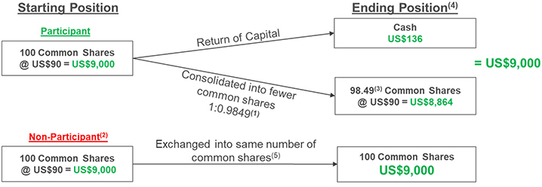

 | (1) | The share consolidation ratio used in this example is for illustrative purposes only. The actual Share Consolidation Ratio will be based on the volume weighted average trading price of the common shares on the NASDAQ for the five trading days immediately prior to the return of capital becoming effective. The ratio in this example is based on a share price of US$90.

 | (2) | As disclosed below, only Eligible Opt-Out Shareholders (which include taxable U.S. resident shareholders and others) will be able to opt out of the Return of Capital.

 | (3) | As disclosed below, fractional shares that would otherwise be held by a shareholder following the Share Consolidation will generally be sold on such holder’s behalf and such holder will receive the net cash proceeds from such sale.

 | (4) | This example does not address tax consequences to shareholders.

 | (5) | Non-participants in the Return of Capital will still participate in the Arrangement, but will ultimately hold the same number of common shares as prior to the transaction.
The special cash distribution amount and any cash payable in respect of fractional share entitlements will be denominated in U.S. dollars. The Depositary’s currency exchange services will be used to convert payment of these amounts based on the address of record of each registered participating shareholder. For more information, see the “Terms of the Arrangement – Exchange Procedure – Currency” section of this circular below.
How do I participate in the Return of Capital?
Participation will be mandatory for all shareholders except Eligible Opt-Out Shareholders who will have the right to opt out.
If you are a registered participating shareholder holding physical share certificate(s) in your own name, your share certificates will need to be updated to reflect the Share Consolidation. Unless indicated in your Letter of Transmittal, you will receive a new DRS statement instead of a new physical share certificate reflecting the Share Consolidation. To receive such DRS statement(s) or share certificate(s), you should deliver your current share certificate(s), together with a duly completed and executed Letter of Transmittal and such additional documents and instruments as may be required by the Depositary or our company, to Computershare Investor Services Inc. at the address set out under the question “Who should I contact if I have any questions?”. If you are a registered participating shareholder holding your shares in book-entry form through DRS, you are not required to submit a Letter of Transmittal. Our transfer agent, Computershare Trust Company of Canada, will update your DRS position to reflect the number of shares that you hold upon completion of the Transaction.
If you are a non-registered participating shareholder holding shares indirectly and the shares are registered in the name of an intermediary (such as an investment dealer, stock broker, bank, trust company or other nominee or intermediary, or Computershare Company Nominees Limited as nominee and custodian), your intermediary will record the share consolidation in your account. While Thomson Reuters and Computershare Trust Company of Canada are not charging any fee to process the Transaction, it is possible that your intermediary may have additional processes and fees that apply. You should contact your intermediary if you have any questions regarding the process and any related fees applicable to the Transaction or if you have any questions.
If you are a registered or non-registered opting-out shareholder, see the questions below entitled “Who can opt out of the Return of Capital and why?” and “If I am an Eligible Opt-Out Shareholder, how do I opt out of the Return of Capital?”.

Management Proxy Circular and Notice of Special Meeting of Shareholders |  | Page 15

What are the income tax consequences of the Transaction?
For Canadian federal income tax purposes: (a) the Return of Capital (i) is not expected to give rise to a dividend on the common shares for any participating shareholder, and (ii) will generally not give rise to a capital gain in respect of the common shares unless the amount of cash received by a participating shareholder exceeds the adjusted cost base of the common shares to the participating shareholder, and (b) the Share Consolidation is not expected to give rise to a capital gain in respect of the common shares (other than in relation to a disposition arising in connection with the treatment of fractional share entitlements). A Canadian Resident Shareholder will be required to include one-half of any capital gain realized in computing income; however, a Non-Canadian Resident Shareholder will not be subject to Canadian federal income tax on a capital gain realized unless the common shares are “taxable Canadian property” to the Non-Canadian Resident Shareholder.
Opting-out shareholders that do not participate in the Return of Capital will still participate in the Arrangement (including certain share exchanges and the Share Consolidation) but will ultimately hold the same number of common shares as prior to the Transaction. Opting-out shareholders will not incur any Canadian federal income tax liability solely as a result of the consummation of the Transaction.
For U.S. federal income tax purposes, the Transaction generally will be treated with respect to a participating shareholder that is a U.S. Holder (as defined in the “Income Tax Considerations – Certain U.S. Federal Income Tax Considerations” section of this circular) either as (a) a sale or exchange eligible for capital gain or loss treatment or (b) a distribution in respect of common shares, depending on the circumstances. Subject to certain assumptions, opting-out shareholders that do not participate in the Return of Capital should not incur any U.S. federal income tax liability solely as a result of the consummation of the Transaction.
Certain Canadian federal income tax considerations and certain U.S. federal income tax considerations are described in general terms in the “Income Tax Considerations” section of this circular. Shareholders are urged to carefully consider the income tax consequences of participating in the Return of Capital and to consult their own tax advisors in this regard.
This document does not address tax consequences to shareholders subject to tax in jurisdictions other than Canada and the United States. We encourage such shareholders to seek their own tax advice on these transactions.
Who can opt out of the Return of Capital and why?
If you are an Eligible Opt-Out Shareholder, you may opt out of the Return of Capital. This right to opt out is being provided to those shareholders because in jurisdictions other than Canada the tax consequences of not participating in the Return of Capital may be preferable to those associated with participating in the Return of Capital. If you choose to opt out, while you will still participate in the Arrangement (including certain share exchanges and the Share Consolidation), you will not receive the special cash distribution and will ultimately continue to hold the same number of shares that you currently hold.
None of Thomson Reuters, our board of directors, the Information Agent or the Depositary makes any recommendation to any shareholder as to whether to opt out of the Return of Capital. Shareholders are urged to evaluate carefully all information in this circular, the accompanying Letter of Transmittal and Opt-Out Election and Certification Form, and other materials related to the Transaction, consult their own financial, legal, investment and tax advisors and make their own decisions as to whether to exercise the opt-out right.
For more information on the opt-out right, see the “Terms of the Arrangement – Opt-Out Right” section of this circular.
If I am an Eligible Opt-Out Shareholder, how do I opt out of the Return of Capital?
If you are an eligible registered shareholder and wish to opt out, you must deposit with the Depositary a duly completed Opt-Out Election and Certification Form indicating your election prior to 5:00 p.m. (Toronto time) on April 27, 2026. If you are a registered shareholder holding our company’s share certificate(s) in your own name, you will also need to complete a Letter of Transmittal and deliver it and any certificates representing your shares to the Depositary by this opt-out deadline. You will be entitled to receive new DRS statements (or share certificates) reflecting the new CUSIP number for the shares, representing the post-consolidated number of shares held.
If you are a non-registered shareholder, you should contact your intermediary to exercise the opt-out right. The opt-out deadline for non-registered shareholders is expected to be earlier than the date and time for registered shareholders. The deadline for non-registered shareholders will be specified by intermediaries to such shareholders. Your account will be adjusted by your intermediary to reflect the new CUSIP number for the shares. While Thomson Reuters and Computershare Trust Company of Canada are not charging any fee to process the Transaction, it is possible that your intermediary may have additional processes and fees that apply. You should contact your intermediary if you have any questions regarding the process and any related fees applicable to the Transaction or if you have any questions.

Management Proxy Circular and Notice of Special Meeting of Shareholders |  | Page 16

You may withdraw your Opt-Out Election and Certification Form prior to the opt-out deadline, but it is irrevocable thereafter. The deadline for non-registered shareholders will be specified by intermediaries to such shareholders.
Any shareholder who does not opt out prior to the opt-out deadline will automatically participate in the Return of Capital without further action, and will therefore receive the special cash distribution and have their shares consolidated.
For more information on the opt-out right, see the “Terms of the Arrangement – Opt-Out Right” section of this circular.
What happens if I wish to sell or transfer my shares after I have opted out?
If you are a registered holder and wish to sell or transfer your shares after you have opted out, you must provide written notice to the Depositary prior to the opt-out deadline revoking your election with respect to the shares that you wish to transfer and request the return of such shares to you. Registered shareholders should allow sufficient time for this process in order to transfer deposited shares. Otherwise, you will not be able to transfer your shares until after the Transaction is completed. If you are a non-registered shareholder, you must contact your intermediary to revoke your opt-out prior to effecting such transfer.
How many votes are required to approve the Transaction?
The special resolution must be passed by not less than two-thirds (more than 66.67%) of votes cast by shareholders, during the meeting or by proxy.
Woodbridge, our principal and controlling shareholder, holds, directly and indirectly, approximately 70% of the shares (together with its affiliates) and has advised us that it intends to vote all of its shares in favour of the Transaction. Accordingly, we expect the resolution will be approved.
Does the board of directors recommend that shareholders vote in favour of the Transaction?
Yes. The board of directors, upon careful consideration of a number of factors, has determined that the Transaction is in the best interests of our company and unanimously recommends that you vote to approve the Transaction.
What other approvals are required?
The Arrangement requires final approval of the Court. If shareholders pass the special resolution at the meeting, we expect to make an application for the Final Order from the Court approving the Arrangement on April 29, 2026 at 11:00 a.m. (Toronto time), or as soon thereafter as is reasonably practicable. Completion of the Transaction is subject to fulfilling all of the requirements of the TSX and Nasdaq.
Will the Transaction affect future dividends?
We do not expect that the announcement or completion of the Transaction will affect the amount or timing of future dividends per share. If you hold shares on a dividend record date, you will continue to receive the applicable dividend to which such record date applies. Details about any future dividend, including its amount, record date and payment date, will be announced at the time that such dividend is formally declared by the Board.
Who should I contact if I have any questions?
For further information regarding the Transaction, a shareholder may contact the Information Agent, the Depositary or consult its own stock broker or other professional advisors. The telephone numbers and e-mail addresses of the Information Agent and the Depositary are set forth below:
All Shareholders
D.F. King & Co., Inc.
Toll-Free in Canada and the U.S.: 1.800.967.5068
Outside Canada and the U.S., Banks, Brokers and Collect Calls: 1.212.561.5870
Email: tri@dfking.com

Management Proxy Circular and Notice of Special Meeting of Shareholders |  | Page 17

Registered Shareholders
Computershare Investor Services Inc.
Toll-Free in Canada and the U.S.: 1.800.564.6253
Outside Canada and the U.S.: 1.514.982.7555
E-mail address for inquiries from registered shareholders: corporateactions@computershare.com
E-mail address for registered shareholders to submit Opt-Out Election and Certification Forms: onlinedeposits@computershare.com

Management Proxy Circular and Notice of Special Meeting of Shareholders |  | Page 18

Cautionary Note Concerning Factors That May Affect Future Results
Certain statements in this circular are forward-looking, including, but not limited to, timing for the approval and implementation of the Arrangement; the anticipated tax treatment for shareholders participating in the Return of Capital and those opting out; our company continuing to have sufficient financial resources and working capital to conduct our operations and continuing to have sufficient financial resources to pursue our foreseeable or planned opportunities including strategic acquisitions; and our company’s expectations regarding its dividend and trading liquidity following the Transaction. The words “will”, “expect”, “believe”, “target” “estimate”, “could”, “should”, “intend”, “predict”, “project” and similar expressions identify forward-looking statements. While we believe that we have a reasonable basis for making forward-looking statements in this circular, they are not a guarantee of future performance or outcomes and there is no assurance that any of the events described in any forward-looking statement will materialize. Forward-looking statements are subject to a number of risks, uncertainties and assumptions that could cause actual results or events to differ materially from current expectations. Many of these risks, uncertainties and assumptions are beyond our company’s control and the effects of them can be difficult to predict.
Some of the material risk factors that could cause actual results or events to differ materially from those expressed in or implied by forward-looking statements in this circular include, but are not limited to, failure to complete or realize the anticipated benefits of the Transaction; actions of competitors; uncertainty, downturns and changes in the markets that the Company serves; failures of artificial intelligence (“AI”) initiatives to enhance products or meet customer expectations; failure to keep pace with technological developments to provide new products, services, applications and functionalities to meet customers’ needs, attract new customers and retain existing ones, or expand into new geographic markets and identify areas of higher growth; failure to derive fully the anticipated benefits from existing or future acquisitions, dispositions or other strategic investments, including joint ventures and investments; failure to protect the brands and reputation of Thomson Reuters; social and ethical issues from the use of new and evolving technologies in our products and services; risks related to cybersecurity threats and incidents for us and our third-party providers; dependency on cloud providers, local data centers, software-as-a-service providers and other third parties for services; failure to attract, engage and retain the right management, key employees and skills to the organization; failure to adapt to organizational changes and effectively implement strategic initiatives; failure to meet the challenges involved in operating globally, including risks associated with persisting geopolitical tensions and ongoing protectionism measures (including the potential imposition of new tariffs as well as related retaliatory measures); dependency on third parties for data, information and other services; changes to law and regulations related to privacy, data security, data protection, the use of AI, and other areas; inadequate protection of intellectual property rights; tax matters, including changes to tax laws, regulations and treaties; threat of legal actions and claims; risk of antitrust/competition-related claims or investigations; failure to maintain a high renewal rate for recurring, subscription-based services; fluctuations in foreign currency exchange and interest rates; downgrading of credit ratings and adverse conditions in the credit markets; the effect of factors outside of the control of Thomson Reuters on funding obligations in respect of pension and post-retirement benefit arrangements; impairment of goodwill and other identifiable intangible assets; actions or potential actions that could be taken by the Company’s principal shareholder, The Woodbridge Company Limited; and the ability of Thomson Reuters Founders Share Company to affect the Company’s governance and management.
See the “Risk Factors” section of this circular for additional risk factors associated with the implementation of the Transaction. This is not an exhaustive list of the factors and risks that may affect any of our forward-looking statements. Some of these and other factors are discussed in more detail on pages 19 - 32 in the “Risk Factors” section of our 2025 annual report. Investors and others should carefully consider these and other factors and not place undue reliance on the forward-looking statements. These and other risk factors are discussed in materials that Thomson Reuters from time-to-time files with, or furnishes to, the Canadian securities regulatory authorities and the U.S. Securities and Exchange Commission (SEC). Thomson Reuters’ annual and quarterly reports are also available in the “Investor Relations” section of thomsonreuters.com.
Forward-looking statements contained in this circular are based on information currently available to the Company and is based on various external and internal assumptions made by the Company in light of its experience and perception of historical trends, current conditions and expected future developments, as well as other factors that the Company believes are appropriate under the circumstances.
You are cautioned not to place undue reliance on forward-looking statements which reflect expectations only as of the date of this circular.

Management Proxy Circular and Notice of Special Meeting of Shareholders |  | Page 19

Except as may be required by applicable law, Thomson Reuters disclaims any obligation to update or revise any forward-looking statements.
Notice-and-Access
Why did I receive a notice in the mail regarding the website availability of this circular and proxy materials?
We are using the “notice-and-access” system for the delivery of our proxy materials through our website. Shareholders who receive a notice have the ability to access the proxy materials on our website and to request a paper copy of the proxy materials. Instructions on how to access the proxy materials through our website or to request a paper copy may be found in the notice.
Electronic delivery reduces the cost and environmental impact of producing and distributing paper copies of documents in very large quantities. It also provides shareholders with faster access to information about Thomson Reuters.
Why didn’t I receive a printed notice in the mail about the website availability of the proxy materials?
Shareholders who previously signed up for electronic delivery of our proxy materials will continue to receive them by e-mail and will not receive a printed notice in the mail.
How do I vote under the “notice-and-access” system?
The voting process is the same as described in the “Voting Information and How to Attend” section of this circular. You have two choices – you can vote by proxy, or you can attend the meeting and vote during the meeting.
Electronic Delivery of Shareholder Communications
Does Thomson Reuters provide electronic delivery of shareholder communications?
Yes. Electronic delivery is a voluntary program for our shareholders. Under this program, an e-mail notification (with links to the documents posted on our website) is sent to you.
Electronic delivery reduces the cost and environmental impact of producing and distributing paper copies of documents in very large quantities. It also provides shareholders with faster access to information about Thomson Reuters.

How can I enroll for electronic delivery of shareholder communications?
For most non-registered shareholders (other than holders of our Depositary Interests), please go to www.proxyvote.com for more instructions and to register. You will need your Enrollment Number/Control Number. You can find this number on your voting instruction form/proxy form.
If you are a registered shareholder, please go to www.investorcentre.com (country – Canada) and click on “Sign up for eDelivery” at the bottom of the page. You will need information from your proxy form to register.

Management Proxy Circular and Notice of Special Meeting of Shareholders |  | Page 20

Principal Shareholder and Share Capital
As of March 12, 2026, Woodbridge and its affiliates beneficially owned 313,118,088 of our common shares, or approximately 70% of our outstanding common shares. Woodbridge is the principal and controlling shareholder of Thomson Reuters.
Woodbridge, a private company, is the primary investment vehicle for members of the family of the late Roy H. Thomson, the first Lord Thomson of Fleet. Woodbridge is a professionally managed company that, in addition to its controlling interest in Thomson Reuters, has other substantial investments.
Prior to his passing in 2006, Kenneth R. Thomson controlled our company through Woodbridge. He did so by holding shares of a holding company of Woodbridge, Thomson Investments Limited. Under his estate arrangements, the 2003 TIL Settlement, a trust of which the trust company subsidiary of a Canadian chartered bank is trustee and members of the family of the late first Lord Thomson of Fleet are beneficiaries, holds those holding company shares. Kenneth R. Thomson established these arrangements to provide for long-term stability of the business of Woodbridge. The equity of Woodbridge continues to be owned by members of successive generations of the family of the first Lord Thomson of Fleet.
Under the estate arrangements of Kenneth R. Thomson, the directors and officers of Woodbridge are responsible for its business and operations. In certain limited circumstances, including very substantial dispositions of our company’s common shares by Woodbridge, the estate arrangements provide for approval of the trustee to be obtained.
From time to time, in the normal course of business, Thomson Reuters enters into transactions with Woodbridge and certain of its affiliates. These transactions involve providing and receiving product and service offerings and are not material to our results of operations or financial condition either individually or in the aggregate.
To our knowledge, no other person beneficially owns, directly or indirectly, 10% or more of our common shares.

Management Proxy Circular and Notice of Special Meeting of Shareholders |  | Page 21

Information Regarding the Transaction
Background to and Reasons for the Transaction
In October 2018, we sold a 55% interest in our Financial & Risk business to private equity funds managed by Blackstone for approximately $17 billion and retained a 45% interest in the new company, which was renamed as Refinitiv (the “F&R Transaction”). We subsequently returned approximately $10 billion of the proceeds derived from the F&R Transaction to our shareholders through a series of transactions, including by way of a return of capital transaction in 2018.
In January 2021, our company and Blackstone’s consortium sold Refinitiv to LSEG for a total enterprise value of approximately $27 billion (at the time of announcement) (the “LSEG Transaction”) in exchange for consideration comprised solely of LSEG shares. We held our LSEG shares through YPL, a holding company jointly owned by our company, Blackstone’s consortium and certain LSEG and former members of Refinitiv senior management.
During negotiation of the LSEG Transaction and following its closing, management discussed potential uses of the proceeds to be derived from the eventual sale of LSEG shares with the board of directors at scheduled meetings. We committed to our shareholders that those proceeds would be used to pursue organic and inorganic opportunities in key growth segments and provide returns to shareholders.
In March 2021, the company indirectly sold approximately 10.1 million LSEG shares through a placement to institutional investors, receiving proceeds of approximately $1.0 billion.
Between August 2022 and March 2024, our company and Blackstone’s consortium executed the sale of LSEG shares across seven transactions, consisting of: (1) participation in an LSEG open market share repurchase program; (2) a private sale to Microsoft; (3) four placements to institutional investors and an offer to retail investors (including direct sales to LSEG); and (4) a sale of call options with expiry dates between November 2023 and March 2024. In aggregate, approximately 150 million LSEG shares were sold. Of these shares, approximately 66.5 million were indirectly owned by our company and we received approximately $6.7 billion of total gross proceeds, including foreign exchange gains.
On June 23, 2023, we returned approximately $2.0 billion of our portion of the proceeds derived from the LSEG share sales completed prior to that date through a return of capital transaction.
In May 2024, our company and Blackstone’s consortium sold approximately 32.4 million LSEG shares via two transactions: (1) a direct sale to LSEG and (2) a placement to institutional investors and an offer to retail investors (collectively, the “2024 LSEG Share Sales”). Of the shares sold, approximately 5.9 million were indirectly owned by our company, and we received approximately $610 million of related gross proceeds.
Altogether, we have received approximately $8.3 billion of gross proceeds derived from the disposition of approximately 82.5 million LSEG shares indirectly owned by our company.
At this time, we are proposing to return to our shareholders $605 million of the gross proceeds derived from the 2024 LSEG Share Sales. Management considered multiple alternatives for returning those proceeds to shareholders in a way that would reduce our company’s outstanding share count and position our company to maintain our dividend amount per share, as well as limit the reduction in the public float and provide returns to our company’s public shareholders in a manner that treats them equally, and noted that the Transaction can be executed in an efficient manner as it is not limited by any securities or stock exchange liquidity rules and involves an immediate consolidation of shares in proportion to the Return of Capital. In considering different options, management consulted Woodbridge, as our principal shareholder. Woodbridge indicated that it was fully supportive of our company’s objective of returning $605 million of the gross proceeds derived from the 2024 LSEG Share Sales and wanted to receive its proportionate share of those proceeds in a manner that would be fair to all shareholders of our company. Following consideration, management determined to recommend proceeding with the Transaction to our board of directors for the reasons described below, including that the Transaction would facilitate the distribution of the gross proceeds derived from the 2024 LSEG Share Sales on a timely and efficient basis while treating all shareholders fairly.
On February 24, 2026, our board of directors met to consider the special distribution of $605 million to our shareholders. After discussion, including a separate discussion among our independent directors without members of management or representatives

Management Proxy Circular and Notice of Special Meeting of Shareholders |  | Page 22

of Woodbridge present, our board of directors determined that the Transaction would be in the best interests of our company and approved proceeding with it.
In considering whether the Transaction would be in the best interests of our company, our board of directors gave careful consideration to a number of factors, including, without limitation, the following:

the Return of Capital facilitates the distribution on a timely and efficient basis of $605 million of the gross proceeds derived from the 2024 LSEG Share Sales;

the Transaction can be executed in an efficient manner as it is not limited by any securities or stock exchange liquidity rules and involves an immediate consolidation of shares in proportion to the Return of Capital;

the Transaction provides for fair treatment of all shareholders;

the Return of Capital permits the distribution of cash on a basis that is generally expected to be tax-free for Canadian federal income tax purposes;

the Transaction is structured in a way that permits Eligible Opt-Out Share-holders to opt out in the event that they determine (among other relevant considerations) that the tax consequences in the relevant foreign jurisdiction of not participating in the Return of Capital would be preferable to those associated with participating in the Return of Capital;

implementing the Share Consolidation reduces our company’s share count on a basis proportional to the Return of Capital and reduces the cash outflow required for our company to pay dividends, but permits our company to maintain its dividend amount per share;

participating shareholders wishing to maintain the value of their investment in our company may use the cash they receive to purchase additional shares;

the Share Consolidation allows the market price of our shares and other per share market data, such as earnings and dividends per share, to remain comparable before and after the Effective Date;

the Return of Capital is consistent with previous disclosure made to our company’s shareholders regarding the uses of proceeds derived from our sale of LSEG shares;

after implementing the Return of Capital, our company will continue to have sufficient financial resources and working capital to conduct its ongoing business and operations and will continue to have sufficient financial resources to pursue its foreseeable or planned organic and inorganic business and strategic opportunities;

Woodbridge indicated that it would vote in favour of the Transaction, which meets its objectives of receiving its proportionate share and fairness to all shareholders of our company;

the Arrangement must be approved by the Court, which will consider, among other things, the fairness and reasonableness of the Transaction to all shareholders; and

the Transaction is not expected to adversely affect the liquidity of the shares.
The foregoing summary of the factors considered by the board of directors is not, and is not intended to be, exhaustive. In view of the variety of factors and the amount of information considered in connection with its determination to proceed with the Transaction, the board of directors did not find it practical to, and did not, quantify or otherwise attempt to assign any relative weight to each specific factor considered in reaching its conclusion.
For the reasons set forth above, we believe that implementing the Transaction represents an appropriate use of our portion of the proceeds derived from the sale of LSEG shares in May 2024 described above.
Concurrent with announcement of the Transaction on February 25, 2026, we also announced a new $600 million share repurchase program, which will be completed pursuant to our normal course issuer bid.
Recommendation of the Board of Directors

Our board of directors has determined that the Arrangement is in the best interests of our company and unanimously recommends that you vote to approve the Arrangement.

Management Proxy Circular and Notice of Special Meeting of Shareholders |  | Page 23

Notice to U.S. Shareholders
The Transaction is being implemented by Thomson Reuters, a Canadian issuer, and while the Transaction is subject to the disclosure requirements of the Province of Ontario and the other provinces of Canada, U.S. shareholders should be aware that these disclosure requirements are different from those of the United States. Our financial statements have been prepared in accordance with International Financial Reporting Standards as issued by the International Accounting Standards Board and, therefore, they may not be comparable to financial statements of U.S. companies prepared in accordance with U.S. generally accepted accounting principles.
The enforcement by shareholders of civil liabilities under U.S. federal securities laws may be adversely affected by the fact that our company is continued under the provincial laws of Ontario, that some of our directors and officers are non-residents of the United States, that some of the experts named in the circular are non-residents of the United States and that some of the assets of our company and said persons are located outside the United States. It may be difficult to effect service of process on our company, our officers and directors and the experts named in the circular. Additionally, it might be difficult for shareholders to enforce judgments of United States courts based on civil liability provisions of the U.S. federal securities laws or the securities or “blue sky” laws of any state within the United States in a Canadian court against our company or any of our non-U.S. resident directors, officers or the experts named in the circular or to bring an original action in a Canadian court to enforce liabilities based on the U.S. federal or state securities laws against such persons.
The issuance of the shares pursuant to the Transaction will not be registered under the U.S. Securities Act of 1933, as amended (the “U.S. Securities Act”), and will be made in reliance on Section 3(a)(10) of the U.S. Securities Act. Section 3(a)(10) of the U.S. Securities Act exempts from registration the offer and sale of a security which is issued in exchange for outstanding securities, claims or property interests, or partly in such exchange and partly for cash, where the terms and conditions of such issue and exchange are approved, after a hearing upon the fairness of such terms and conditions at which all persons to whom it is proposed to issue securities in such exchange have the right to appear, by a court or governmental authority expressly authorized by law to grant such approval. In connection with the hearing for the Interim Order, the Court was informed that the Final Order will also constitute the basis for an exemption from registration under the U.S. Securities Act for the shares to be issued pursuant to the Transaction pursuant to Section 3(a)(10) of the U.S. Securities Act. Shareholders are entitled to appear before the Court in connection with their consideration of the Arrangement.
U.S. shareholders should be aware that participating in the Return of Capital may have certain tax consequences under United States and Canadian law. See the sections entitled “Income Tax Considerations – Certain Canadian Federal Income Tax Considerations” and “Income Tax Considerations – Certain U.S. Federal Income Tax Considerations” below in this circular. Shareholders should consult their own tax advisors with respect to their particular circumstances and tax considerations applicable to them. For more information, see the “Court Approval of the Arrangement – Final Order” section of this circular below.
Terms of the Arrangement
Overview
The Arrangement will be effected in accordance with the Plan of Arrangement (attached as Appendix B to this circular) pursuant to section 182 of the OBCA. Subject to obtaining the requisite shareholder approval, obtaining the Final Order from the Court, obtaining TSX and Nasdaq approvals, and filing of articles of arrangement, the Arrangement will become effective on the Effective Date, expected to be on or about May 4, 2026.
Generally, the Arrangement consists of (i) a special cash distribution of $605 million in the aggregate, or approximately $1.36 per participating share (estimated based on the number of common shares issued and outstanding as of the record date and assuming no shareholders opt-out of the Return of Capital), and (ii) a consolidation of our outstanding common shares (or “reverse stock split”) on a basis that is proportional to the special cash distribution. The actual amount of the Cash Distribution Per Share will be determined based on the number of participating shares outstanding at the close of business on the Business Day immediately prior to the Effective Time. As described below, Eligible Opt-Out Shareholders have the right to opt out of the Return of Capital.
The Transaction will be implemented through the following series of steps, which, except as otherwise noted, will occur sequentially commencing at the Effective Time and will not require any action to be taken by shareholders:

our articles will be amended to create an unlimited number of New Common Shares;

each issued and outstanding non-participating share will be disposed of to Thomson Reuters in exchange for one (1) New Common Share, and the non-participating shares so exchanged will be cancelled;

Management Proxy Circular and Notice of Special Meeting of Shareholders |  | Page 24

concurrently with the issuance of the New Common Shares in connection with the exchange of non-participating shares for New Common Shares, the New Common Shares will, outside of the Plan of Arrangement, be listed and posted for trading on the TSX (subject to standard listing conditions imposed by the TSX in similar circumstances), and for greater certainty, such listing will be effective concurrent with the issuance of the New Common Shares above;

in connection with the exchange of non-participating shares for New Common Shares: (i) we will deduct from the stated capital of the shares an amount equal to the aggregate stated capital, immediately before the exchange, of the non-participating shares and (ii) we will add to the stated capital account of the New Common Shares an amount in Canadian dollars equal to the lesser of (x) the aggregate PUC of the non-participating shares immediately prior to the exchange of such non-participating shares and (y) the aggregate stated capital amount deducted in (i);

we will pay to each participating shareholder, being the holders of shares at the time of this step in the Plan of Arrangement, as a return of capital, the Cash Distribution Per Share in respect of each share held by such participating shareholder;

concurrently with the return of capital described in the above step, we will deduct from the stated capital of the shares an amount equal to the Aggregate Cash Distribution Amount as converted into Canadian dollars using the average daily exchange rate as reported by the Bank of Canada on the Business Day immediately preceding the Effective Date;

each issued and outstanding New Common Share will be disposed of to the Corporation in exchange for a number of shares equal to the Conversion Ratio, and the New Common Shares so exchanged will be cancelled;

in connection with the exchange of New Common Shares for shares: (i) we will deduct from the stated capital of the New Common Shares an amount equal to the stated capital of the New Common Shares immediately prior to the exchange of such New Common Shares and (ii) we will add to the stated capital account of the shares such amount;

each issued and outstanding share will be consolidated into a number of post-consolidation shares equal to the Share Consolidation Ratio; and

our articles will be amended to delete the amendments made to the authorized capital of our company pursuant to the Plan of Arrangement, such that our articles as so amended will read as they read immediately before the Effective Time.

Conversion Ratio
The “Conversion Ratio” will be calculated as follows:

1
1 – (Cash Distribution Per Share / $X)
where X is the volume weighted average trading price of our shares on the Nasdaq for the five trading days on which our shares trade on the Nasdaq immediately preceding the Effective Date.
The Conversion Ratio will be fixed after close of business on the last trading day preceding the Effective Date in order to allow us to consolidate the shares on a basis that is proportional to the return of capital distribution.

Share Consolidation Ratio
The “Share Consolidation Ratio” will be calculated as follows:

$X – Cash Distribution Per Share
$X
where X is the volume weighted average trading price of our shares on the Nasdaq for the five trading days on which our shares trade on the Nasdaq immediately preceding the Effective Date.
The Share Consolidation Ratio will be fixed after close of business on the last trading day preceding the Effective Date in order to allow us to consolidate the shares on a basis that is proportional to the return of capital distribution.

Management Proxy Circular and Notice of Special Meeting of Shareholders |  | Page 25

Opt-Out Right
Each shareholder (whether registered or non-registered) who is (a) not a resident of Canada for Canadian federal income tax purposes and is subject to income tax in a jurisdiction other than Canada (and is not exempt from income tax in that jurisdiction) or (b) an individual who is a resident of Canada for Canadian federal income tax purposes and who is also subject to income tax in a jurisdiction other than Canada as a resident of that other jurisdiction (and is not exempt from income tax in that jurisdiction) (each, an “Eligible Opt-Out Shareholder”) may elect to exercise the opt-out right on the terms set out in the Plan of Arrangement and in the Opt-Out Election and Certification Form, as described herein. The opt-out right is being given to those shareholders because in jurisdictions other than Canada the tax consequences of not participating in the Return of Capital may be preferable to those associated with participating in the Return of Capital. For more information, see the “Income Tax Considerations” section of this circular below.
Shares held by a shareholder that has duly exercised the opt-out right will not participate in the Return of Capital and, as such, will not receive the special cash distribution. Each opting-out shareholder will still participate in the Transaction through a share exchange and the Share Consolidation, but will continue to hold the same number of shares that it currently holds. Such opting-out shareholders will realize a proportionate increase in their equity and voting interests in our company by virtue of the consolidation of the participating shares under the Share Consolidation.
In connection with our return of capital transaction in 2023, approximately 7.04% of the issued and outstanding shares were held by shareholders who opted-out of the transaction. Assuming a similar level of opt-outs in this year’s Transaction and based on the number of issued and outstanding shares as of the record date, we would expect that each participating shareholder would receive a special cash distribution of approximately $1.47 per share. The actual amount of the Cash Distribution Per Share will be determined based on the number of participating shares outstanding at the close of business on the Business Day immediately prior to the Effective Time.

An eligible registered shareholder (whether on behalf of itself or on behalf of one or more beneficial holders of shares) may exercise the opt-out right by depositing with the Depositary, prior to the opt-out deadline, a duly completed Opt-Out Election and Certification Form indicating such holder’s election and any such additional documents and instruments as the Depositary or our company may reasonably require. A registered shareholder holding share certificate(s) in its own name will also need to deliver to the Depositary a duly completed and executed Letter of Transmittal and the certificate(s) representing its shares by the opt-out deadline.
Non-registered shareholders who wish to exercise their opt-out right should follow any instructions provided to them by their intermediary (or should contact their intermediary if they did not receive any such instructions).
The opt-out right may only be exercised in respect of all shares held by the ultimate beneficial shareholder. Registered shareholders, other than registered shareholders holding shares for the benefit of one or more other beneficial shareholders, may only exercise the opt-out right in respect of all the shares they beneficially hold. Registered shareholders holding shares for the benefit of one or more other beneficial holders of shares may only exercise the opt-out right, on behalf of each beneficial holder wishing to do so, in respect of all of the shares held by each beneficial holder wishing to opt out.
An Opt-Out Election and Certification Form may be withdrawn by a registered shareholder prior to the opt-out deadline, but is irrevocable thereafter.
Non-registered shareholders should note that their intermediaries may have earlier deadlines for exercising opt-out rights or withdrawing any Opt-Out Election and Certification. Accordingly, such shareholders are urged to contact their intermediaries promptly to learn of the intermediary’s applicable deadlines.
To withdraw an Opt-Out Election and Certification Form, such registered shareholder must provide a written notice of revocation to the Depositary that (i) specifies the name of the shareholder having exercised the opt-out right under the Opt-Out Election and Certification Form to be withdrawn and (ii) is signed by the shareholder in the same manner as the signature on the Opt-Out Election and Certification Form to be withdrawn. If a shareholder does not revoke its election before the opt-out deadline, such shareholder will not be able to transfer its shares for any reason until the completion of the Transaction.
Non-registered shareholders who wish to withdraw an opt-out exercise should follow any instructions provided to them by their intermediary (or should contact their intermediary if they did not receive any such instructions).
As of the Effective Time, each registered opting-out shareholder shall be entitled to receive new DRS statement(s) or share certificate(s) (as applicable) representing its shares reflecting the new CUSIP number for the shares, representing the post-

Management Proxy Circular and Notice of Special Meeting of Shareholders |  | Page 26

consolidated number of shares held. See the “Exchange Procedure” section of this circular below. The accounts of non-registered opting-out shareholders will be adjusted by their intermediary to reflect the new CUSIP number for the shares.
Any shares in respect of which a duly completed Opt-Out Election and Certification Form has not been deposited with the Depositary prior to the opt-out deadline, or in respect of which any other requirements under the Plan of Arrangement and the Opt-Out Election and Certification Form have not been satisfied, shall be deemed to be participating shares.
Shareholders wishing to exercise their opt-out right should consult with their own tax advisors with respect to their particular circumstances and tax considerations applicable to them.
None of Thomson Reuters, our board of directors, the Information Agent or the Depositary makes any recommendation to any shareholder as to whether to opt out of the Return of Capital. Shareholders are urged to evaluate carefully all information in this circular, the accompanying Letter of Transmittal and Opt-Out Election and Certification Form, and other materials related to the Transaction, consult their own financial, legal, investment and tax advisors and make their own decisions as to whether to exercise the opt-out right.
Treatment of Equity-Based Awards
The Transaction has been structured to allow the market price of our shares to remain comparable before and after the Effective Date. As a result, we do not expect that the Transaction will affect the number or value of our outstanding equity-based awards, including stock options, DSUs, TRSUs and PRSUs and stock appreciation rights. Accordingly, equity-based awards outstanding at the Effective Time are expected to be based on the same terms and conditions as were applicable immediately prior to the Effective Time without the need for any adjustments.
Fractional Shares
Where the Share Consolidation would result in a fraction of a share being held by a shareholder, the fractional share that otherwise would be held by that shareholder will be delivered to the Depositary (as agent for that purpose) for sale by the Depositary on behalf of that shareholder. All shares so delivered to the Depositary will be pooled and sold in the market by a broker appointed by the Depositary as soon as practicable after the Effective Date, on such dates and at such prices as the broker determines in its sole discretion. The Depositary will not be obligated to seek or obtain a minimum price for any of the shares sold by it. Each such shareholder will receive a pro rata share of the cash proceeds from the sale of the shares sold by the Depositary (less commissions, other reasonable expenses incurred in connection with the sale of the Shares and any amount withheld in respect of taxes) for the fractional interests in the shares themselves. Neither our company nor the Depositary will be liable for any loss arising out of any such sales.
Shares issued pursuant to our dividend reinvestment plan (“DRIP”) and employee stock purchase plans (“ESPP”) which are held by participating shareholders will participate in the Arrangement and any fractional shares resulting therefrom will remain in such holders’ DRIP or ESPP accounts, as applicable.
Exchange Procedure
On or immediately prior to the Effective Date, we will deposit or cause to be deposited with the Depositary, (a) for the benefit of the participating shareholders, the Aggregate Cash Distribution Amount such shareholders are entitled to receive and a direction to the Depositary to issue DRS statement(s) (or share certificate(s)) representing the shares that such shareholders will hold after giving effect to the Arrangement, and (b) for the benefit of the opting-out shareholders, a direction to the Depositary to issue DRS statement(s) (or share certificate(s)) representing the shares that such shareholders will hold after giving effect to the Arrangement. The cash deposited with the Depositary shall be held by the Depositary as agent and nominee for the participating shareholders for distribution to such shareholders.
As soon as practicable after the Effective Time, the Depositary shall deliver to each registered participating shareholder a cheque for the portion of the Aggregate Cash Distribution Amount that it is entitled to receive as a result of the return of capital (rounded down to the nearest whole cent). A registered participating shareholder may instead request that this cash be paid by wire payment and must properly complete any documents and take all action that the Depositary may reasonably require in connection with such request. The Depositary has informed us that they will charge a banking fee of C$100 (plus applicable sales tax) in connection with any wire transfer. Registered participating shareholders who wish to receive their cash payment by wire transfer should contact the Depositary. Non-registered participating shareholders will receive the distribution through their intermediary.
Through our transfer agent, we will record the effects of the Share Consolidation on our company’s share register.

Management Proxy Circular and Notice of Special Meeting of Shareholders |  | Page 27

Upon surrender to the Depositary for cancellation of a certificate which immediately prior to the Effective Time represented one or more shares, together with a duly completed and executed Letter of Transmittal and such additional documents and instruments as the Depositary or our company may reasonably require, the registered holder of such surrendered certificate shall be entitled to receive in exchange therefor, and the Depositary shall deliver to such holder as soon as practicable following the Effective Time, (i) a new DRS statement (or share certificate), reflecting the new CUSIP for the shares, representing the number of whole shares such holder will hold upon completion of the Arrangement, and (ii) a cheque for any cash such holder is entitled to receive under the Arrangement for fractional shares. Unless indicated in a shareholder’s Letter of Transmittal, each shareholder will receive a new DRS statement instead of a new physical share certificate reflecting the Share Consolidation. Until such documents are received by the Depositary and a registered shareholder receives a new DRS statement (or share certificate) representing its shares reflecting the new CUSIP for the shares, share certificates outstanding on the Effective Date will represent the number of shares that the registered shareholder is entitled to hold following the Effective Time. A registered shareholder will not be able to sell or otherwise transfer its shares unless it obtains a new DRS statement (or share certificate) representing its shares following the Arrangement.
Subject to the above paragraph, registered shareholders holding their shares through DRS are not required to submit a Letter of Transmittal. Our transfer agent, Computershare Trust Company of Canada, will update such shareholder’s DRS position to reflect the number of whole shares such holder will hold upon completion of the Arrangement and such shareholder will be entitled to receive a new DRS statement and a cheque for any cash such holder is entitled to receive under the Arrangement for fractional shares.
If you are a non-registered shareholder, the effects of the Arrangement will be recorded in your account by your intermediary. You should contact your intermediary if you have any questions regarding this process.
DRS Statements
DRS is a system that allows registered shareholders to hold their shares in “book-entry” form without having physical share certificates issued as evidence of ownership. Instead, shares will be held in the name of registered shareholders and registered electronically in our company’s share register, which will be maintained by our transfer agent. The first time the shares are recorded under DRS (upon completion of the Share Consolidation) for registered shareholders who currently hold share certificates, such shareholders will receive an initial DRS statement acknowledging the number of shares held in their DRS account. Any time that there is movement of shares into or out of a registered shareholder’s DRS account, an updated DRS statement will be mailed. Registered shareholders may request a statement at any time by contacting our transfer agent. There is no fee to participate in DRS and dividends will not be affected by DRS.
Currency
The Aggregate Cash Distribution Amount and any cash payable in respect of fractional share entitlements will be denominated in U.S. dollars. The Depositary’s currency exchange services will be used to convert payment of these amounts that each registered participating shareholder is entitled to receive based on the address of record of such shareholder. Each registered participating shareholder with an address within the U.S. or any other country outside of Canada and the United Kingdom will receive payment in U.S. dollars. Each registered participating shareholder with an address in Canada will receive payment in Canadian dollars. Each registered participating shareholder with an address in United Kingdom will receive payment in British Pounds. There is no additional fee payable by registered participating shareholders in relation to such conversions of payments. A shareholder may request that its portion of the Aggregate Cash Distribution Amount and any cash payable in respect of fractional share entitlements be paid in a different currency from that specified above. The shareholder should contact the Depositary in connection with such request.
The exchange rates that will be used to convert payments from U.S. dollars into Canadian dollars and into British Pounds will be the rates established by Computershare Trust Company of Canada, in its capacity as the foreign exchange service provider, on the date that the funds are converted, which rates will be based on the prevailing market rates on such date. The risk of any fluctuations in exchange rates, including risks relating to the particular date and time at which funds are converted, will be borne solely by the registered participating shareholder. Computershare Trust Company of Canada will act as principal in such currency conversion transactions.
Non-registered participating shareholders should contact their intermediary in connection with the currency of payment.
Lost, Stolen or Destroyed Certificates
In the event any certificate which immediately prior to the Effective Time represented one or more shares shall have been lost, stolen or destroyed, upon the making of an affidavit of that fact by the registered shareholder claiming such certificate to be lost, stolen or destroyed, the Depositary will deliver in exchange therefor the DRS statement (or share certificate) and/or the cash

Management Proxy Circular and Notice of Special Meeting of Shareholders |  | Page 28

amount that such registered shareholder is entitled to receive under the Arrangement. When authorizing the delivery of such DRS statement (or share certificate) and/or cash in exchange for any lost, stolen or destroyed certificate, the registered shareholder to whom such DRS statement (or share certificate) and/or cash are being delivered shall, as a condition precedent to the delivery thereof, give a bond satisfactory to the Depositary and the company in such sum as the Depositary or we may direct and shall indemnify the Depositary and the company in a manner satisfactory to the Depositary and the company against any claim that may be made against the Depositary or the company with respect to the certificate alleged to have been lost, stolen or destroyed. Alternatively, a registered shareholder should refer to Box E in the Letter of Transmittal for additional replacement instructions if the value of the replacement is less than C$200,000.00.
Withholding Rights
Thomson Reuters and the Depositary shall be entitled to deduct and withhold from any payment, dividend, distribution or consideration otherwise payable to any registered shareholder such amounts as Thomson Reuters or the Depositary is required to deduct and withhold with respect to such payment under the Tax Act, the U.S. Internal Revenue Code of 1986, as amended, or any provision of federal, provincial, territorial, state, local or foreign tax law, in each case, as amended. To the extent that amounts are so withheld, such withheld amounts shall be treated for all purposes hereof as having been paid to the holder of the securities in respect of which such deduction and withholding was made, provided that such withheld amounts are actually remitted to the appropriate taxing authority. To the extent that the amount so required to be deducted or withheld from any payment to a holder exceeds the cash portion of the payment, dividend, distribution or consideration otherwise payable to the holder, Thomson Reuters and the Depositary are hereby authorized to sell or otherwise dispose of such portion of the non-cash consideration as is necessary to provide sufficient funds to Thomson Reuters or the Depositary, as the case may be, to enable it to comply with such deduction or withholding requirement, and Thomson Reuters or the Depositary shall notify the holder thereof and remit any unapplied balance of the net proceeds of such sale.
Plan Amendments
The Plan of Arrangement may, at any time before or after the special meeting, but not later than the Effective Time, be amended, modified and/or supplemented and any such amendment, modification or supplement will be effected in accordance with the terms of the Plan of Arrangement.
Dividends
Future Dividends
We do not expect that the announcement or completion of the Transaction will affect the amount or timing of future dividends per share. If you hold shares on a dividend record date, you will continue to receive the applicable dividend to which such record date applies. Details about any future dividend, including its amount, record date and payment date, will be announced at the time that such dividend is formally declared by the Board.
Stock Exchange Listings
Our shares are listed on Nasdaq and the TSX under the symbol “TRI”. The Transaction has been structured to allow the market price of our shares and other per share market data, such as earnings and dividends per share, to remain comparable before and after the Effective Date. The post-consolidation shares are expected to begin trading on the TSX and Nasdaq when markets open on the Effective Date. Completion of the Transaction is subject to fulfilling all of the requirements of the TSX and the Nasdaq.
Required Shareholder Approval
Shareholders are asked to consider and, if considered appropriate, to pass, with or without variation, the special resolution. The special resolution must be passed by not less than two-thirds (more than 66.67%) of votes cast by shareholders, in person or by proxy. The board of directors recommends that shareholders vote to approve the special resolution for the factors set out in the “Background to and Reasons for the Transaction” section of this circular. It is the intention of our directors designated in the enclosed form of proxy to vote the shares in respect of which they are appointed proxy to approve the special resolution unless a shareholder has specified in its proxy that the shareholder’s shares are to be voted against the special resolution.
Our principal and controlling shareholder, Woodbridge, holds, directly and indirectly, approximately 70% of the shares and has advised us that it intends to vote all of its shares in favour of the special resolution. Accordingly, we expect the resolution will be approved.

Management Proxy Circular and Notice of Special Meeting of Shareholders |  | Page 29

Court Approval of the Arrangement
Interim Order
We obtained the Interim Order from the Court on March 11, 2026. The Interim Order provides, among other things, that we are authorized to call, hold and conduct the special meeting in the manner set forth in the Interim Order, and at the time and place set forth in the Notice, for the shareholders to consider and, if deemed advisable, pass, the special resolution. The Interim Order is attached as Appendix C to this circular.
Final Order
Pursuant to the OBCA, the Arrangement requires approval of the Court. If shareholders approve the special resolution at the special meeting, we expect to make an application for the Final Order to be held by videoconference at 11:00 a.m. (Toronto time) on April 29, 2026, or as soon thereafter as is reasonably practicable, before the Court at 330 University Avenue, Toronto, Ontario. At the hearing for the Final Order, approval by the Court may be granted if the Court determines that the Arrangement meets the requirements of the Interim Order and the OBCA, that nothing has been done or purported to be done that is not authorized by the OBCA, and that the Arrangement is fair and reasonable. The Court may approve the Arrangement either as proposed or as amended in any manner the Court may direct, subject to compliance with those terms and conditions, if any, as the Court deems fit. The Notice of Application for the Final Order is attached as Appendix D to this circular.
In connection with the hearing for the Interim Order, the Court was informed that the Final Order will also constitute the basis for an exemption from registration under the U.S. Securities Act for the shares to be issued pursuant to the Transaction pursuant to Section 3(a)(10) of the U.S. Securities Act. Shareholders are entitled to appear before the Court in connection with their consideration of the Arrangement.
Filing of Articles of Arrangement
The Arrangement will take place on the date shown on the certificate of arrangement to be endorsed by the Director appointed under the OBCA. We will announce the expected Effective Date after the special meeting. In the event that shareholder approval is not given to the Arrangement, the TSX does not approve the Arrangement, or Nasdaq raises any objections to the Arrangement, the Final Order is not granted or our board of directors otherwise decides to revoke the special resolution prior to the Arrangement coming into force, the articles of arrangement will not be filed and the Arrangement will not be effective.

Management Proxy Circular and Notice of Special Meeting of Shareholders |  | Page 30

Interest of Certain Persons in Matters to be Acted Upon
Directors and officers who are Eligible Opt-Out Shareholders may elect to opt out of the Return of Capital. Other than the foregoing sentence, no person who has been a director or an officer of our company since the beginning of our company’s most recently completed financial year, or any associate or affiliate of any of the foregoing persons, has any material interest, direct or indirect, by way of beneficial ownership of securities or otherwise, in any matter to be acted upon at the special meeting.
Risk Factors
The completion of the Transaction is subject to a number of conditions precedent, some of which are outside the control of our company, including receipt of approval of the applicable special resolution by the shareholders, the approval of the Court and the TSX and no objections being raised by Nasdaq. There can be no certainty, nor can our company provide any assurance, that these conditions precedent will be satisfied or, if satisfied, when they will be satisfied.
There can be no assurance that calculating the Share Consolidation Ratio using the volume weighted average trading price of our shares on the Nasdaq will result in a share consolidation that is exactly proportional to the Aggregate Cash Distribution Amount.
There can be no assurance that the trading price of our shares will remain comparable before and after the Transaction. Furthermore, the liquidity of our shares could be adversely affected by the reduced number of shares that would be outstanding after the Transaction.
The Transaction may result in some shareholders owning “odd lots” of fewer than 100 shares. Odd lots may be more difficult to sell or involve greater transaction costs, including higher brokerage commissions.
Shareholders who do not hold a sufficient number of our shares to receive at least one share under the Arrangement will not have a continuing interest in our company upon completion of the Transaction.
Notwithstanding the shareholders approving the Arrangement, the board of directors will retain the discretion not to proceed with the Transaction if it determines that such transaction is no longer in the best interests of our company.
There are certain costs related to the Transaction, such as legal and accounting fees incurred, that must be paid even if the Transaction is not completed.
For more information about risks that we believe are material to our company, please see the “Risk Factors” section of our 2025 annual report, which is available on our website at www.thomsonreuters.com, as well as on www.sedarplus.ca and www.sec.gov.
Depositary
We have retained the services of Computershare Investor Services Inc. as the Depositary for the receipt of the Letters of Transmittal, the Opt-Out Election and Certification Forms and the certificates representing the shares and for the delivery and payment of the consideration payable as a result of the Transaction. The Depositary will receive reasonable and customary compensation for its services in connection with the Transaction, will be reimbursed for certain reasonable out-of-pocket expenses and will be indemnified against certain liabilities, including liabilities under securities laws and expenses in connection therewith.

Management Proxy Circular and Notice of Special Meeting of Shareholders |  | Page 31

Information Agent
We have retained the services of D.F. King as the Information Agent to solicit proxies from shareholders for the special meeting for a fee of approximately $25,000. The Information Agent will be reimbursed for certain reasonable out-of-pocket expenses. All costs of the solicitation will be borne by the company.
Income Tax Considerations
This document does not address tax consequences to shareholders subject to tax in jurisdictions other than Canada and the United States. We encourage such shareholders to seek their own tax advice on these transactions.
Certain Canadian Federal Income Tax Considerations
General
In the opinion of Torys LLP, the following summary describes, as of the date hereof, certain of the material Canadian federal income tax considerations under the Tax Act of the Transaction generally applicable to shareholders.
This summary is based on the current provisions of the Tax Act and the regulations thereunder, all specific proposals to amend the Tax Act and the regulations thereunder publicly announced by or on behalf of the Minister of Finance (Canada) prior to the date hereof (referred to in this part as the Tax Proposals), counsel’s understanding of the current administrative polices and assessing practices of the Canada Revenue Agency which have been published in writing prior to the date hereof, and a certificate as to certain factual matters from an executive officer of the company. The summary assumes that all of the Tax Proposals will be implemented in the form proposed, although no assurance in this regard can be given. This summary does not otherwise take into account or anticipate any changes in law or administrative policies and practices, whether by legislative, regulatory, administrative or judicial decision or action, nor does it take into account provincial, territorial or foreign tax considerations, which may differ significantly from those discussed herein.
This summary is not applicable to a shareholder (i) that is a “financial institution” for the purposes of the “mark-to-market” rules, (ii) that is a “specified financial institution”, (iii) that reports its “Canadian tax results” in a currency other than Canadian dollars, (iv) an interest in which is a “tax shelter investment”, or (v) that has entered into a “derivative forward agreement”, “synthetic disposition arrangement” or a “dividend rental arrangement” as defined in the Tax Act in respect of the common shares, as each of those terms is defined in the Tax Act. This summary is also not applicable to a shareholder that acquired common shares pursuant to the exercise of an employee stock option and whose common shares participate in the Transaction. All of the foregoing shareholders should consult their own tax advisors regarding their particular circumstances.
This summary assumes that the common shares will remain listed on a “designated stock exchange” within the meaning of the Tax Act (the current definition of which includes the TSX) at all relevant times, including at the time of the disposition of such shares pursuant to the Plan of Arrangement, and that the New Common Shares will be listed on such a “designated stock exchange” when issued and at all relevant times thereafter, including at the time of the disposition or any deemed disposition of such New Common Shares pursuant to the Plan of Arrangement.
This summary is not exhaustive of all Canadian federal income tax considerations. Further, this summary is of a general nature only and is not intended to be, nor should it be considered to be, legal or tax advice to any particular shareholder and no representation is made with respect to the income tax consequences to any particular shareholder. Accordingly, shareholders should consult their own tax advisors concerning the application and effect of the income and other taxes of any country, province, territory, state or local tax authority, having regard to their particular circumstances.
Canadian Currency
Generally, for purposes of the Tax Act, all amounts relating to the acquisition, holding or disposition or deemed disposition of a common share or a New Common Share must be expressed in Canadian dollars. Amounts denominated in another currency must be

Management Proxy Circular and Notice of Special Meeting of Shareholders |  | Page 32

converted into Canadian dollars using the applicable rate of exchange (for purposes of the Tax Act) quoted by the Bank of Canada on the date such amounts arose, or such other rate of exchange as is acceptable to the Canadian Revenue Agency.
Tax Consequences to Canadian Resident Shareholders Who Participate in the Return of Capital
The following portion of the summary is, subject to the discussion under “General” above, applicable to a shareholder who, for the purposes of the Tax Act and at all relevant times, is or is deemed to be resident in Canada, deals at arm’s length with, and is not affiliated with, Thomson Reuters, holds its common shares as capital property and is not exempt from tax under Part I of the Tax Act (each, a “Canadian Resident Shareholder”) and is a participating shareholder (each, an “Canadian Resident Participating Shareholder”). The common shares will generally be considered to be capital property to a Canadian Resident Shareholder provided that the Canadian Resident Shareholder does not hold the common shares in the course of carrying on a business of buying and selling shares and has not acquired the common shares in a transaction considered to be an adventure or concern in the nature of trade. Certain Canadian Resident Shareholders that might not otherwise be considered to hold their common shares as capital property may, in certain circumstances, be entitled to have such shares and all other “Canadian securities” (as defined in the Tax Act) owned by such Canadian Resident Shareholders in the taxation year of the election and all subsequent taxation years deemed to be capital property by making the irrevocable election permitted by subsection 39(4) of the Tax Act. Such Canadian Resident Shareholders should consult their own tax advisors for advice with respect to whether an election under subsection 39(4) of the Tax Act is available or advisable having regard to their particular circumstances.
The Return of Capital
Participating shareholders will receive the Return of Capital as a return of capital on their common shares. The Aggregate Cash Distribution Amount will reduce the PUC of the common shares by an equivalent amount. Management of Thomson Reuters has determined, and this summary assumes, that (i) the estimated PUC of the common shares as of March 12, 2026 was C$6.41 per share and (ii) the PUC per common share will be, as of the effective time of the Return of Capital, in excess of the Cash Distribution Per Share (expressed in Canadian dollars).
The PUC of a class of shares of a corporation is the aggregate of all amounts received by the corporation upon the issuance of such class of shares, adjusted in certain circumstances in accordance with the Tax Act, including as reduced by a return of capital payment. PUC differs from the adjusted cost base of shares to any particular shareholder because adjusted cost base is calculated based on the amount paid or deemed paid (whether in cash or other property) by a shareholder to acquire shares of a corporation, whether on issuance by the corporation or through the marketplace.
Unless an exception applies, an amount paid by a public corporation as defined for the purposes of the Tax Act to its shareholders on a reduction of PUC in respect of any class of its shares is generally deemed to be a dividend by virtue of subsection 84(4.1) of the Tax Act. Exceptions include that the amount may reasonably be considered to be derived from proceeds of disposition realized by the corporation, or by a person or partnership in which the corporation had a direct or indirect interest at the time that the proceeds were realized, from a transaction that occurred outside the ordinary course of the business of the corporation or the person or partnership that realized the proceeds, within the period that commenced 24 months before the payment, and no amount that may reasonably be considered to be derived from those proceeds was paid by the corporation on a previous reduction of the paid-up capital in respect of any class of shares of the corporation. Counsel is of the view that subsection 84(4.1) of the Tax Act should not deem the amount paid to the participating shareholders on the Return of Capital to be a dividend, as the Return of Capital can reasonably be considered to be derived from the company’s share of the proceeds of disposition realized by YPL (a person in which the company had a direct or indirect interest at the time that the proceeds were realized) from the 2024 LSEG Share Sales (transactions that occurred outside the ordinary course of the business of YPL). The balance of the summary assumes that the Return of Capital is treated as a return of PUC of the common shares pursuant to the exception contained in subsection 84(4.1) of the Tax Act.
Provided that the Cash Distribution Per Share (expressed in Canadian dollars) does not exceed the PUC per common share and that subsection 84(4.1) does not apply, the Company will not be deemed to have paid, and a participating shareholder will not be deemed to have received, a dividend, for purposes of the Tax Act. If either of these requirements were not to be satisfied, the return of capital on the common shares could be deemed to have been paid by the company, and received by a participating shareholder, as a taxable dividend on the common shares. In such a case, the provisions of the Tax Act regarding taxable dividends from a taxable Canadian corporation would generally apply and the summary below would not be applicable. For a description of the Canadian federal income tax

Management Proxy Circular and Notice of Special Meeting of Shareholders |  | Page 33

treatment of taxable dividends, see section under the heading “Tax Consequences of Holding and Disposing of the Common Shares After the Arrangement – Shareholders Resident in Canada – Dividends on Common Shares (Post-Arrangement)” below.
Subject to the below, the amount received by a Canadian Resident Participating Shareholder as a return of capital on the common shares should not be included in computing the Canadian Resident Participating Shareholder’s income for Canadian federal income tax purposes. The amount received will reduce the adjusted cost base of the common shares held by the Canadian Resident Participating Shareholder. To the extent that the amount required to be deducted from the Canadian Resident Participating Shareholder’s adjusted cost base of its common shares exceeds such adjusted cost base, the excess amount will be deemed to be a capital gain realized by such Canadian Resident Participating Shareholder, from the disposition of the common shares, in the taxation year that includes the Return of Capital, and the adjusted cost base of such common shares to such Canadian Resident Participating Shareholder will be nil immediately after the Return of Capital. Canadian Resident Participating Shareholders may wish to consult with their own tax advisors to confirm the adjusted cost base of their shares. For a description of the Canadian federal income tax treatment of capital gains and capital losses, see “– Taxation of Capital Gains and Losses” below.
The Share Consolidation
If the Share Consolidation results in a fraction of a common share being held by a Canadian Resident Participating Shareholder, the fractional common share will be sold on behalf of the Canadian Resident Participating Shareholder in the manner described in section 2.5 of the Plan of Arrangement. A Canadian Resident Participating Shareholder’s adjusted cost base of each post-consolidation common share will be equal to such shareholder’s aggregate adjusted cost base of the common shares immediately before the consolidation divided by the number of the post-consolidation common shares held by such shareholder following the consolidation.
The Share Consolidation may result in a fraction of a common share being held by a Canadian Resident Participating Shareholder, as described in section 2.5 of the Plan of Arrangement, the fractional common share will be sold on behalf of the Canadian Resident Participating Shareholder. This disposition will generally result in a capital gain (or subject to certain rules in the Tax Act, a capital loss) to the extent that the proceeds of disposition, net of any reasonable costs of disposition, exceed (or are less than) the adjusted cost base to the Canadian Resident Participating Shareholder of the fractional common share immediately before the disposition. For a description of the Canadian federal income tax treatment of capital gains and capital losses, see “– Taxation of Capital Gains and Losses” below.
Taxation of Capital Gains and Losses
Generally, a Canadian Resident Participating Shareholder will be required to include in computing its income for a taxation year one-half of any capital gain (a “taxable capital gain”) realized by it in that year. Subject to and in accordance with the provisions of the Tax Act, a Canadian Resident Participating Shareholder must deduct one-half of the amount of any capital loss realized in a taxation year from taxable capital gains realized by the Canadian Resident Participating Shareholder in that year, and any excess may be carried back to any of the three preceding taxation years or carried forward to any subsequent taxation year and deducted against net taxable capital gains realized in such years.
The amount of a capital loss realized on the disposition of a common share by a Canadian Resident Participating Shareholder that is a corporation may, to the extent and under the circumstances specified in the Tax Act, be reduced by the amount of dividends received or deemed to be received on the common shares. Similar rules may apply where a corporation is a member of a partnership or a beneficiary of a trust that owns common shares, directly or indirectly, through a partnership or trust. Canadian Resident Participating Shareholders who may be affected by these rules are urged to consult with their own tax advisors in this regard.
A Canadian Resident Participating Shareholder who is an individual, including most trusts, may have all or a portion of any capital loss on the disposition of common shares pursuant to the Arrangement denied if the “superficial loss” rules in the Tax Act apply. This may arise where the Canadian Resident Participating Shareholder (or a person affiliated with the Canadian Resident Participating Shareholder for purposes of the Tax Act) acquires additional common shares in the period commencing 30 days prior to, and ending 30 days after, the disposition of the common shares pursuant to the Arrangement. Canadian Resident Participating Shareholders are urged to consult their own tax advisors with respect to the “superficial loss” rules.
Similarly, a Canadian Resident Participating Shareholder that is a corporation may have all or a portion of any capital loss on the disposition of the common shares pursuant to the Arrangement suspended if it (or a person affiliated with it for purposes of the Tax Act) acquires additional common shares in the period commencing 30 days prior, and ending 30 days after, the disposition of

Management Proxy Circular and Notice of Special Meeting of Shareholders |  | Page 34

common shares pursuant to the Arrangement. A Canadian Resident Participating Shareholder that is a corporation is urged to consult its own tax advisors with respect to the “suspended loss” rules.
A capital gain realized by a Canadian Resident Participating Shareholder who is an individual, including a trust (other than certain specified trusts), as a result of the disposition of common shares pursuant to the Arrangement may give rise to a liability for alternative minimum tax. Such Canadian Resident Participating Shareholder should consult their own tax advisors with respect to the alternative minimum tax rules set out in the Tax Act.
A Canadian Resident Participating Shareholder that is a Canadian-controlled private corporation throughout the year or a “substantive CCPC” at any time in the year, each as defined in the Tax Act, may be liable to pay an additional tax (refundable in certain circumstances) on its “aggregate investment income” for the year, which is defined to include an amount in respect of taxable capital gains.
Tax Consequences to Non-Canadian Resident Shareholders Who Participate in the Return of Capital
The following portion of the summary is, subject to the discussion under “General” above, applicable to a shareholder who, for purposes of the Tax Act and at all relevant times: (i) is not resident or deemed to be resident in Canada, (ii) does not use or hold, and is not deemed to use or hold, its common shares in connection with carrying on a business in Canada, (iii) deals at arm’s length with, and is not affiliated with, Thomson Reuters, (iv) is not an insurer that carries on an insurance business in Canada and elsewhere, (v) is not an “authorized foreign bank” (as defined in the Tax Act), and (vi) is not a “foreign affiliate” (as defined in the Tax Act) of a person resident in Canada (each, a “Non-Canadian Resident Shareholder”) and is a participating shareholder (each, an “Non-Canadian Resident Participating Shareholder”).
The Return of Capital
The receipt of the Return of Capital by a Non-Canadian Resident Participating Shareholder should be treated as a return of PUC for the same reasons discussed above in this summary under “Tax Consequences to Canadian Resident Shareholders Who Participate in the Return of Capital – The Return of Capital”.
The amount received by a Non-Canadian Resident Participating Shareholder as a return of capital on the common shares should not be subject to Part XIII withholding tax under the Tax Act. However, if any portion of the Return of Capital is treated as a deemed dividend, as described above under the heading “Tax Consequences to Canadian Resident Shareholders Who Participate in the Return of Capital – The Return of Capital”, the tax treatment of dividends is discussed in greater detail below under the heading “Tax Consequences of Holding and Disposing of the Common Shares After the Arrangement – Shareholders Not Resident in Canada – Dividends on Common Shares (Post-Arrangement)”.
A Non-Canadian Resident Participating Shareholder will not be subject to tax under the Tax Act in respect of any capital gain realized on a deemed disposition of common shares pursuant to the Return of Capital unless the common shares are “taxable Canadian property” to the Non-Canadian Resident Participating Shareholder at the time of such deemed disposition and such gain is not otherwise exempt from tax under the Tax Act pursuant to the provisions of an applicable tax treaty (if any). For additional details, see the discussion in this portion of the summary below under the heading “– Taxation of Capital Gains and Losses”.
The Share Consolidation
No tax will be payable by a Non-Canadian Resident Participating Shareholder as a result of the Share Consolidation. The Canadian federal income tax consequences of the Share Consolidation are generally the same as described above for a Canadian Resident Participating Shareholder.
If the Share Consolidation results in a fraction of a common share being held by a Non-Canadian Resident Participating Shareholder, the fractional common share will be sold on behalf of the Non-Canadian Resident Participating Shareholder in the manner described in section 2.5 of the Plan of Arrangement. A Non-Canadian Resident Participating Shareholder will generally not be subject to tax under the Tax Act on any gain realized on a disposition of fractional common shares sold, unless the common shares are taxable Canadian property of the Non-Canadian Resident Participating Shareholder at the time of disposition and the Non-Canadian Resident Participating Shareholder is not entitled to relief under an applicable tax treaty. For additional details, see the discussion in this portion of the summary below under the heading “– Taxation of Capital Gains and Losses”.

Management Proxy Circular and Notice of Special Meeting of Shareholders |  | Page 35

Taxation of Capital Gains and Losses
A Non-Canadian Resident Participating Shareholder will not be subject to tax under the Tax Act in respect of any capital gain realized on the disposition or deemed disposition of common shares unless the common shares are “taxable Canadian property” to the Non-Canadian Resident Participating Shareholder at the time of such disposition or deemed disposition and such gain is not otherwise exempt from tax under the Tax Act pursuant to the provisions of an applicable tax treaty (if any). Generally, provided the common shares are listed on a “designated stock exchange” as defined in the Tax Act (which includes the TSX) at the time of disposition or deemed disposition, the common shares will not constitute taxable Canadian property to a Non-Canadian Resident Participating Shareholder, unless, at any time during the 60-month period immediately preceding the disposition or deemed disposition, (a) the Non-Canadian Resident Participating Shareholder, persons with whom the Non-Canadian Resident Participating Shareholder did not deal at arm’s length, partnerships in which the Non-Canadian Resident Participating Shareholder or such non-arm’s length persons holds a membership interest directly or indirectly, or the Non-Canadian Resident Participating Shareholder together with all such foregoing persons, owned 25% or more of the issued common shares or any other issued class of Thomson Reuters’ common shares AND (b) more than 50% of the fair market value of the common shares was derived directly or indirectly from any one or combination of (i) real or immovable property situated in Canada, (ii) Canadian resource properties, (iii) timber resource properties, and (iv) options in respect of, or interests in, or for civil law rights in, property described in any of (i) to (iii), whether or not that property exists. A common share may also be deemed to be taxable Canadian property to a Non-Canadian Resident Participating Shareholder in certain circumstances specified in the Tax Act.
Even if a common share is taxable Canadian property to a Non-Canadian Resident Participating Shareholder, any gain realized on a disposition or deemed disposition of the common share may be exempt from tax under the Tax Act pursuant to the provisions of an applicable tax treaty (if any). Non-Canadian Resident Participating Shareholders should consult their own tax advisors in this regard.
In the event a common share is taxable Canadian property to a Non-Canadian Resident Participating Shareholder at the time of disposition and the capital gain realized on the disposition or deemed disposition of the common share is not exempt from tax under the Tax Act pursuant to the provisions of an applicable tax treaty, the tax consequences in respect of capital gains described above under “Tax Consequences to Canadian Resident Shareholders Who Participate in the Return of Capital – Taxation of Capital Gains and Losses” will generally apply.
Tax Consequences to Canadian Resident Shareholders Who Opt-Out of the Return of Capital
The following portion of the summary is, subject to the discussion under “General” above, applicable to a Canadian Resident Shareholder that is an opting-out shareholder (each, an “Canadian Resident Opting-Out Shareholder”).
Exchange of Common Shares for New Common Shares
Pursuant to the Arrangement, each common share held by a Canadian Resident Opting-Out Shareholder will be exchanged for one New Common Share. On such exchange, a Canadian Resident Opting-Out Shareholder will be deemed to have disposed of such common share for proceeds of disposition equal to the adjusted cost base to the Canadian Resident Opting-Out Shareholder of such share immediately before the exchange and to have acquired the New Common Shares at a cost equal to such amount. Accordingly, a Canadian Resident Opting-Out Shareholder will not realize a capital gain or a capital loss as a result of such exchange.
Exchange of New Common Shares for Common Shares
Pursuant to the Arrangement and following the Return of Capital, the New Common Shares held by a Canadian Resident Opting-Out Shareholder will be exchanged for a number of common shares equal to the number of New Common Shares exchanged multiplied by the Conversion Ratio. Canadian Resident Opting-Out Shareholders will be deemed not to have disposed of the New Common Shares on such exchange.
The aggregate adjusted cost base of the common shares acquired by a Canadian Resident Opting-Out Shareholder on such exchange will be equal to the Canadian Resident Opting-Out Shareholder’s aggregate adjusted cost base of its New Common Shares immediately before such exchange.
The Share Consolidation
The Share Consolidation will not result in a disposition of the common shares and Canadian Resident Opting-Out Shareholders will not realize any capital gain or loss on the consolidation. A Canadian Resident Opting-Out Shareholder’s adjusted cost base of each post-consolidation common share will be equal to such holder’s aggregate adjusted cost base of the common shares immediately

Management Proxy Circular and Notice of Special Meeting of Shareholders |  | Page 36

before the consolidation divided by the number of the post-consolidation common shares held by such holder following the consolidation.
As the Share Consolidation is not expected to result in a fraction of a common share being held by a Canadian Resident Opting-Out Shareholder, no fractional common share will be sold on behalf of a Canadian Resident Opting-Out Shareholder.
Tax Consequences to Non-Canadian Resident Shareholders Who Opt-Out of the Return of Capital
The following portion of the summary is, subject to the discussion under “General” above, applicable to a Non-Canadian Resident Shareholder that is an opting-out shareholder (each, an “Non-Canadian Resident Opting-Out Shareholder”).
A Non-Canadian Resident Opting-Out Shareholder whose common shares and New Common Shares do not constitute “taxable Canadian property” (as defined in the Tax Act) to such holder will not be subject to income tax under the Tax Act as a result of the Arrangement. A Non-Canadian Resident Opting-Out Shareholder whose common shares and/or New Common Shares constitute “taxable Canadian property” (as defined in the Tax Act) will generally be subject to the same Canadian federal income tax consequences as a Canadian Resident Opting-Out Shareholder in respect of the exchange of common shares for New Common Shares, the exchange of New Common Shares for common shares and the Share Consolidation, as discussed above in this summary under “Tax Consequences to Canadian Resident Shareholders Who Opt-Out of the Return of Capital”.
Tax Consequences of Holding and Disposing of the Common Shares After the Arrangement
Shareholders Resident in Canada
The following portion of the summary is, subject to the discussion under “General” above, applicable to a Canadian Resident Shareholder.
Dividends on Common Shares (Post-Arrangement)
Dividends received, or deemed to be received, by a Canadian Resident Shareholder on its common shares will be included in computing the Canadian Resident Shareholder’s income for the purposes of the Tax Act. In the case of a Canadian Resident Shareholder who is an individual (other than certain trusts), such dividends will generally be subject to the gross-up and dividend tax credit rules in the Tax Act normally applicable to “taxable dividends” received from “taxable Canadian corporations”, including the enhanced gross-up and dividend tax credit rules applicable to any dividends designated as “eligible dividends” for these purposes (all within the meaning of the Tax Act).
Dividends received, or deemed to be received, on common shares by a Canadian Resident Shareholder who is an individual (including certain trusts) may result in such Canadian Resident Shareholder being liable for alternative minimum tax under the Tax Act. Canadian Resident Shareholders who are individuals should consult their own tax advisors in this regard.
Dividends received, or deemed to be received, by a Canadian Resident Shareholder that is a corporation on its common shares will be required to be included in computing the corporation’s income, but such dividends will generally be deductible in computing the corporation’s taxable income, subject to certain limitations in the Tax Act. In certain circumstances, subsection 55(2) of the Tax Act will treat a taxable dividend received by a Canadian Resident Shareholder that is a corporation as proceeds of disposition or a capital

Management Proxy Circular and Notice of Special Meeting of Shareholders |  | Page 37

gain. Canadian Resident Shareholders that are corporations should consult their own tax advisors having regard to their own circumstances.
A Canadian Resident Shareholder that is a “private corporation” or a “subject corporation” (each as defined in the Tax Act) may be liable to pay a refundable tax on dividends received or deemed to be received on the common shares to the extent such dividends are deductible in computing the Canadian Resident Shareholder’s taxable income.
A Canadian Resident Shareholder that is a Canadian-controlled private corporation throughout the year or a “substantive CCPC” at any time in the year, each as defined in the Tax Act, may be liable to pay an additional tax (refundable in certain circumstances) on its “aggregate investment income” for the year, which is defined to include taxable dividends that are not deductible in computing taxable income.
Dispositions of Common Shares (Post-Arrangement)
A disposition by a Canadian Resident Shareholder of common shares after the Transaction (including dispositions arising in connection with the treatment of fractional share entitlements) generally will result in a capital gain (or a capital loss) to such Canadian Resident Shareholder to the extent that the proceeds of disposition received exceed (or are exceeded by) the total of the Canadian Resident Shareholder’s adjusted cost base of the common shares and any reasonable costs of disposition. The tax treatment of capital gains and capital losses is discussed above in the portion of the summary under the heading “Tax Consequences to Canadian Resident Shareholders Who Participate in the Return of Capital – Taxation of Capital Gains and Losses”.
Shareholders Not Resident in Canada
The following portion of the summary is, subject to the discussion under “General” above, applicable to a Non-Canadian Resident Shareholder.
Dividends on Common Shares (Post-Arrangement)
Dividends on common shares that are paid or credited, or that are deemed to be paid or credited, to a Non-Canadian Resident Shareholder will be subject to Canadian withholding tax at the rate of 25% of the gross amount of such dividends. This rate may be reduced under the provisions of an applicable tax treaty. For example, under the U.S. Treaty, a Non-Canadian Resident Shareholder that is a resident of the United States for the purposes of the U.S. Treaty and entitled to full benefits thereunder will generally be subject to Canadian withholding tax at a rate of 15% of the amount of such dividends.
Dispositions of Common Shares (Post-Arrangement)
A Non-Canadian Resident Shareholder will generally not be subject to tax under the Tax Act on any gain realized on a disposition of common shares after the Arrangement (including dispositions arising in connection with the treatment of fractional share entitlements), unless the common shares are taxable Canadian property of the Non-Canadian Resident Shareholder at the time of disposition and the Non-Canadian Resident Shareholder is not entitled to relief under an applicable tax treaty. For additional details, see the discussion under the heading “Tax Consequences to Non-Canadian Resident Shareholder Who Participate in the Return of Capital – Taxation of Capital Gains and Losses”.
Certain U.S. Federal Income Tax Considerations
The following is a summary of certain material U.S. federal income tax consequences of the Transaction to shareholders. This summary is based on the U.S. Internal Revenue Code of 1986, as amended (the “Tax Code”), applicable U.S. Treasury Regulations, and administrative and judicial interpretations, all as of the date hereof, and all of which are subject to change (possibly with retroactive effect). This summary does not discuss all the tax consequences that may be relevant to a particular shareholder in light of the shareholder’s particular circumstances, including the impact of the Medicare contribution tax on net investment income. Different rules that are not discussed below may apply to shareholders subject to special tax rules, such as partnerships (or entities classified as partnerships for U.S. federal income tax purposes), insurance companies, tax-exempt persons, financial institutions, regulated investment companies, dealers or traders in securities or currencies, persons that hold common shares as a position in a “straddle” or as part of a “hedge”, “conversion transaction” or other integrated investment, persons who received their common shares through the exercise of employee stock options or otherwise as compensation or through tax-qualified retirement plans, persons who own or have owned (directly, indirectly, or by attribution) 10% or more of the total combined voting power or value of all outstanding stock of our company, U.S. Holders (as defined below) whose functional currency is other than the United States dollar, Non-U.S. Holders (as defined below) who hold common shares in connection with a trade or business conducted in the United States, or Non-U.S. Holders who are individuals present in the United States for 183 days or more in the taxable year of the

Management Proxy Circular and Notice of Special Meeting of Shareholders |  | Page 38

Transaction. This summary does not address any state, local, or non-U.S. tax or alternative minimum tax considerations that may be relevant to a shareholder’s participation in the Return of Capital. This summary assumes common shares are held as capital assets within the meaning of Section 1221 of the Tax Code. This summary further assumes that all payments made to U.S. Holders who participate in the Return of Capital will be made in U.S. dollars.
A “U.S. Holder” is a beneficial owner of common shares who is:

a citizen or individual resident of the United States;

a corporation (or other business entity treated as a corporation for U.S. federal income tax purposes) created or organized in or under the laws of the United States, any state thereof, or the District of Columbia;

an estate the income of which is subject to U.S. federal income tax regardless of its source; or

a trust that (a) is subject to the primary supervision of a court within the United States and the control of one or more U.S. persons or (b) otherwise has validly elected to be treated as a U.S. domestic trust for U.S. federal income tax purposes.
A “Non-U.S. Holder” is a beneficial owner of common shares, other than a U.S. Holder or an entity or arrangement classified as a partnership or otherwise treated as fiscally transparent for U.S. federal income tax purposes.
The U.S. federal income tax treatment of a partner in a partnership (or an entity or arrangement classified as a partnership for U.S. federal income tax purposes) that holds common shares will depend on the status of the partner and the activities of the partnership. Prospective participants in the Return of Capital that are partnerships (or entities or arrangements classified as partnerships for U.S. federal income tax purposes) are urged to consult their own tax advisors concerning the U.S. federal income tax consequences to them of participating in the Return of Capital.
This summary is not exhaustive of all U.S. federal income tax considerations. Further, this summary is of a general nature only and is not intended to be, nor should it be considered to be, legal or tax advice to any particular shareholder, and no representation is made with respect to the income tax consequences to any particular shareholder. Accordingly, shareholders should consult their own tax advisors concerning the U.S. federal, state, local, and non-U.S. income tax consequences of the Transaction, having regard to their particular circumstances.
Tax Consequences to U.S. Holders Who Participate in the Return of Capital
The U.S. federal income tax consequences to a U.S. Holder who participates in the Return of Capital depend on whether any other shareholder elects to exercise the opt-out right. If no shareholder elects to exercise the opt-out right, then the gross amount of cash received by each U.S. Holder who participates in the Return of Capital will be treated as a taxable distribution to such holder, as described below under “Distribution in Respect of Common Shares.” No shareholder has provided a firm commitment to our company to opt out of the Return of Capital, however, and no assurance can be provided that the foregoing tax consequences will not apply to U.S. Holders who participate in the Return of Capital. U.S. Holders are urged to consult their own tax advisors regarding the tax consequences of the Return of Capital if no shareholder elects to opt out. The following discussion assumes that at least some shareholders elect to opt out of the Return of Capital, so that the foregoing tax consequences do not apply to U.S. Holders who participate in the Return of Capital.
Treatment of the Return of Capital
We believe the Return of Capital in conjunction with the Share Consolidation and certain related steps pursuant to the Transaction should be treated for U.S. federal income tax purposes as a redemption by our company of participating shares for cash. However, such treatment is not entirely free from doubt, and no assurance can be provided that the U.S. Internal Revenue Service (the “IRS”) will not assert a contrary position or that a court would not sustain such a position if asserted by the IRS. The following discussion assumes that the foregoing tax treatment as a redemption is correct.
Our company’s redemption of common shares from a U.S. Holder in the Return of Capital will be treated either as a sale of the common shares or as a distribution by our company, depending upon the circumstances at the time of the Transaction. The redemption will be treated as a sale if (a) the redemption results in a “complete redemption” of the U.S. Holder’s equity interest in our company, (b) the receipt of cash by the U.S. Holder is “not essentially equivalent to a dividend”, or (c) as a result of the redemption there is a “substantially disproportionate” reduction in the U.S. Holder’s equity interest in our company, each within the meaning of Section 302(b) of the Tax Code, as described below (referred to as the “Section 302 Tests”). The redemption of common shares from a particular U.S. Holder will be treated as a distribution if none of the Section 302 Tests is satisfied with respect to such holder.

Management Proxy Circular and Notice of Special Meeting of Shareholders |  | Page 39

In applying the Section 302 Tests, the constructive ownership rules of Section 318 of the Tax Code apply. Thus, a U.S. Holder is treated as owning not only shares actually owned by the U.S. Holder but also shares actually (and in some cases constructively) owned by others. Under the constructive ownership rules, a U.S. Holder will be considered to own shares owned, directly or indirectly, by certain members of the U.S. Holder’s family and by certain entities (such as corporations, partnerships, trusts, and estates) in which the U.S. Holder has an equity interest, as well as shares that the U.S. Holder has an option to purchase.

Complete Redemption. The redemption of common shares in the Return of Capital will result in a “complete redemption” of the U.S. Holder’s interest in our company if, immediately after the Transaction, either (1) the U.S. Holder owns, actually and constructively, no stock of our company; or (2) the U.S. Holder actually owns no stock of our company and effectively waives constructive ownership of any constructively owned shares under the procedures described in Section 302(c)(2) of the Tax Code. U.S. Holders who desire to file such a waiver are urged to consult their own tax advisors.

Not Essentially Equivalent to a Dividend. The redemption of common shares in the Return of Capital will be treated as “not essentially equivalent to a dividend” if it results in a “meaningful reduction” in the U.S. Holder’s proportionate interest in our company. Whether a U.S. Holder meets this test will depend on relevant facts and circumstances. In measuring the change, if any, in a U.S. Holder’s proportionate interest in our company, the meaningful reduction test is applied by taking into account all common shares redeemed in the Return of Capital, including common shares redeemed from other shareholders. In a published ruling, the IRS held that, under the particular facts of the ruling, a small reduction in the percentage share ownership of a small minority shareholder in a publicly and widely held corporation who did not exercise any control over corporate affairs constituted a “meaningful reduction”. If, taking into account the constructive ownership rules of Section 318 of the Tax Code, a U.S. Holder owns shares that constitute only a minimal interest in our company, and such holder does not exercise any control over the affairs of our company, then any reduction in the U.S. Holder’s percentage ownership interest in our company should constitute a “meaningful reduction”. Such participating U.S. Holder should, under these circumstances, be entitled to treat the redemption of such holder’s common shares in the Return of Capital as a sale for U.S. federal income tax purposes. Shareholders are urged to consult their own tax advisors with respect to the application of the “not essentially equivalent to a dividend” test in their particular circumstances.

Substantially Disproportionate. The redemption of common shares in the Return of Capital will be “substantially disproportionate” as to a U.S. Holder if the percentage of the then outstanding common shares actually and constructively owned by such U.S. Holder immediately after the Transaction is less than 80% of the percentage of the outstanding common shares actually and constructively owned by such U.S. Holder immediately before the Return of Capital. Shareholders are urged to consult their own tax advisors with respect to the application of the “substantially disproportionate” test in their particular circumstances.
It may be possible for a participating U.S. Holder to satisfy one of the Section 302 Tests by contemporaneously selling or otherwise disposing of some or all of the shares that such U.S. Holder actually or constructively owns that are not redeemed in the Return of Capital. Correspondingly, a participating U.S. Holder may not be able to satisfy one of the Section 302 Tests because of contemporaneous acquisitions of shares by such U.S. Holder or a related party whose shares are attributed to such U.S. Holder. Shareholders are urged to consult their own tax advisors regarding the tax consequences of such sales or acquisitions in their particular circumstances.
Sale of Common Shares
If any of the Section 302 Tests is satisfied by a U.S. Holder, then such holder generally will recognize taxable gain or loss equal to the difference between the amount of cash received in the Return of Capital (without reduction for withholding tax, if any) and such holder’s adjusted tax basis in the common shares deemed to be redeemed. A U.S. Holder’s adjusted tax basis in such common shares generally will be the amount paid to acquire the common shares. Any gain or loss will be capital gain or loss and will be long-term capital gain or loss if the holding period for the common shares is longer than one year at the time of the redemption. Any long-term capital gain recognized by a non-corporate U.S. Holder generally will be eligible for preferential tax rates. The deductibility of capital losses is subject to limitations. Any gain or loss recognized generally will be treated as U.S.-source gain or loss for U.S. foreign tax credit purposes. U.S. Holders who acquired different blocks of common shares at different times or at different prices are urged to consult their own tax advisors regarding the application of the foregoing rules in their particular circumstances.
Distribution in Respect of Common Shares
If none of the Section 302 tests is satisfied by a U.S. Holder, then the gross amount of cash received in the Return of Capital (without reduction for withholding tax, if any) will be treated as a distribution with respect to such holder’s common shares. The tax basis of the U.S. Holder’s common shares deemed to be redeemed will be added to the tax basis of such holder’s remaining common shares.

Management Proxy Circular and Notice of Special Meeting of Shareholders |  | Page 40

This distribution will be treated as a dividend to the extent paid out of our current or accumulated earnings and profits, as determined under U.S. federal income tax principles. The dividend will be includible in a U.S. Holder’s gross income without reduction for the tax basis of the redeemed common shares, and no current loss will be recognized. To the extent that the amount received exceeds a U.S. Holder’s share of our current and accumulated earnings and profits, the excess first will be treated as a tax-free return of capital to the extent of such U.S. Holder’s tax basis in such common shares and then as capital gain from the sale or exchange of such common shares. However, because we do not calculate earnings and profits under U.S. federal income tax principles, U.S. Holders should expect the entire amount of cash received in the Return of Capital to be taxed as a dividend if such amount is treated as a distribution as described above.
Subject to applicable limitations, dividends paid to certain non-corporate U.S. Holders will be eligible for taxation as “qualified dividend income” and therefore will be taxable at rates applicable to long-term capital gains, provided that certain holding period and other requirements are satisfied. The amount of the dividend will be treated as foreign-source dividend income for U.S. foreign tax credit purposes. Any dividends paid will not be eligible for the dividends-received deduction generally allowed to U.S. corporations under the Tax Code.
Passive Foreign Investment Company Rules
We believe that our company is not a passive foreign investment company (a “PFIC”) for U.S. federal income tax purposes. However, because PFIC status depends upon the composition of our company’s income and assets from time to time, no assurance can be provided that our company has not been, and will not be, a PFIC for any taxable year. If our company were a PFIC for any taxable year in which a U.S. Holder held shares, then the U.S. federal income tax consequences to such holder of participating in the Return of Capital could differ materially and adversely from those described above. Such holder could be subject to additional U.S. federal income tax on gain recognized with respect to the common shares and on certain distributions, plus an interest charge on certain taxes treated as having been deferred under the PFIC rules. A non-corporate U.S. Holder would not be eligible for reduced rates of taxation on any dividends received from our company if we were a PFIC for the taxable year in which such dividends were paid or for the preceding taxable year. U.S. Holders are urged to consult their own tax advisors regarding the adverse tax consequences if our company were a PFIC for any relevant taxable year.
Tax Consequences to Non-U.S. Holders Who Participate in the Return of Capital
Non-U.S. Holders generally will not be subject to U.S. federal income taxation as a result of participating in the Return of Capital. Non-U.S. Holders are urged to consult their own tax advisors concerning the application of U.S. federal, state, local and non-U.S. income tax laws in their particular circumstances.
Tax Consequences to Shareholders Who Opt Out of the Return of Capital
We believe the Transaction is an isolated transaction and not part of a plan to periodically increase any shareholder’s proportionate interest in our assets or earnings and profits. Assuming this is correct, and given the transitory nature of the New Common Shares, opting-out shareholders should not incur any U.S. federal income tax liability solely as a result of the consummation of the Transaction. The U.S. federal income tax laws applicable to the Transaction are, however, complex. Opting-out shareholders are urged to consult their own tax advisors regarding the tax consequences of the Transaction in their particular circumstances.
Backup Withholding
Under the U.S. federal income tax laws, payments to a participating shareholder may be subject to “backup withholding” at the applicable statutory rate, unless a participating shareholder (a) provides a correct taxpayer identification number and any other required information and otherwise complies with the backup withholding rules or (b) is an exempt recipient and, when required, demonstrates this fact.
A shareholder that does not provide a correct taxpayer identification number may be subject to penalties imposed by the IRS. To prevent backup withholding on cash payable in the Return of Capital, each shareholder that is a U.S. person (as defined in the instructions to the IRS Form W-9 included with the Letter of Transmittal) should provide the Depositary or other applicable withholding agent with his or her correct taxpayer identification number and certify that he or she is not subject to backup withholding by completing the IRS Form W-9. To eliminate any U.S. backup withholding, a shareholder that is not a U.S. person may be required to provide the Depositary or other applicable withholding agent with the appropriate IRS Form W-8, attesting to that shareholder’s non-U.S. status.
Backup withholding is not an additional tax. Taxpayers may use amounts withheld as a credit against their U.S. federal income tax liability, and may claim a refund if they timely provide certain required information to the IRS.

Management Proxy Circular and Notice of Special Meeting of Shareholders |  | Page 41

Additional Information
How to Contact the Board
Shareholders and other interested parties may contact the Board or its non-management or independent directors as a group, or the directors who preside over their meetings, by writing to them by e-mail at board@thomsonreuters.com or by mail c/o Norie Campbell, Chief Legal Officer and Company Secretary, Thomson Reuters, 19 Duncan Street, Toronto, Ontario, M5H 3H1, Canada.
Special Meeting – Questions from Shareholders
At the special meeting, shareholders in attendance will be provided with an opportunity to submit or ask questions. If you are a shareholder who is viewing the meeting by webcast or is unable to attend the meeting but have a question, you may e-mail your question to investor.relations@thomsonreuters.com.
While we will seek to respond to as many shareholder questions as possible at the meeting, we cannot assure you that all questions will be able to be addressed at the meeting. If there are questions pertinent to meeting matters that are unanswered during the meeting due to time constraints, we will post questions and answers in the “Investor Relations” section of our website, www.thomsonreuters.com, as soon as practicable after the meeting.
A replay of the special meeting webcast will be posted on our website after the meeting.
Where to find Corporate Governance and Continuous Disclosure Documents
Our Code of Business Conduct and Ethics, Corporate Governance Guidelines and charters for the Audit Committee, Corporate Governance Committee, HR Committee and Risk Committee and position descriptions for the Chairman, Lead Independent Director, CEO and the Chair of each committee are available in print free of charge to any shareholder who requests a copy in writing to: Thomson Reuters, Attention: Investor Relations Department, 3 Times Square, New York, New York 10036, United States or by an e-mail request sent to investor.relations@thomsonreuters.com. These documents are also available on our website, www.thomsonreuters.com.
Financial information about our company is provided in our consolidated financial statements and MD&A. You can obtain copies of these financial statements and MD&A by contacting our Investor Relations department by mail or e-mail as indicated in the paragraph immediately above. You can also find these financial statements and MD&A on our website, www.thomsonreuters.com.
You may access other information about our company, including our continuous disclosure materials, reports, statements and other information that we file with the Canadian securities regulatory authorities through SEDAR+ at www.sedarplus.ca and in the United States with the SEC through EDGAR at www.sec.gov. A copy of our Corporate Governance Guidelines has been filed on SEDAR+ and EDGAR and is incorporated by reference in this circular.
Under Rule 5615(a)(3) of the Nasdaq listing rules, we are required to disclose any home country practices we follow as a foreign private issuer in lieu of certain Nasdaq corporate governance requirements. Pursuant to Nasdaq Rule 5615(a)(3), Thomson Reuters follows home country practices in lieu of Nasdaq Rule 5620(c). Nasdaq Rule 5620(c) requires that the minimum quorum for a shareholder meeting shall be 33-1/3% of the outstanding common shares, whereas Thomson Reuters’ by-laws provide that a quorum for a shareholder meeting shall either be: (a) two persons present and each are entitled to vote or (b) the holder of the Thomson Reuters Founders Share. However, if the shareholder meeting includes the consideration of any resolution on which the holder of the Founders Share is entitled to vote, a quorum shall not be present for any purpose unless the holder of the Founders Share is present. Thomson Reuters’ quorum requirements comply with the Business Corporations Act (Ontario), and the TSX rules do not contain specific quorum requirements. Over the last five years, at least 90% of our shares have been represented at the annual general meeting.
Thomson Reuters Trust Principles and Thomson Reuters Founders Share Company
We have issued a Founders Share to the Thomson Reuters Founders Share Company which enables it to exercise extraordinary voting power to safeguard the Thomson Reuters Trust Principles.
The directors of the Thomson Reuters Founders Share Company are experienced and eminent people from the world of politics, diplomacy, media, public service and business. They generally have all held high offices in their respective sectors. The directors are

Management Proxy Circular and Notice of Special Meeting of Shareholders |  | Page 42

selected by a nomination committee and proposed to the board of the Thomson Reuters Founders Share Company to be considered for appointment. The nomination committee assists in scrutinizing candidates’ suitability and its members include two persons appointed by the chairman after consultation with the European Court of Human Rights (ECHR). These have historically been judges of the ECHR. Our Board currently has one representative on the nomination committee. In addition to the chairman and deputy chairman of the Thomson Reuters Founders Share Company, who are also members of the nomination committee, the chairman of the Thomson Reuters Founders Share Company appoints three other directors of the Thomson Reuters Founders Share Company to the nomination committee. Other members are representatives of press associations from the United Kingdom and Australia. The chairman of the Thomson Reuters Founders Share Company acts as chairman of the nomination committee.
Approval from the Thomson Reuters Founders Share Company is not required for the Transaction. For additional information about the Thomson Reuters Founders Share Company, its directors, the Thomson Reuters Trust Principles, the Founders Share that our company has issued to the Thomson Reuters Founders Share Company and the Amended and Restated Reuters Support Agreement, please see our 2025 annual report.

Management Proxy Circular and Notice of Special Meeting of Shareholders |  | Page 43

Directors’ Approval
The Board of Directors of Thomson Reuters Corporation has approved the contents of this circular and the mailing of the circular to our shareholders.
/s/ Michael Eastwood
Chief Financial Officer
March 13, 2026

Management Proxy Circular and Notice of Special Meeting of Shareholders |  | Page 44

Appendix A – Special Resolution
THOMSON REUTERS CORPORATION
(the “Corporation”)
BE IT RESOLVED AS A SPECIAL RESOLUTION THAT:

1. | the arrangement (the “Arrangement”) pursuant to section 182 of the Business Corporations Act (Ontario) (the “Act”), as more particularly described and set forth in the accompanying management proxy circular (as the Arrangement may be, or have been, modified or amended), is hereby authorized, approved and adopted;

2. | the plan of arrangement involving the Corporation and implementing the Arrangement (the “Plan of Arrangement”), the full text of which is set out as Appendix B to the accompanying management proxy circular (as the Plan of Arrangement may be, or may have been, modified or amended), is hereby authorized, approved and adopted;

3. | the Corporation is hereby authorized and approved to apply for a final order from the Ontario Superior Court of Justice (Commercial List) (the “Court”) to approve the Arrangement on the terms set forth in the Plan of Arrangement;

4. | notwithstanding that this resolution has been passed (and the Arrangement adopted) by the common shareholders of the Corporation or that the Arrangement has been approved by the Court, the board of directors of the Corporation is hereby authorized and empowered in its sole discretion without further notice to, or the approval of, the common shareholders of the Corporation (a) to amend the Plan of Arrangement, or (b) to not proceed with the Arrangement;

5. | any director or officer of the Corporation is hereby authorized and directed for and on behalf of the Corporation to execute and deliver articles of arrangement and such other documents as are necessary or desirable to the Director under the Act to implement the Arrangement; and

6. | any director or officer of the Corporation is hereby authorized and directed for and on behalf of the Corporation to execute or cause to be executed and to deliver or cause to be delivered all such other documents, agreements and instruments and to perform or cause to be performed all such other acts and things as in such person’s opinion may be necessary or desirable to give full effect to the foregoing resolutions and the matters authorized thereby, such determination to be conclusively evidenced by the execution and delivery of such document, agreement or instrument or the doing of any such act or thing.

Management Proxy Circular and Notice of Special Meeting of Shareholders |  | Page A-1

Appendix B – Plan of Arrangement
UNDER SECTION 182 OF THE
BUSINESS CORPORATIONS ACT (ONTARIO)
ARTICLE 1
INTERPRETATION
1.1 Definitions
In this Plan of Arrangement, the following terms have the following meanings:

(a) | “Act” means the Business Corporations Act (Ontario), R.S.O. 1990, c. B.16, as amended;

(b) | “Aggregate Cash Distribution Amount” means US$605 million;

(c) | “Arrangement” means the arrangement pursuant to the provisions of Section 182 of the Act on the terms and subject to the conditions set out in this Plan of Arrangement as supplemented, modified or amended;

(d) | “Business Day” means any day, other than a Saturday, a Sunday, a statutory holiday in Toronto, Ontario, Canada, or a United States federal holiday;

(e) | “Cash Distribution Per Share” means the Aggregate Cash Distribution Amount divided by the number of Participating Shares;

(f) | “Conversion Ratio” means
1
1 – (Cash Distribution Per Share / US$X)
X = the volume weighted average trading price of Shares on the Nasdaq for the five trading days on which such Shares trade on the Nasdaq immediately preceding the Effective Date;

(g) | “Corporation” means Thomson Reuters Corporation;

(h) | “Court” means the Ontario Superior Court of Justice (Commercial List);

(i) | “Depositary” means Computershare Investor Services Inc. at its offices set out in the Letter of Transmittal;

(j) | “DRS” means the direct registration system on the records of the Corporation’s transfer agent, Computershare Trust Company of Canada;

(k) | “Effective Date” means the date the Arrangement is effective under the Act;

(l) | “Effective Time” means 3:01 a.m. (Toronto time) on the Effective Date, or such other time on the Effective Date as may be determined by the Corporation;

(m) | “Exchange” means the Toronto Stock Exchange;

(n) | “Interim Order” means the interim order of the Court dated March 11, 2026 under Subsection 182(5) of the Act containing declarations and directions with respect to the Arrangement, as such order may be affirmed, amended or modified by any court of competent jurisdiction;

(o) | “Letter of Transmittal” means the letter of transmittal for use by Shareholders, in the form accompanying the Circular;

(p) | “Meeting” means the special meeting of Shareholders to be held on April 28, 2026 to consider, among other things, the Arrangement and related matters, and any adjournment thereof;

(q) | “New Common Shares” has the meaning ascribed thereto in Section 2.2(a);

(r) | “Non-Participating Shares” means the Shares held by Opting Out Shareholders at the Effective Time;

(s) | “Opt-Out Deadline” means 5:00 p.m. (Toronto time) on the date that is one Business Day prior to the date of the Meeting;

Management Proxy Circular and Notice of Special Meeting of Shareholders |  | Page B-1

(t) | “Opt-Out Election and Certification Form” means the opt-out election and certification form for use by Opting Out Shareholders, in the form accompanying the Circular;

(u) | “Opt-Out Right” has the meaning ascribed thereto in Section 2.3;

(v) | “Opting Out Shareholder” means a Shareholder that has duly exercised its Opt-Out Right;

(w) | “Participating Shareholder” means a Shareholder other than an Opting Out Shareholder;

(x) | “Participating Shares” means the Shares held by Participating Shareholders at the Effective Time;

(y) | “Person” means and includes any individual, sole proprietorship, partnership, joint venture, unincorporated association, unincorporated syndicate, unincorporated organization, trust, body corporate, a trustee, executor, administrator or other legal representative and any governmental authority or any agency or instrumentality thereof;

(z) | “Plan of Arrangement” means this plan of arrangement, as amended or supplemented from time to time in accordance with the terms hereof;

(aa) | “PUC” means “paid-up capital” as defined in subsection 89(1) of the Tax Act;

(bb) | “Share Consolidation Ratio” means
US$X – Cash Distribution Per Share
US$X
X = the volume weighted average trading price of Shares on the Nasdaq for the five trading days on which such Shares trade on the Nasdaq immediately preceding the Effective Date;

(cc) | “Shareholders” means the holders of Shares;

(dd) | “Shares” means the common shares in the capital of the Corporation; and

(ee) | “Tax Act” means the Income Tax Act (Canada), R.S.C. 1985, c. 1 (5th Supp), as amended.
1.2 Interpretation Not Affected by Headings, etc.
The division of this Plan of Arrangement into Articles and Sections and the insertion of headings are for convenience of reference only and shall not affect the construction or interpretation of this Plan of Arrangement.
1.3 Article References
Unless reference is specifically made to some other document or instrument, all references herein to Articles and Sections are to Articles and Sections of this Plan of Arrangement.
1.4 Number and Gender
Unless the context otherwise requires, words importing the singular shall include the plural and vice versa; and words importing any gender shall include all genders.
1.5 Date for Any Action
In the event that the date on which any action is required to be taken pursuant to this Plan of Arrangement by the Corporation is not a Business Day in the place where the action is required to be taken, such action shall be required to be taken on the next succeeding day which is a Business Day in such place.
1.6 Statutory References
References in this Plan of Arrangement to any statute or section thereof shall include such statute as amended or substituted and any regulations promulgated thereunder from time to time in effect.
1.7 Currency
Unless otherwise indicated, references in this Plan of Arrangement to “US$” or “dollars” are in U.S. dollars and references to “C$” are to Canadian dollars.
1.8 Schedules
The following schedules to this Plan of Arrangement are incorporated by reference herein and form part of this Plan of Arrangement.
Schedule “A” Rights, privileges, restrictions and conditions attaching to the New Common Shares

Management Proxy Circular and Notice of Special Meeting of Shareholders |  | Page B-2

ARTICLE 2
ARRANGEMENT
2.1 Binding Effect
This Plan of Arrangement and the Arrangement will become effective at, and be binding at and after, the Effective Time on the Shareholders (including the Opting Out Shareholders) and the Corporation, without any further act or formality on the part of any Person, except as otherwise provided herein.
2.2 Arrangement
Commencing at the Effective Time, except as otherwise noted, the following events or transactions shall occur and shall be deemed to occur in the following sequence without any further act or formality:

(a) | the articles of incorporation of the Corporation will be amended to create and authorize the issuance of an unlimited number of new common shares (the “New Common Shares”), with rights, privileges, restrictions and conditions as set out in Schedule “A” hereto;

(b) | each issued and outstanding Non-Participating Share will be disposed of to the Corporation in exchange for one (1) New Common Share, and the Non-Participating Shares so exchanged will be cancelled;

(c) | concurrently with the issuance of the New Common Shares in connection with the exchange of Non-Participating Shares for New Common Shares, the New Common Shares will, outside of this Plan of Arrangement, be listed and posted for trading on the Exchange (subject to standard listing conditions imposed by the Exchange in similar circumstances), and for greater certainty, such listing will be effective concurrent with the issuance of the New Common Shares in Section 2.2(b);

(d) | in connection with the exchange of Non-Participating Shares for New Common Shares: (i) the Corporation will deduct from the stated capital of the Shares an amount equal to the aggregate stated capital, immediately before the exchange, of the Non-Participating Shares and (ii) the Corporation will add to the stated capital account of the New Common Shares an amount in Canadian dollars equal to the lesser of (x) the aggregate PUC of the Non-Participating Shares immediately prior to the exchange of such Non-Participating Shares and (y) the aggregate stated capital amount deducted in (i) of this Section 2.2(d);

(e) | the Corporation will pay to each Participating Shareholder, being the holders of Shares at the time of the step described in this Section 2.2(e), as a return of capital, the Cash Distribution Per Share in respect of each Share held by such Participating Shareholder;

(f) | concurrently with the return of capital described in Section 2.2(e), the Corporation will deduct from the stated capital of the Shares an amount equal to the Aggregate Cash Distribution Amount as converted into Canadian dollars using the average daily exchange rate as reported by the Bank of Canada on the Business Day immediately preceding the Effective Date;

(g) | each issued and outstanding New Common Share will be disposed of to the Corporation in exchange for a number of Shares equal to the Conversion Ratio, and the New Common Shares so exchanged will be cancelled;

(h) | in connection with the exchange of New Common Shares for Shares: (i) the Corporation will deduct from the stated capital of the New Common Shares an amount equal to the stated capital of the New Common Shares immediately prior to the exchange of such New Common Shares and (ii) the Corporation will add to the stated capital account of the Shares such amount;

(i) | each issued and outstanding Share will be consolidated into a number of post-consolidation Shares equal to the Share Consolidation Ratio; and

(j) | the articles of incorporation of the Corporation will be amended to delete the amendments made to the authorized capital of the Corporation pursuant to Section 2.2(a), such that the articles of incorporation of the Corporation as so amended will be the articles of the Corporation as they read immediately before the Effective Time.
2.3 Opt-Out Right
With respect to the Arrangement:
(a) each Shareholder who is:

 | (i) | not a resident of Canada for Canadian federal income tax purposes and is subject to income tax in a jurisdiction other than Canada (and is not exempt from income tax in that jurisdiction); or

Management Proxy Circular and Notice of Special Meeting of Shareholders |  | Page B-3

 | (ii) | an individual who is a resident of Canada for Canadian federal income tax purposes and who is also subject to income tax in a jurisdiction other than Canada as a resident of that other jurisdiction (and is not exempt from income tax in that other jurisdiction);
may elect to opt out of the Arrangement (the “Opt-Out Right”) in accordance with this Section 2.3 and the Opt-Out Election and Certification Form, and subject to the following limitations:

 | (iii) | a registered Shareholder, other than a registered Shareholder holding Shares for the benefit of one or more other beneficial holders, may exercise the Opt-Out Right only in respect of all of the Shares beneficially held by such Shareholder; and

 | (iv) | a registered Shareholder holding Shares for the benefit of one or more other beneficial holders may exercise the Opt-Out Right only in respect of all of the Shares held by each beneficial holder wishing to opt out;

(b) | a registered Shareholder (whether on behalf of itself or on behalf of one or more beneficial holders) shall exercise the Opt-Out Right by depositing with the Depositary, prior to the Opt-Out Deadline, a duly completed Opt-Out Election and Certification Form indicating such holder’s election together with certificates representing the holder’s Shares, if any;

(c) | an Opt-Out Election and Certification Form deposited with the Depositary may be withdrawn by a Shareholder prior to the Opt-Out Deadline, but is irrevocable thereafter. To withdraw an Opt-Out Election and Certification Form, such Shareholder must provide a written notice of revocation to the Depositary that (i) specifies the name of the Shareholder having exercised the Opt-Out Right under the Opt-Out Election and Certification Form to be withdrawn and (ii) is signed by the Shareholder in the same manner as the signature on the Opt-Out Election and Certification Form to be withdrawn; and

(d) | any Shares in respect of which (i) no duly completed Opt-Out Election and Certification Form has been deposited with the Depositary prior to the Opt-Out Deadline, or (ii) any other requirements of this Section 2.3 and the Opt-Out Election and Certification Form have not been satisfied, shall be deemed to be Participating Shares.
As of the Effective Time, each registered Opting Out Shareholder shall be entitled to receive new DRS statement(s) (or share certificate(s), if requested by such Shareholder in the Letter of Transmittal) representing its Shares reflecting the new CUSIP number for the Shares.
2.4 Post-Effective Time Procedures
On or immediately prior to the Effective Date, the Corporation shall deposit or cause to be deposited with the Depositary:

(a) | for the benefit of the Participating Shareholders, the Aggregate Cash Distribution Amount that such Shareholders are entitled to receive and a direction to the Depositary to issue DRS statement(s) (or share certificate(s)) representing the Shares that such Shareholders will hold after giving effect to Section 2.2(i); and

(b) | for the benefit of the Opting Out Shareholders, a direction to the Depositary to issue DRS statement(s) (or share certificate(s)) representing the Shares that such Shareholders will hold after giving effect to Section 2.2(i).
The cash deposited with the Depositary pursuant to this Section 2.4 shall be held by the Depositary as agent and nominee for the Participating Shareholders for distribution to such Shareholders in accordance with the provisions of Article 3.
2.5 No Fractional Shares
Where the consolidation of Shares pursuant to Section 2.2(i) would result in a fraction of a Share being held by a Shareholder, the fractional Share that otherwise would be held by that Shareholder will be delivered to the Depositary (as agent for that purpose) for sale by the Depositary on behalf of that Shareholder. All Shares so delivered to the Depositary will be pooled and sold in the market by a broker appointed by the Depositary as soon as practicable after the Effective Date, on such dates and at such prices as the broker determines in its sole discretion. The Depositary shall not be obligated to seek or obtain a minimum price for any of the Shares sold by it. Each such Shareholder will receive a pro rata share of the cash proceeds from the sale of the Shares sold by the Depositary (less commissions, other reasonable expenses incurred in connection with the sale of the Shares and any amount withheld in respect of taxes) for its fractional interest in a Share. The net proceeds will be remitted to Shareholders in the same manner as other payments pursuant to Article 3. Neither the Corporation nor the Depositary will be liable for any loss arising out of any such sales. Notwithstanding the foregoing, Shares in the Corporation’s Dividend Reinvestment Plan and Employee Share Purchase Plans held by Shareholders will participate in the Arrangement and any fractions resulting therefrom will remain in such holders’ Dividend Reinvestment Plan and Employee Share Purchase Plans accounts, as applicable.

Management Proxy Circular and Notice of Special Meeting of Shareholders |  | Page B-4

ARTICLE 3
DELIVERY OF CONSIDERATION
3.1 Delivery of Shares and Cash

(a) | As soon as practicable following the Effective Time, the Depositary shall deliver to each registered Participating Shareholder a cheque for the portion of the Aggregate Cash Distribution Amount that it is entitled to receive pursuant to Section 2.2(e) (rounded down to the nearest whole cent), unless such Shareholder requests that such cash be paid by wire payment and properly completes any documents and takes all action that the Depositary may reasonably require in connection with such request.

(b) | Subject to Section 3.1(c), as soon as practicable following the Effective Time, the Depositary shall deliver to each registered Shareholder holding Shares in DRS, (i) a new DRS statement, reflecting the new CUSIP number for the Shares, representing the number of whole Shares such Shareholder will hold upon completion of the Arrangement; and (ii) a cheque for any cash such holder is entitled to receive pursuant to Section 2.5.

(c) | Upon surrender to the Depositary for cancellation of a certificate which immediately prior to the Effective Time represented one or more outstanding Shares, together with a duly completed and executed Letter of Transmittal, and such additional documents and instruments as the Depositary may reasonably require, the holder of such surrendered share certificate shall be entitled to receive in exchange therefor, and the Depositary shall deliver to such holder as soon as practicable following the Effective Time (i) a new DRS statement (or a new share certificate, if requested by such Shareholder in its Letter of Transmittal), reflecting the new CUSIP for the Shares, representing the number of whole Shares will hold upon completion of the Arrangement; and (ii) a cheque for any cash such holder is entitled to receive pursuant to Section 2.5.

(d) | After the Effective Time and until surrendered for cancellation as contemplated by Section 3.1(c), each certificate which immediately prior to the Effective Time represented one or more Shares shall be deemed at all times to represent only the right to receive in exchange therefor the entitlements which the holder of such certificate is entitled to receive in accordance with Section 3.1(c).
3.2 Lost Certificates
In the event any certificate which immediately prior to the Effective Time represented one or more Shares shall have been lost, stolen or destroyed, upon the making of an affidavit of that fact by the Person claiming such certificate to be lost, stolen or destroyed, the Depositary will deliver in exchange therefor the DRS statement (or share certificate) and/or the cash amount that such Person is entitled to receive under Section 3.1(c). When authorizing the delivery of such DRS statement (or share certificate) and/or cash in exchange for any lost, stolen or destroyed certificate, the Person to whom such DRS statement (or share certificate) and/or cash are being delivered shall, as a condition precedent to the delivery thereof, give a bond satisfactory to the Depositary and the Corporation in such sum as the Depositary or the Corporation may direct and shall indemnify the Depositary and the Corporation in a manner satisfactory to the Depositary and the Corporation against any claim that may be made against the Depositary or the Corporation with respect to the certificate alleged to have been lost, stolen or destroyed.
3.3 Withholding Rights
The Corporation and the Depositary shall be entitled to deduct and withhold from any payment, dividend, distribution or consideration otherwise payable to any Shareholder such amounts as the Corporation or the Depositary is required to deduct and withhold with respect to such payment under the Tax Act, the United States Internal Revenue Code of 1986, as amended, or any provision of federal, provincial, territorial, state, local or foreign tax law, in each case, as amended. To the extent that amounts are so withheld, such withheld amounts shall be treated for all purposes hereof as having been paid to the holder of the securities in respect of which such deduction and withholding was made, provided that such withheld amounts are actually remitted to the appropriate taxing authority. To the extent that the amount so required to be deducted or withheld from any payment to a holder exceeds the cash portion of the payment, dividend, distribution or consideration otherwise payable to the holder, the Corporation and the Depositary are hereby authorized to sell or otherwise dispose of such portion of the non-cash consideration as is necessary to provide sufficient funds to the Corporation or the Depositary, as the case may be, to enable it to comply with such deduction or withholding requirement and, the Corporation or the Depositary shall notify the holder thereof and remit any unapplied balance of the net proceeds of such sale.
3.4 Extinction of Rights
On the sixth anniversary of the Effective Date, any Participating Shareholder that has not claimed its portion of the Aggregate Cash Distribution Amount will cease to have any rights thereto. Any such unclaimed portion of the Aggregate Cash Distribution Amount shall be deemed to have been surrendered to the Corporation and shall be transferred to the Corporation from the Depositary as

Management Proxy Circular and Notice of Special Meeting of Shareholders |  | Page B-5

soon as practicable following the sixth anniversary of the Effective Date. For greater certainty, any Shareholder that has not deposited its certificate which immediately prior to the Effective Time represented outstanding Shares that were exchanged pursuant to Section 2.2, together with all other instruments required by Section 3.1, on or prior to the sixth anniversary of the Effective Date shall continue to be entitled to the Shares (and/or cash proceeds from the sale of fractional interests therein) to be held pursuant to Sections 2.2 and 2.5, together with all entitlements to dividends, distributions and interest thereon held for such registered holder.
3.5 Illegality of Delivery of Shares
Notwithstanding the foregoing, if it appears to the Corporation that it would be contrary to applicable law to issue Shares or New Common Shares pursuant to the Arrangement to a Person that is not a resident of Canada, the Shares that otherwise would be issued to that Person will be issued to the Depositary (as agent for that purpose) for sale by the Depositary on behalf of that Person. All Shares so issued to the Depositary will be pooled and sold as soon as practicable after the Effective Date, on such dates and at such prices as the Depositary determines in its sole discretion. The Depositary shall not be obligated to seek or obtain a minimum price for any of the Shares sold by it. Each such Person will receive a pro rata share of the cash proceeds from the sale of the Shares sold by the Depositary (less commissions, other reasonable expenses incurred in connection with the sale of the Shares and any amount withheld in respect of taxes) for the Shares themselves. The net proceeds will be remitted in the same manner as other payments pursuant to this Article 3. None of the Corporation or the Depositary will be liable for any loss arising out of any such sales.
ARTICLE 4
AMENDMENTS
4.1 Amendments to Plan of Arrangement

(a) | The Corporation reserves the right to amend, modify and/or supplement this Plan of Arrangement at any time and from time to time prior to the Effective Date, provided that each such amendment, modification and/or supplement must be (i) set out in writing, (ii) filed with the Court and, if made following the Meeting, approved by the Court, and (iii) communicated to Shareholders if and as required by the Court.

(b) | Any amendment, modification or supplement to this Plan of Arrangement may be proposed by the Corporation at any time prior to the Meeting with or without any other prior notice or communication, and if so proposed and accepted by the Persons voting at the Meeting (other than as may be required under the Interim Order), shall become part of this Plan of Arrangement for all purposes.

(c) | Any amendment, modification or supplement to this Plan of Arrangement that is approved by the Court following the Meeting shall be effective only if (i) it is consented to by the Corporation, and (ii) if required by the Court, it is consented to by the holders of Shares voting in the manner directed by the Court.

(d) | Any amendment, modification or supplement to this Plan of Arrangement may be made unilaterally by the Corporation, without shareholder or Court approval, provided that it concerns a matter which, in the reasonable opinion of the Corporation, is of an administrative nature required to better give effect to the implementation of this Plan of Arrangement or includes a change to the sequence of the events of transactions contemplated by Section 2.2 and, in each case, is not adverse to the financial or economic interests of any holder of Shares.
ARTICLE 5
FURTHER ASSURANCES
Notwithstanding that the transactions and events set out herein shall occur and be deemed to occur in the order as set out in this Plan of Arrangement without any further act or formality, each of the Parties shall make, do and execute, or cause to be made, done and executed, all such further acts, deeds, agreements, transfers, assurances, instruments or documents as may reasonably be required by any of them in order to further document or evidence any of the transactions or events set out herein.

Management Proxy Circular and Notice of Special Meeting of Shareholders |  | Page B-6

Schedule A
THOMSON REUTERS CORPORATION
(the “Corporation”)
Share Terms for New Common Shares
All capitalized terms used but not defined herein shall have the meanings ascribed to such terms in the Certificate and Articles of Amendment of the Corporation dated October 1, 2018.
New Common Shares
The rights, privileges, restrictions and conditions attaching to the New Common Shares are as follows:
1. Ranking of New Common Shares
The New Common Shares shall rank junior to the Preference Shares and shall rank equally with the Common Shares with respect to the payment of dividends and in the distribution of assets in the event of liquidation, dissolution or winding up of the Corporation, whether voluntary or involuntary, or any other distribution of assets of the Corporation among its shareholders for the purpose of winding up its affairs.
2. Notice of Meetings and Voting Rights
Except for meetings of holders of a particular class or series of shares other than the New Common Shares required by Applicable Laws to be held as a separate class or series meeting, the holders of the New Common Shares shall be entitled to receive notice of and to attend all meetings of the shareholders of the Corporation and at any such meeting to vote on all matters submitted to a vote on the basis of one vote for each New Common Share held.
3. Dividends
Subject to the rights, privileges, restrictions and conditions attaching to the Preference Shares and to Applicable Laws, the holders of the New Common Shares shall be entitled to receive and the Corporation shall pay thereon, if, as and when declared by the Board of Directors out of the assets of the Corporation properly applicable to the payment of dividends, Canadian dollar denominated dividends in such amounts and payable in such manner as the Board of Directors may from time to time determine.
4. Liquidation, Dissolution and Winding Up
Subject to the rights, privileges, restrictions and conditions attaching to the Preference Shares, upon the liquidation, dissolution or winding up of the Corporation, whether voluntary or involuntary, or in the event of any other distribution of the assets of the Corporation among its shareholders for the purpose of winding up its affairs, the holders of the New Common Shares and the Common Shares shall be entitled to share equally, on a share for share basis, in all remaining property and assets of the Corporation.
5. Conversion into Common Shares
Any holder of New Common Shares shall be entitled at any time (subject as hereinafter provided) to have all or any of the New Common Shares held by such holder converted into Common Shares as the same shall be constituted at the time of the conversion at a conversion rate based upon one New Common Share for each one Common Share in respect of which the conversion right is exercised, subject to such adjustments as may be approved by the Board of Directors. The right of conversion herein provided for may be exercised by notice in writing given to the Corporation at its registered office accompanied by the certificate or certificates, or direct registration system statement or statements, as applicable, representing the New Common Shares in respect of which the holder thereof desires to exercise such right of conversion and such notice shall be signed by the person registered on the books of the Corporation as the holder of the New Common Shares in respect of which such right is being exercised or by such person’s duly authorized attorney and shall specify the number of New Common Shares which the holder desires to have converted. Upon receipt of such notice the Corporation shall issue certificates, or direct registration system statements, as applicable, representing Common Shares upon the basis above prescribed and in accordance with the provisions hereof to the registered holder of the New Common Shares represented by the certificate or certificates, or direct registration system statement or statements, as applicable, accompanying such notice. If less than all the New Common Shares represented by any certificate, or direct registration system statement, as applicable, are to be converted, the holder shall be entitled to receive a new certificate, or direct registration system statement, as applicable, for the New Common Shares representing the Common Shares comprised in the original certificate, or direct registration system statement, as applicable, which are not to be converted.

Management Proxy Circular and Notice of Special Meeting of Shareholders |  | Page B-7

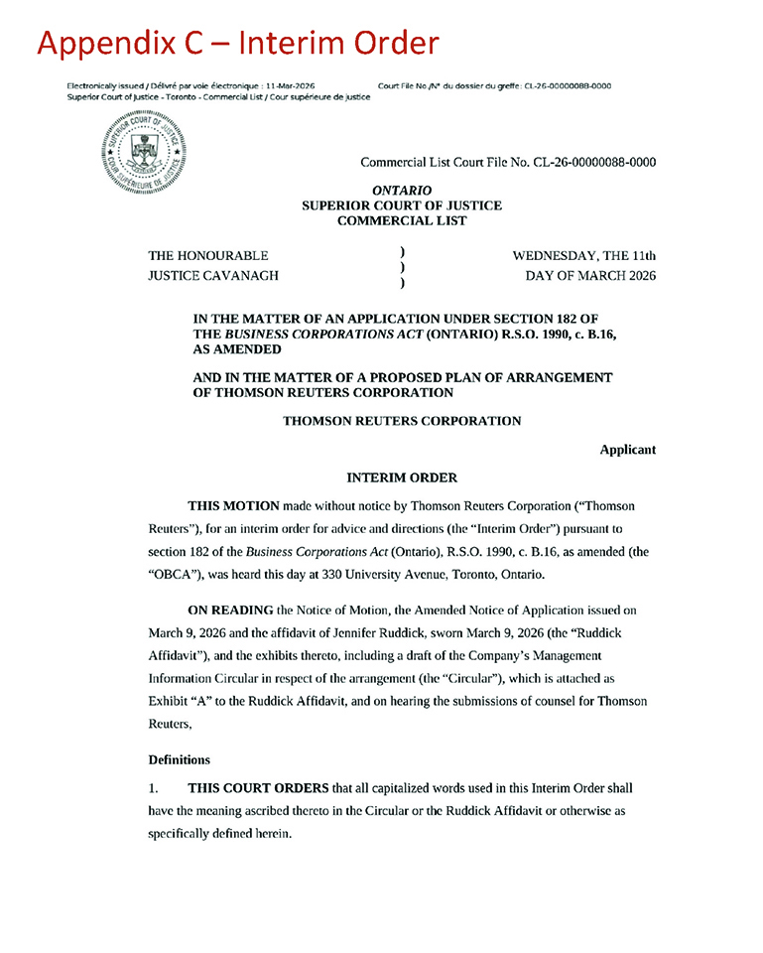
Appendix C – Interim Order Electronically issued/ Delivre par voie electronique: 11-Mar-2026 Court File No./N” du dossier du greffe: CL-26-00000088-0000 Superior Court of Justice - Toronto - Commercial List / Cour superieure de justice [GRAPHIC APPEARS HERE] Commercial List Court File No. CL-26-00000088-0000 ONTARIO SUPERIOR COURT OF JUSTICE COMMERCIAL LIST THE HONOURABLE ) WEDNESDAY, THE 11th JUSTICE CAVANACH ) DAY OF MARCH 2026 ) IN THE MATIER OF AN APPLICATION UNDER SECTION 182 OF THE BUSINESS CORPORATIONS ACT (ONTARIO) RS.O. 1990, c. B.16, AS AMENDED AND IN THE MATTER OF A PROPOSED PLAN OF ARRANGEMENT OF THOMSON REUTERS CORPORATION THOMSON REUTERS CORPORATION Applicant INTERIM ORDER THIS MOTION made without notice by Thomson Reuters Corporation (“Thomson Reuters”), for an interim order for advice and directions (the “Interim Order”) pursuant to section 182 of the Business Corporations Act (Ontario), R.S.O. 1990, c. B.16, as amended (the “OBCA”), was heard this day at 330 University Avenue, Toronto, Ontario. ON READING the Notice of Motion, the Amended Notice of Application issued on March 9, 2026 and the affidavit of Jennifer Ruddick, sworn March 9, 2026 (the “Ruddick Affidavit”), and the exhibits thereto, including a draft of the Company’s Management Information Circular in respect of the arrangement (the “Circular”), which is attached as Exhibit “A” to the Ruddick Affidavit, and on hearing the submissions of counsel for Thomson Reuters, Definitions 1. THIS COURT ORDERS that all capitalized words used in this Interim Order shall have the meaning ascribed thereto in the Circular or the Ruddick Affidavit or otherwise as specifically defined herein.

Management Proxy Circular and Notice of Special Meeting of Shareholders |  | Page C-1

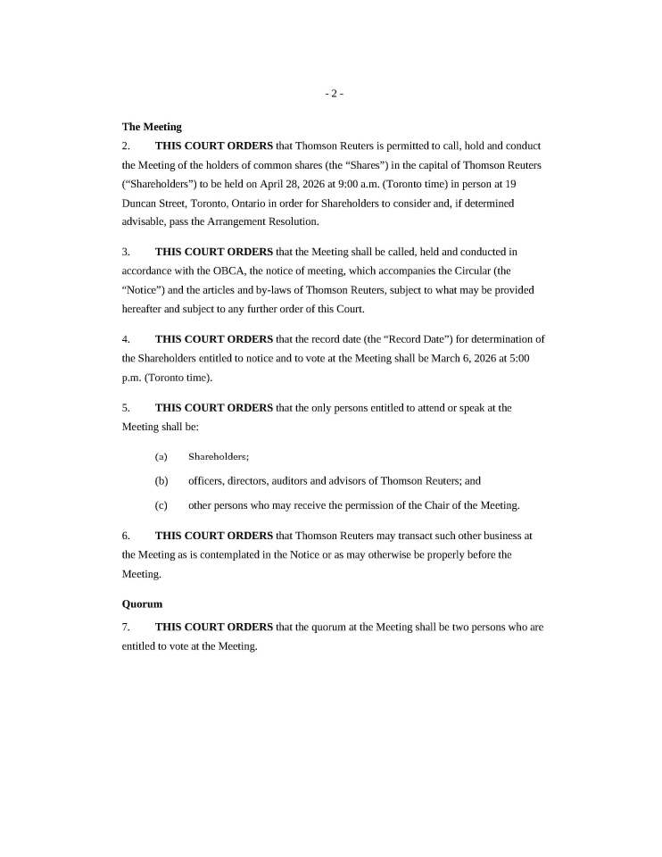
The Meeting 2. THIS COURT ORDERS that Thomson Reuters is permitted to call, hold and conduct the Meeting of the holders of common shares (the “Shares”) in the capital of Thomson Reuters (“Shareholders”) to be held on April 28, 2026 at 9:00 a.m. (Toronto time) in person at 19 Duncan Street, Toronto, Ontario in order for Shareholders to consider and, if determined advisable, pass the Arrangement Resolution. 3. THIS COURT ORDERS that the Meeting shall be called, held and conducted in accordance with the OBCA, the notice of meeting, which accompanies the Circular (the “Notice”) and the articles and by-laws of Thomson Reuters, subject to what may be provided hereafter and subject to any further order of this Court. 4. THIS COURT ORDERS that the record date (the “Record Date”) for determination of the Shareholders entitled to notice and to vote at the Meeting shall be March 6, 2026 at 5:00 p.m. (Toronto time). 5. THIS COURT ORDERS that the only persons entitled to attend or speak at the Meeting shall be: (a) Shareholders; (b) officers, directors, auditors and advisors of Thomson Reuters; and (c) other persons who may receive the permission of the Chair of the Meeting. 6. THIS COURT ORDERS that Thomson Reuters may transact such other business at the Meeting as is contemplated in the Notice or as may otherwise be properly before the Meeting. Quorum 7. THIS COURT ORDERS that the quorum at the Meeting shall be two persons who are entitled to vote at the Meeting.

Management Proxy Circular and Notice of Special Meeting of Shareholders |  | Page C-2

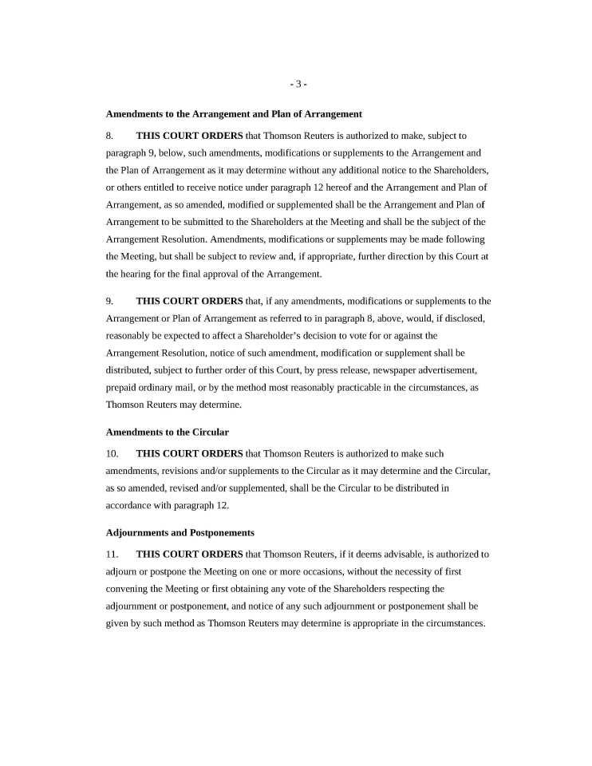
Amendments to the Arrangement and Plan of Arrangement 8. THIS COURT ORDERS that Thomson Reuters is authorized to make, subject to paragraph 9, below, such amendments, modifications or supplements to the Arrangement and the Plan of Arrangement as it may determine without any additional notice to the Shareholders, or others entitled to receive notice under paragraph 12 hereof and the Arrangement and Plan of Arrangement, as so amended, modified or supplemented shall be the Arrangement and Plan of Arrangement to be submitted to the Shareholders at the Meeting and shall be the subject of the Arrangement Resolution. Amendments, modifications or supplements may be made following the Meeting, but shall be subject to review and, if appropriate, further direction by this Court at the hearing for the final approval of the Arrangement. 9. THIS COURT ORDERS that, if any amendments, modifications or supplements to the Arrangement or Plan of Arrangement as referred to in paragraph 8, above, would, if disclosed, reasonably be expected to affect a Shareholder’s decision to vote for or against the Arrangement Resolution, notice of such amendment, modification or supplement shall be distributed, subject to further order of this Court, by press release, newspaper advertisement, prepaid ordinary mail, or by the method most reasonably practicable in the circumstances, as Thomson Reuters may determine. Amendments to the Circular 10. THIS COURT ORDERS that Thomson Reuters is authorized to make such amendments, revisions and/or supplements to the Circular as it may determine and the Circular, as so amended, revised and/or supplemented, shall be the Circular to be distributed in accordance with paragraph 12. Adjournments and Postponements 11. THIS COURT ORDERS that Thomson Reuters, if it deems advisable, is authorized to adjourn or postpone the Meeting on one or more occasions, without the necessity of first convening the Meeting or first obtaining any vote of the Shareholders respecting the adjournment or postponement, and notice of any such adjournment or postponement shall be given by such method as Thomson Reuters may determine is appropriate in the circumstances.

Management Proxy Circular and Notice of Special Meeting of Shareholders |  | Page C-3

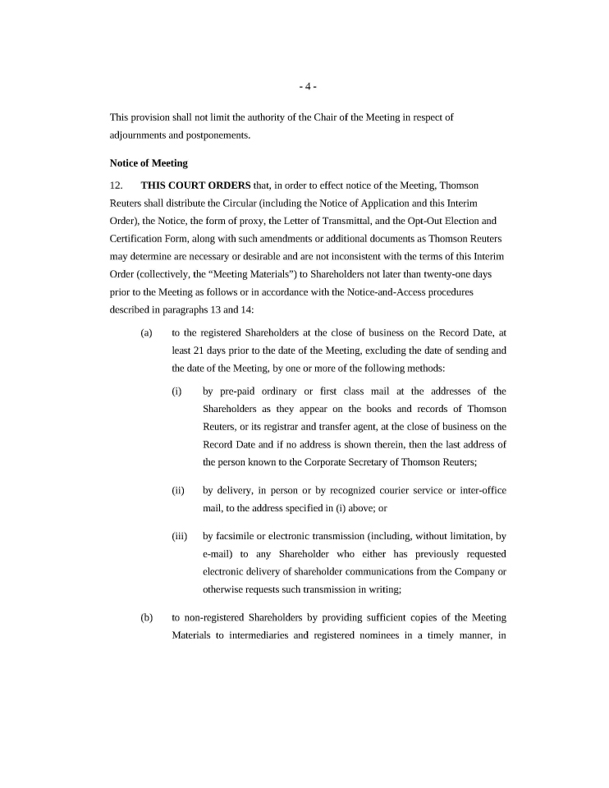
This provision shall not limit the authority of the Chair of the Meeting in respect of adjournments and postponements. Notice of Meeting 12. THIS COURT ORDERS that, in order to effect notice of the Meeting, Thomson Reuters shall distribute the Circular (including the Notice of Application and this Interim Order), the Notice, the form of proxy, the Letter of Transmittal, and the Opt-Out Election and Certification Form, along with such amendments or additional documents as Thomson Reuters may determine are necessary or desirable and are not inconsistent with the terms of this Interim Order (collectively, the “Meeting Materials”) to Shareholders not later than twenty-one days prior to the Meeting as follows or in accordance with the Notice-and-Access procedures described in paragraphs 13 and 14: (a) to the registered Shareholders at the close of business on the Record Date, at least 21 days prior to the date of the Meeting, excluding the date of sending and the date of the Meeting, by one or more of the following methods: (i) by pre-paid ordinary or first class mail at the addresses of the Shareholders as they appear on the books and records of Thomson Reuters, or its registrar and transfer agent, at the close of business on the Record Date and if no address is shown therein, then the last address of the person known to the Corporate Secretary of Thomson Reuters; (ii) by delivery, in person or by recognized courier service or inter-office mail, to the address specified in (i) above; or (iii) by facsimile or electronic transmission (including, without limitation, by e-mail) to any Shareholder who either has previously requested electronic delivery of shareholder communications from the Company or otherwise requests such transmission in writing; (b) to non-registered Shareholders by providing sufficient copies of the Meeting Materials to intermediaries and registered nominees in a timely manner, in

Management Proxy Circular and Notice of Special Meeting of Shareholders |  | Page C-4

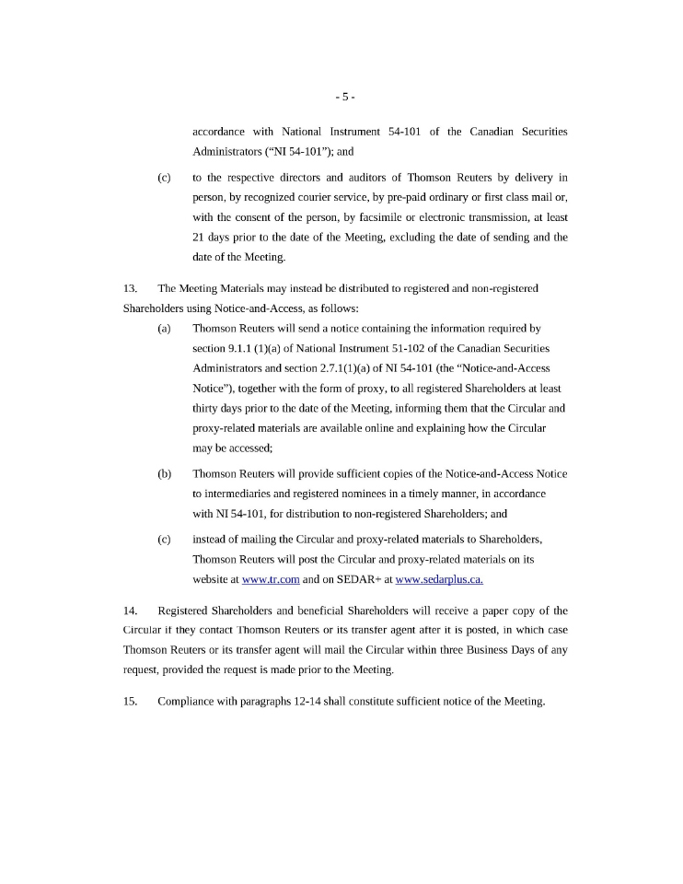
accordance with National Instrument 54-101 of the Canadian Securities Administrators (“NI 54-101”); and (c) to the respective directors and auditors of Thomson Reuters by delivery in person, by recognized courier service, by pre-paid ordinary or first class mail or, with the consent of the person, by facsimile or electronic transmission, at least 21 days prior to the date of the Meeting, excluding the date of sending and the date of the Meeting. 13. The Meeting Materials may instead be distributed to registered and non-registered Shareholders using Notice-and-Access, as follows: (a) Thomson Reuters will send a notice containing the information required by section 9.1.1 (l)(a) of National Instrument 51-102 of the Canadian Securities Administrators and section 2.7.l(l)(a) of NI 54-101 (the “Notice-and-Access Notice”), together with the form of proxy, to all registered Shareholders at least thirty days prior to the date of the Meeting, informing them that the Circular and proxy-related materials are available online and explaining how the Circular may be accessed; (b) Thomson Reuters will provide sufficient copies of the Notice-and-Access Notice to intermediaries and registered nominees in a timely manner, in accordance with NI 54-101, for distribution to non-registered Shareholders; and (c) instead of mailing the Circular and proxy-related materials to Shareholders, Thomson Reuters will post the Circular and proxy-related materials on its website at www.tr.com and on SEDAR+ at www.sedarplus.ca. 14. Registered Shareholders and beneficial Shareholders will receive a paper copy of the Circular if they contact Thomson Reuters or its transfer agent after it is posted, in which case Thomson Reuters or its transfer agent will mail the Circular within three Business Days of any request, provided the request is made prior to the Meeting. 15. Compliance with paragraphs 12-14 shall constitute sufficient notice of the Meeting.

Management Proxy Circular and Notice of Special Meeting of Shareholders |  | Page C-5

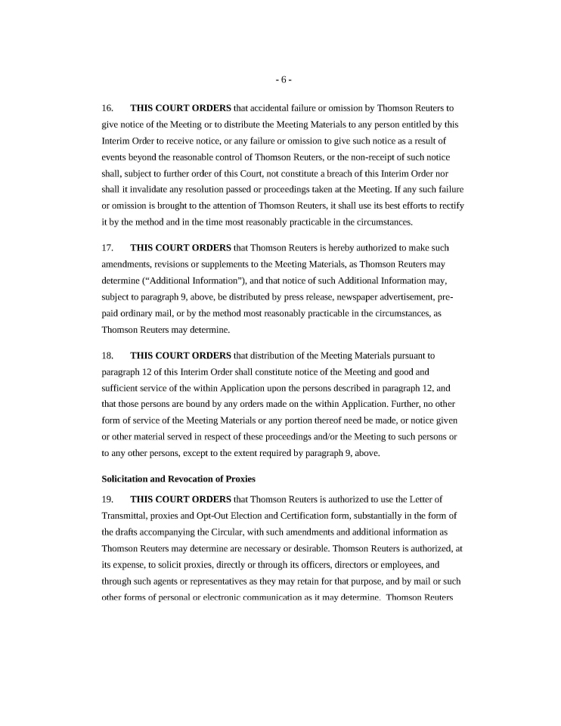
16. THIS COURT ORDERS that accidental failure or omission by Thomson Reuters to give notice of the Meeting or to distribute the Meeting Materials to any person entitled by this Interim Order to receive notice, or any failure or omission to give such notice as a result of events beyond the reasonable control of Thomson Reuters, or the non-receipt of such notice shall, subject to further order of this Court, not constitute a breach of this Interim Order nor shall it invalidate any resolution passed or proceedings taken at the Meeting. If any such failure or omission is brought to the attention of Thomson Reuters, it shall use its best efforts to rectify it by the method and in the time most reasonably practicable in the circumstances. 17. THIS COURT ORDERS that Thomson Reuters is hereby authorized to make such amendments, revisions or supplements to the Meeting Materials, as Thomson Reuters may determine (“Additional Information”), and that notice of such Additional Information may, subject to paragraph 9, above, be distributed by press release, newspaper advertisement, prepaid ordinary mail, or by the method most reasonably practicable in the circumstances, as Thomson Reuters may determine. 18. THIS COURT ORDERS that distribution of the Meeting Materials pursuant to paragraph 12 of this Interim Order shall constitute notice of the Meeting and good and sufficient service of the within Application upon the persons described in paragraph 12, and that those persons are bound by any orders made on the within Application. Further, no other form of service of the Meeting Materials or any portion thereof need be made, or notice given or other material served in respect of these proceedings and/or the Meeting to such persons or to any other persons, except to the extent required by paragraph 9, above. Solicitation and Revocation of Proxies 19. THIS COURT ORDERS that Thomson Reuters is authorized to use the Letter of Transmittal, proxies and Opt-Out Election and Certification form, substantially in the form of the drafts accompanying the Circular, with such amendments and additional information as Thomson Reuters may determine are necessary or desirable. Thomson Reuters is authorized, at its expense, to solicit proxies, directly or through its officers, directors or employees, and through such agents or representatives as they may retain for that purpose, and by mail or such other forms of personal or electronic communication as it may determine. Thomson Reuters

Management Proxy Circular and Notice of Special Meeting of Shareholders |  | Page C-6

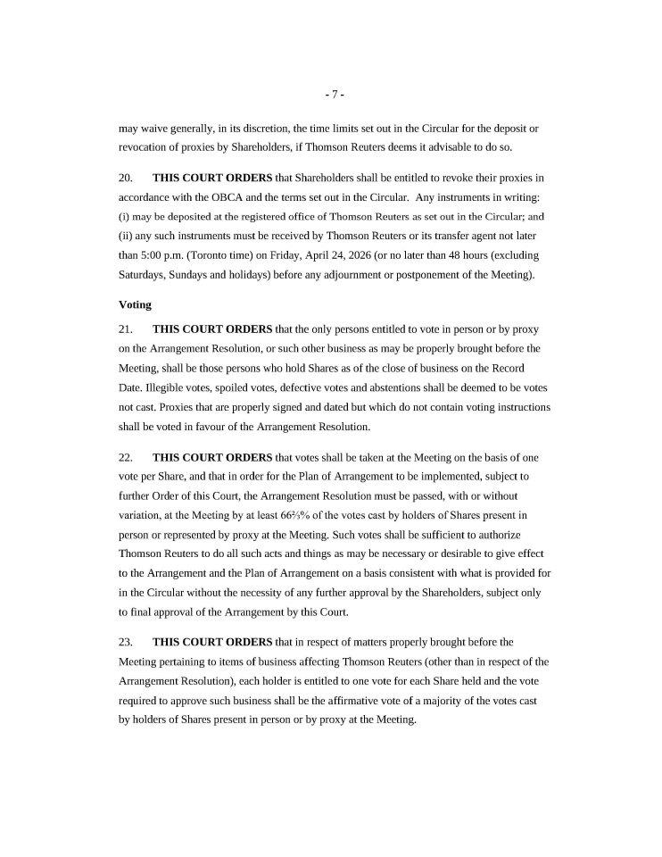
may waive generally, in its discretion, the time limits set out in the Circular for the deposit or revocation of proxies by Shareholders, if Thomson Reuters deems it advisable to do so. 20. THIS COURT ORDERS that Shareholders shall be entitled to revoke their proxies in accordance with the OBCA and the terms set out in the Circular. Any instruments in writing: may be deposited at the registered office of Thomson Reuters as set out in the Circular; and any such instruments must be received by Thomson Reuters or its transfer agent not later than 5:00 p.m. (Toronto time) on Friday, April 24, 2026 (or no later than 48 hours (excluding Saturdays, Sundays and holidays) before any adjournment or postponement of the Meeting). Voting 21. THIS COURT ORDERS that the only persons entitled to vote in person or by proxy on the Arrangement Resolution, or such other business as may be properly brought before the Meeting, shall be those persons who hold Shares as of the close of business on the Record Date. Illegible votes, spoiled votes, defective votes and abstentions shall be deemed to be votes not cast. Proxies that are properly signed and dated but which do not contain voting instructions shall be voted in favour of the Arrangement Resolution. 22. THIS COURT ORDERS that votes shall be taken at the Meeting on the basis of one vote per Share, and that in order for the Plan of Arrangement to be implemented, subject to further Order of this Court, the Arrangement Resolution must be passed, with or without variation, at the Meeting by at least 661/3% of the votes cast by holders of Shares present in person or represented by proxy at the Meeting. Such votes shall be sufficient to authorize Thomson Reuters to do all such acts and things as may be necessary or desirable to give effect to the Arrangement and the Plan of Arrangement on a basis consistent with what is provided for in the Circular without the necessity of any further approval by the Shareholders, subject only to final approval of the Arrangement by this Court. 23. THIS COURT ORDERS that in respect of matters properly brought before the Meeting pertaining to items of business affecting Thomson Reuters ( other than in respect of the Arrangement Resolution), each holder is entitled to one vote for each Share held and the vote required to approve such business shall be the affirmative vote of a majority of the votes cast by holders of Shares present in person or by proxy at the Meeting .

Management Proxy Circular and Notice of Special Meeting of Shareholders |  | Page C-7

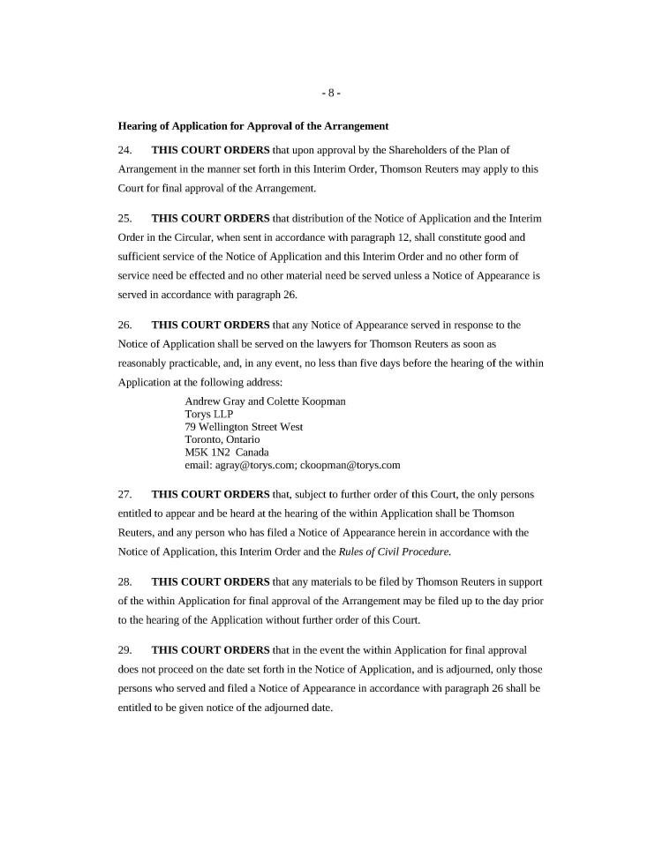
1 Hearing of Application for Approval of the Arrangement 24. THIS COURT ORDERS that upon approval by the Shareholders of the Plan of Arrangement in the manner set forth in this Interim Order, Thomson Reuters may apply to this Court for final approval of the Arrangement. 25. THIS COURT ORDERS that distribution of the Notice of Application and the Interim Order in the Circular, when sent in accordance with paragraph 12, shall constitute good and sufficient service of the Notice of Application and this Interim Order and no other form of service need be effected and no other material need be served unless a Notice of Appearance is served in accordance with paragraph 26. 26. THIS COURT ORDERS that any Notice of Appearance served in response to the Notice of Application shall be served on the lawyers for Thomson Reuters as soon as reasonably practicable, and, in any event, no less than five days before the hearing of the within Application at the following address: Andrew Gray and Colette Koopman Torys LLP 79 Wellington Street West Toronto, Ontario MSK 1N2 Canada email: agray@torys.com; ckoopman@torys.com 27. THIS COURT ORDERS that, subject to further order of this Court, the only persons entitled to appear and be heard at the hearing of the within Application shall be Thomson Reuters, and any person who has filed a Notice of Appearance herein in accordance with the Notice of Application, this Interim Order and the Rules of Civil Procedure. 28. THIS COURT ORDERS that any materials to be filed by Thomson Reuters in support of the within Application for final approval of the Arrangement may be filed up to the day prior to the hearing of the Application without further order of this Court. 29. THIS COURT ORDERS that in the event the within Application for final approval does not proceed on the date set forth in the Notice of Application, and is adjourned, only those persons who served and filed a Notice of Appearance in accordance with paragraph 26 shall be entitled to be given notice of the adjourned date.

Management Proxy Circular and Notice of Special Meeting of Shareholders |  | Page C-8

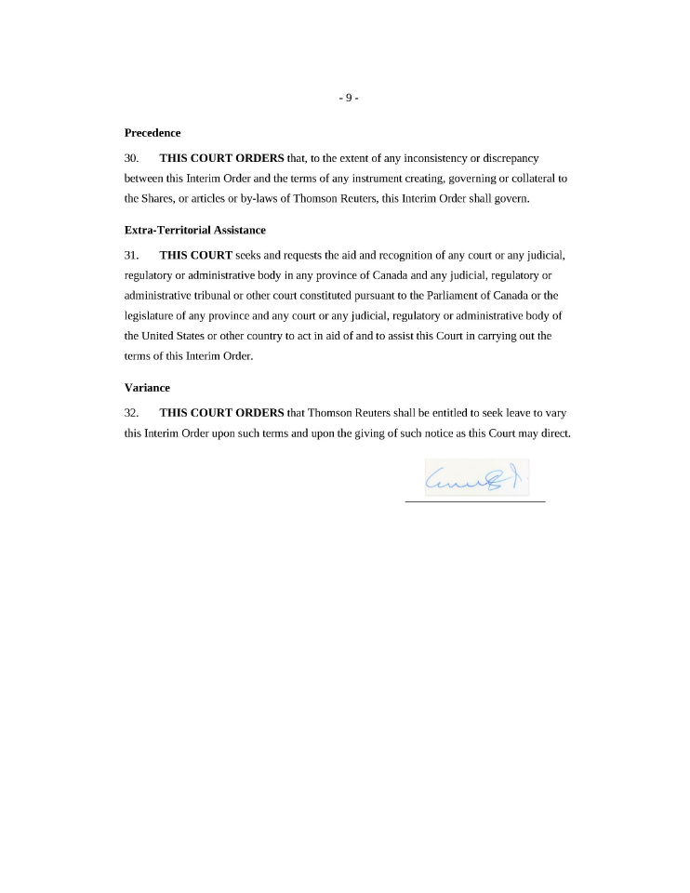
-9- Precedence 30. THIS COURT ORDERS that, to the extent of any inconsistency or discrepancy between this Interim Order and the terms of any instrument creating, governing or collateral to the Shares, or articles or by-laws of Thomson Reuters, this Interim Order shall govern. Extra-Territorial Assistance 31. THIS COURT seeks and requests the aid and recognition of any court or any judicial, regulatory or administrative body in any province of Canada and any judicial, regulatory or administrative tribunal or other court constituted pursuant to the Parliament of Canada or the legislature of any province and any court or any judicial, regulatory or administrative body of the United States or other country to act in aid of and to assist this Court in carrying out the terms of this Interim Order. Variance 32. THIS COURT ORDERS that Thomson Reuters shall be entitled to seek leave to vary this Interim Order upon such terms and upon the giving of such notice as this Court may direct.

Management Proxy Circular and Notice of Special Meeting of Shareholders |  | Page C-9

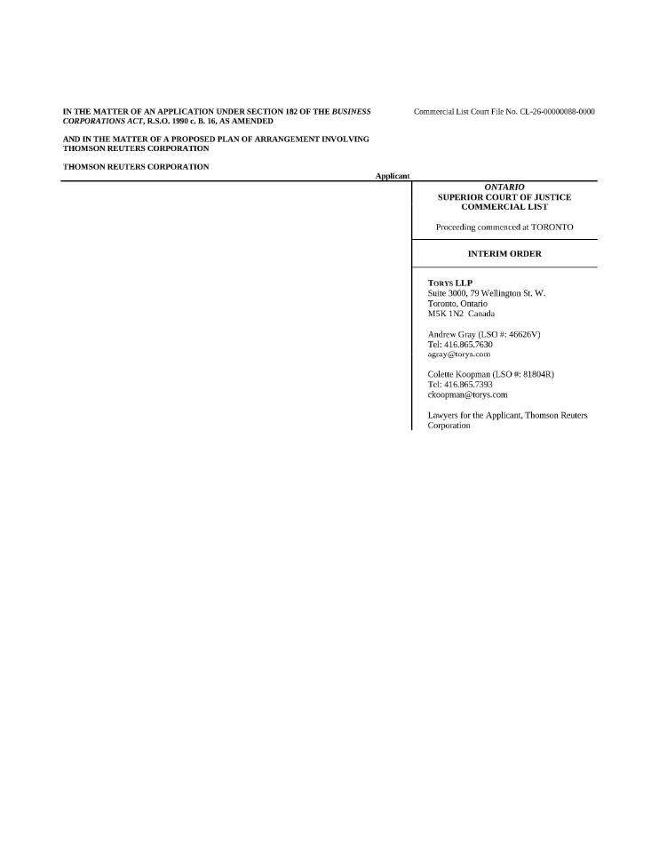
pgss THE MATTER OF AN APPLICATION UNDER SECTION 182 OF THE BUSINESS CORPORATIONS ACT, R.S.O. 1990 c. B. 16, AS AMENDED Commercial List Court File No. CL-26-00000088-0000 AND IN THE MATTER OF A PROPOSED PLAN OF ARRANGEMENT INVOLVING THOMSON REUTERS CORPORATION THOMSON REUTERS CORPORATION Applicant ONTARIO SUPERIOR COURT OF JUSTICE COMMERCIAL LIST Proceeding commenced at TORONTO INTERIM ORDER TORYS LLP Suite 3000, 79 Wellington St. W. Toronto, Ontario M5K 1N2 Canada Andrew Gray (LSO #: 46626V) Tel: 416.865.7630 agray@torys.com Colette Koopman (LSO #: 81804R) Tel: 416.865.7393 ckoopman@torys.com Lawyers for the Applicant, Thomson Reuters Corporation

Management Proxy Circular and Notice of Special Meeting of Shareholders |  | Page C-10

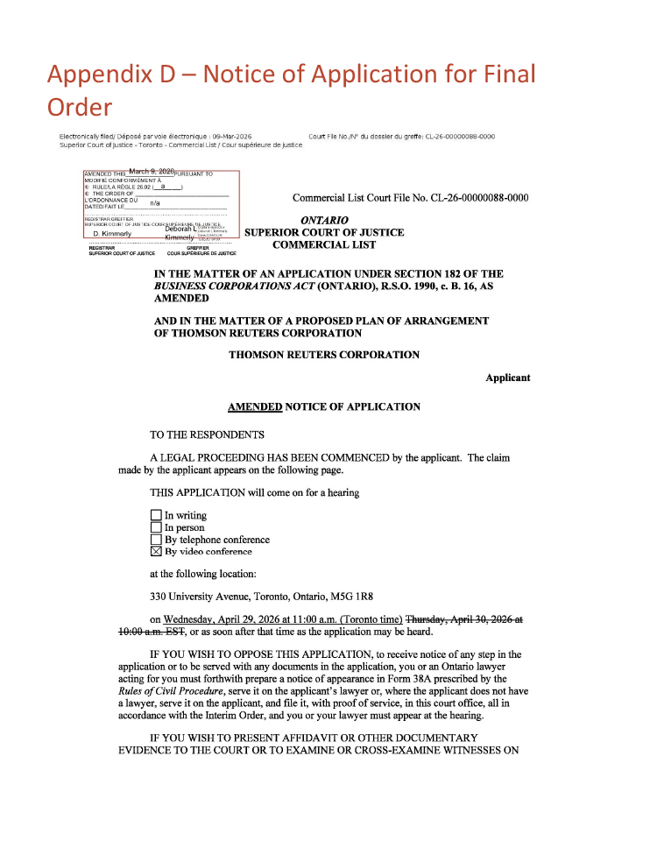
Appendix D – Notice of Application for Final Order Appendix D – Notice of Application for Order Final Electronically filed/ Depose par voie electronique : 09-Mar-2026 court File No./N° du dossier du greffe: CL-26-00000088-0000 Superior Court of Justice—Toronto—Commercial List/ Cour superieure de justice AMENDED THIS March 9, 2026 PURSUANT TO MODIFIE CONFORMEMENT A RULE/LA REGLE 26.02 (_a __) TH E ORDER OF L’ORDONNANCE DU DATED/FAIT LE n/a REGISTRAR GREFFIER SUPERIOR COURT OF JUSTICE COUR SUPERIEURE DE JUSTICE D. Kimmerly Deborah L Kimmerly Digital signed by Deborah L Kimmerly Date: 2026.03.09 15:05:13 -4’00’ REGISTRAR GREFFIER SUPERIOR COURT OF JUSTICE COUR SUPERIEURE DE JUSTICE Commercial List Court File No. CL-26-00000088-0000 ONTARIO SUPERIOR COURT OF JUSTICE COMMERCIAL LIST IN THE MATTER OF AN APPLICATION UNDER SECTION 182 OF THE BUSINESS CORPORATIONS ACT (ONTARIO), R.S.O. 1990, c. B. 16, AS AMENDED AND IN THE MATTER OF A PROPOSED PLAN OF ARRANGEMENT OF THOMSON REUTERS CORPORATION THOMSON REUTERS CORPORATION Applicant AMENDED NOTICE OF APPLICATION TO THE RESPONDENTS A LEGAL PROCEEDING HAS BEEN COMMENCED by the applicant. The claim made by the applicant appears on the following page. THIS APPLICATION will come on for a hearing In writing In person By telephone conference By video conference at the following location: 330 University Avenue, Toronto, Ontario, M5G IRS on Wednesday, April 29, 2026 at 11 :00 a.m. (Toronto time) Thw:sday, April 30, 2026 at lQ:QQ a.m. BgT, or as soon after that time as the application may be heard. IF YOU WISH TO OPPOSE THIS APPLICATION, to receive notice of any step in the application or to be served with any documents in the application, you or an Ontario lawyer acting for you must forthwith prepare a notice of appearance in Form 38A prescribed by the Rules ofCivil Procedure, serve it on the applicant’s lawyer or, where the applicant does not have a lawyer, serve it on the applicant, and file it, with proof of service, in this court office, all in accordance with the Interim Order, and you or your lawyer must appear at the hearing. IF YOU WISH TO PRESENT AFFIDAVIT OR OTHER DOCUMENTARY EVIDENCE TO THE COURT OR TO EXAMINE OR CROSS-EXAMINE WITNESSES ON

Management Proxy Circular and Notice of Special Meeting of Shareholders |  | Page D-1

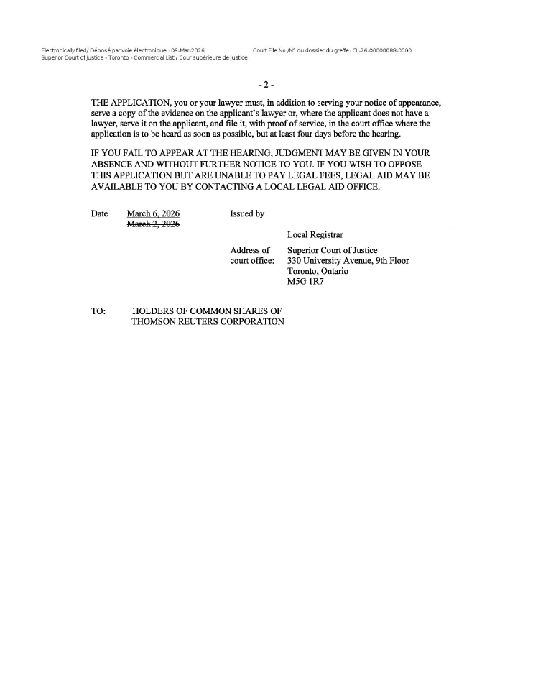
Electronically filed/ Depose par voie electronique: 09-Mar-2026 Court File No,/N’ du dossier du greffe: CL-26-00000088-0000 superior court of Justice—Toronto—commercial List / cour superieure de justice -2- THE APPLICATION, you or your lawyer must, in addition to serving your notice of appearance, serve a copy of the evidence on the applicant’s lawyer or, where the applicant does not have a lawyer, serve it on the applicant, and file it, with proof of service, in the court office where the application is to be heard as soon as possible, but at least four days before the hearing. IF YOU FAIL TO APPEAR AT THE HEARING, JUDGMENT MAY BE GIVEN IN YOUR ABSENCE AND WITHOUT FURTHER NOTICE TO YOU. IF YOU WISH TO OPPOSE THIS APPLICATION BUT ARE UNABLE TO PAY LEGAL FEES, LEGAL AID MAY BE AVAILABLE TO YOU BY CONTACTING A LOCAL LEGAL AID OFFICE. Date March 6, 2026 Issued by March 2, 2026 Local Registrar Address of Superior Court of Justice court office: 330 University Avenue, 9th Floor Toronto, Ontario MSG 1R7 TO: HOLDERS OF COMMON SHARES OF THOMSON REUTERS CORPORATION

Management Proxy Circular and Notice of Special Meeting of Shareholders |  | Page D-2

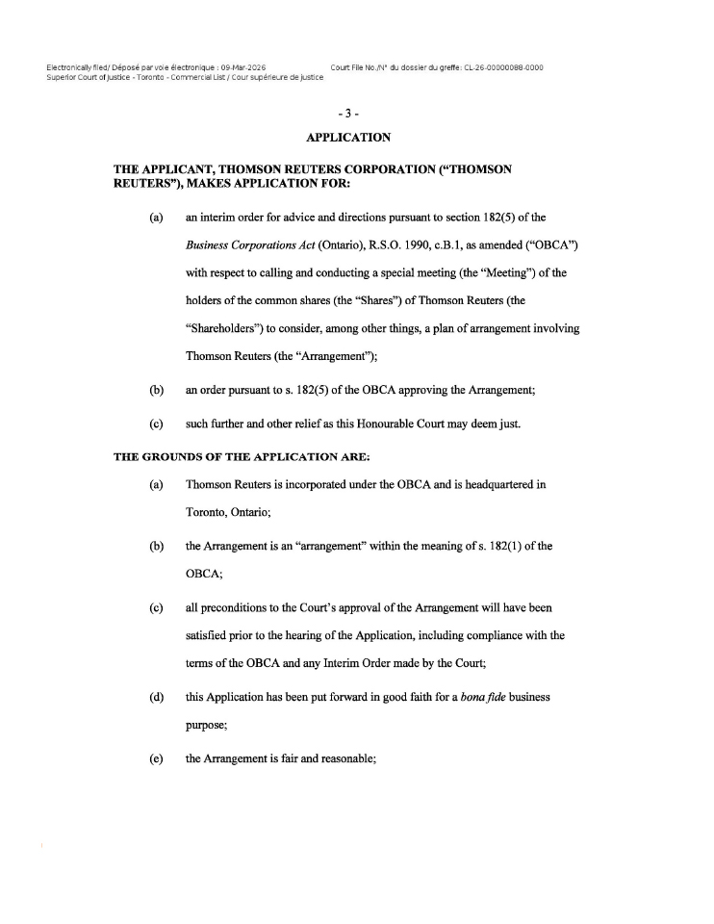
-3- APPLICATION THE APPLICANT, THOMSON REUTERS CORPORATION (“THOMSON REUTERS”), MAKES APPLICATION FOR: (a) an interim order for advice and directions pursuant to section 182(5) of the Business Corporations Act (Ontario), R.S.O. 1990, c.B.1, as amended (“OBCA”) with respect to calling and conducting a special meeting (the “Meeting”) of the holders of the common shares (the “Shares”) of Thomson Reuters (the “Shareholders”) to consider, among other things, a plan of arrangement involving Thomson Reuters (the “Arrangement”); (b) an order pursuant to s. 182(5) of the OBCA approving the Arrangement; (c) such further and other relief as this Honourable Court may deem just. THE GROUNDS OF THE APPLICATION ARE: (a) Thomson Reuters is incorporated under the OBCA and is headquartered in Toronto, Ontario; (b) the Arrangement is an “arrangement” within the meaning of s. 182(1) of the OBCA; (c) all preconditions to the Court’s approval of the Arrangement will have been satisfied prior to the hearing of the Application, including compliance with the terms of the OBCA and any Interim Order made by the Court; ( d) this Application has been put forward in good faith for a bona fide business purpose; (e) the Arrangement is fair and reasonable;

Management Proxy Circular and Notice of Special Meeting of Shareholders |  | Page D-3

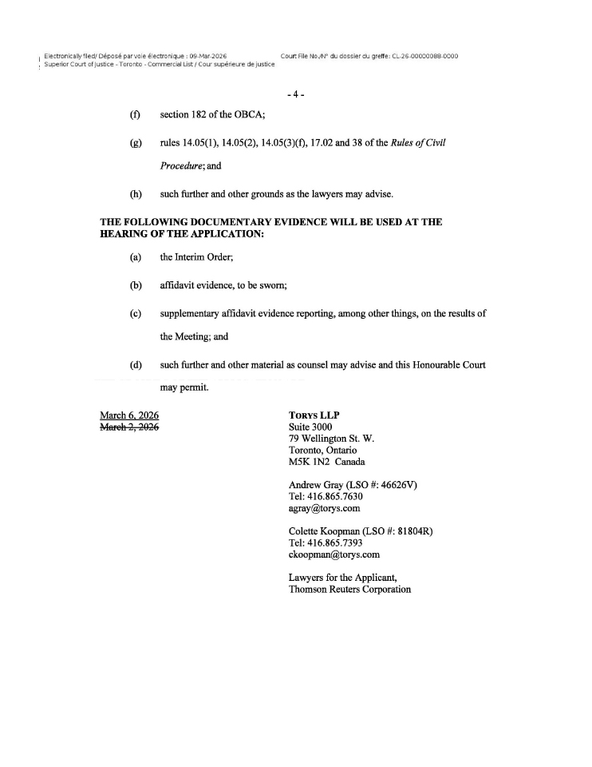
-4- section 182 of the OBCA; rules 14.05(1), 14.05(2), 14.05(3)(f), 17.02 and 38 of the Rules of Civil Procedure; and such further and other grounds as the lawyers may advise. THE FOLLOWING DOCUMENTARY EVIDENCE WILL BE USED AT THE HEARING OF THE APPLICATION: (a) the Interim Order; (b) affidavit evidence, to be sworn; (c) supplementary affidavit evidence reporting, among other things, on the results of the Meeting; and (d) such further and other material as counsel may advise and this Honourable Court may permit. March 6, 2026 T0RYSLLP March 2, 2926 Suite 3000 79 Wellington St. W. Toronto, Ontario M5K 1N2 Canada Andrew Gray (LSO #: 46626V) Tel: 416.865 .7630 agray@torys.com Colette Koopman (LSO #: 81804R) Tel: 416.865.7393 ckoopman@torys.com Lawyers for the Applicant, Thomson Reuters Corporation

Management Proxy Circular and Notice of Special Meeting of Shareholders |  | Page D-4

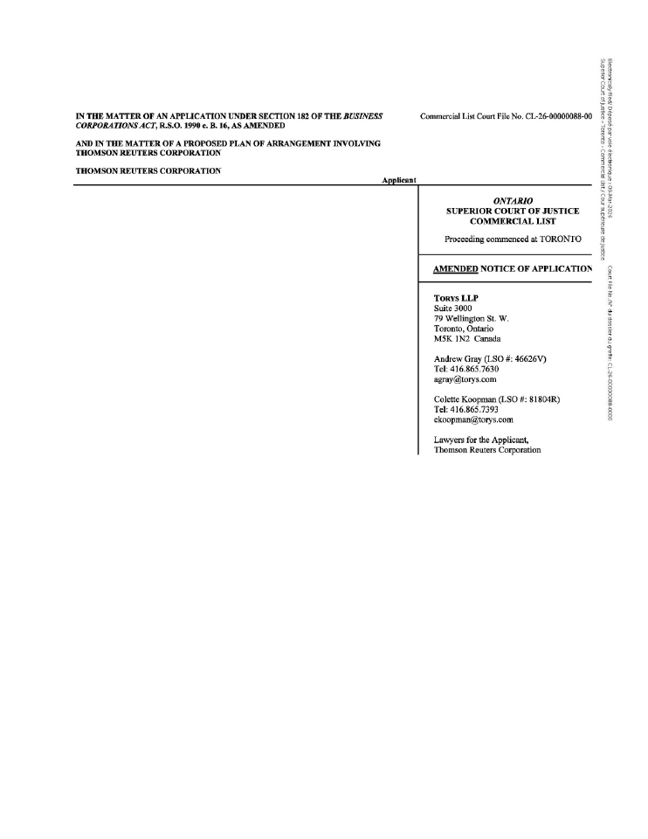
IN THE MATTER OF AN APPLICATION UNDER SECTION 182 OF THE BUSINESS Commercial List Court File No. CL-26-00000088-00 CORPORATIONS ACT, R.S.O. 1990 c. B. 16, AS AMENDED AND IN THE MATTER OF A PROPOSED PLAN OF ARRANGEMENT INVOLVING THOMSON REUTERS CORPORATION THOMSON REUTERS CORPORATION Applicant ONTARIO SUPERIOR COURT OF JUSTICE COMMERCIAL LIST Proceeding commenced at TORONTO AMENDED NOTICE OF APPLICATION TORYSLLP Suite 3000 79 Wellington St. W. Toronto, Ontario M5K 1N2 Canada Andrew Gray (LSO #: 46626V) Tel: 416.865.7630 agray@torys.com Colette Koopman (LSO #: 81804R) Tel: 416.865 .7393 ckooprnan@torys.com Lawyers for the Applicant, Thomson Reuters Corporation

Management Proxy Circular and Notice of Special Meeting of Shareholders |  | Page D-5


THOMSON REUTERS 19 Duncan Street Toronto, Ontario M5H 3H1 Canada tel: +1 647 480 7000 www.thomsonreuters.com
Exhibit 99.3
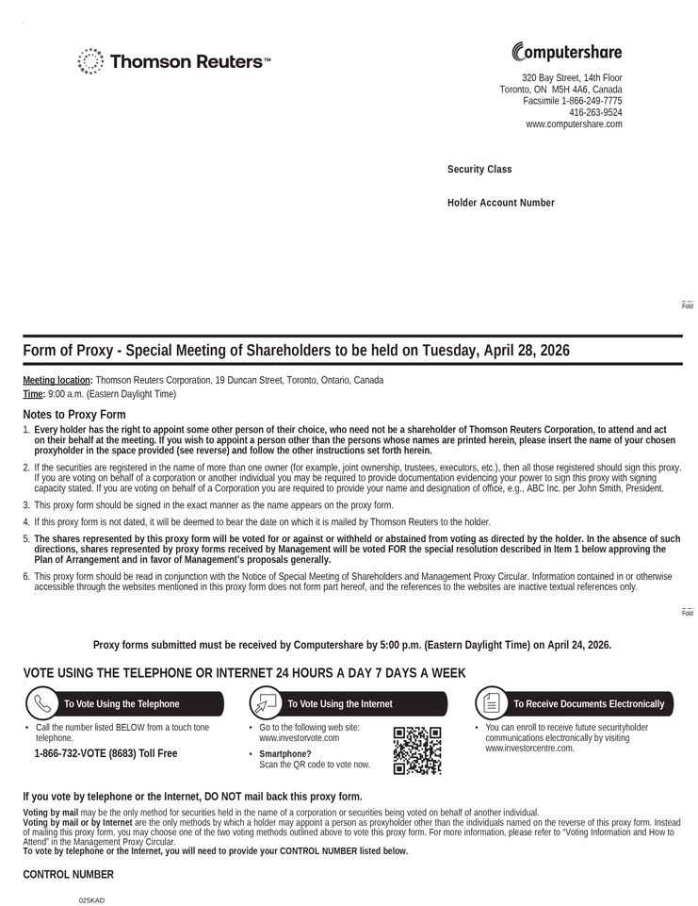
320 Bay Street, 14th Floor Toronto, ON M5H 4A6, Canada Facsimile 1-866-249-7775 416-263-9524 www.computershare.com MR SAM SAMPLE 123 SAMPLES STREET SAMPLETOWN SS X9X 9X9 Security Class 123 Holder Account Number C1234567890 XXX Form of Proxy - Special Meeting of Shareholders to be held on Tuesday, April 28, 2026 Meeting location: Thomson Reuters Corporation, 19 Duncan Street, Toronto, Ontario, Canada Time: 9:00 a.m. (Eastern Daylight Time) Notes to Proxy Form 1. Every holder has the right to appoint some other person of their choice, who need not be a shareholder of Thomson Reuters Corporation, to attend and act on their behalf at the meeting. If you wish to appoint a person other than the persons whose names are printed herein, please insert the name of your chosen proxyholder in the space provided (see reverse) and follow the other instructions set forth herein. 2. If the securities are registered in the name of more than one owner (for example, joint ownership, trustees, executors, etc.), then all those registered should sign this proxy. If you are voting on behalf of a corporation or another individual you may be required to provide documentation evidencing your power to sign this proxy with signing capacity stated. If you are voting on behalf of a Corporation you are required to provide your name and designation of office, e.g., ABC Inc. per John Smith, President. 3. This proxy form should be signed in the exact manner as the name appears on the proxy form. 4. If this proxy form is not dated, it will be deemed to bear the date on which it is mailed by Thomson Reuters to the holder. 5. The shares represented by this proxy form will be voted for or against or withheld or abstained from voting as directed by the holder. In the absence of such directions, shares represented by proxy forms received by Management will be voted FOR the special resolution described in Item I below approving the Plan of Arrangement and in favor of Management’s proposals generally. 6. This proxy form should be read in conjunction with the Notice of Special Meeting of Shareholders and Management Proxy Circular. Information contained in or otherwise accessible through the websites mentioned in this proxy form does not form part hereof, and the references to the websites are inactive textual references only. Fold Proxy forms submitted must be received by Computershare by 5:00 p.m. (Eastern Daylight Time) on April 24, 2026. VOTE USING THE TELEPHONE OR INTERNET 24 HOURS A DAY 7 DAYS A WEEK To Vote Using the Telephone To Vote Using the Internet To Receive Documents Electronically To Vote Using the Internet Call the number listed BELOW from a touch tone telephone. 1-866-732-VOTE (8683) Toll Free Go to the following web site: www.investorvote.com  Smartphone? Scan the QR code to vote now. You can enroll to receive future securityholder communications electronically by visitingwww.investorcentre.com. If you vote by telephone or the Internet, DO NOT mail back this proxy form. Voting by mail may be the only method for securities held in the name of a corporation or securities being voted on behalf of another individual. Voting by mail or by Internet are the only methods by which a holder may appoint a person as proxyholder other than the individuals named on the reverse of this proxy form. Instead of mailing this proxy form, you may choose one of the two voting methods outlined above to vote this proxy form. For more information, please refer to “Voting Information and How to Attend” in the Management Proxy Circular. To vote by telephone or the Internet, you will need to provide your CONTROL NUMBER listed below. CONTROL NUMBER 123456789012345 025KAC CPUQC01.E.INT/000001/i1234 025KAC

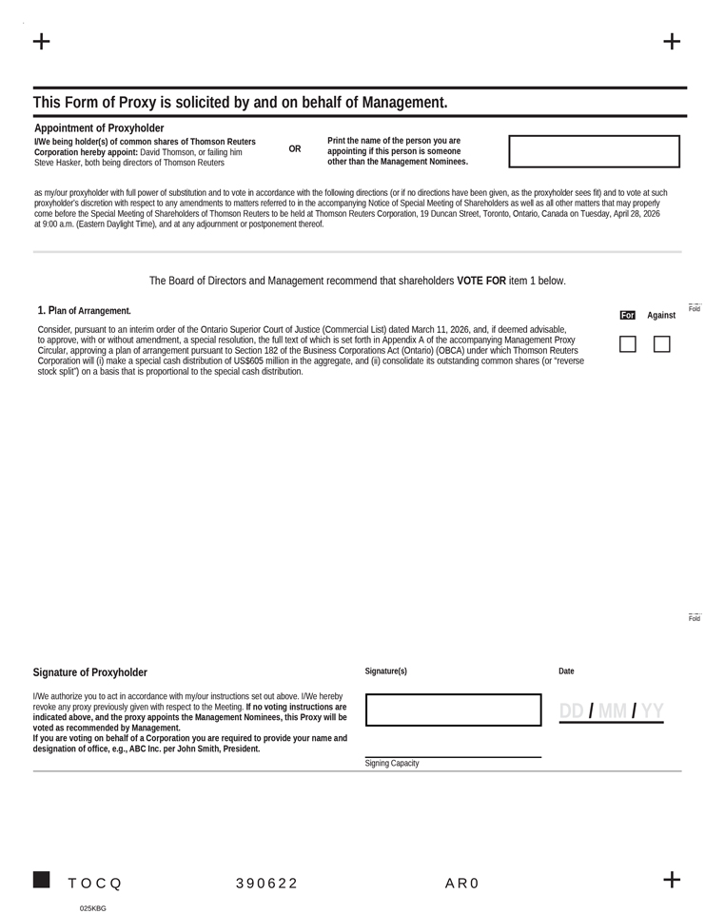
MR SAM SAMPLE C1234567890 XXX 123 This Form of Proxy is solicited by and on behalf of Management. Appointment of Proxyholder I/We being holder(s) of common shares of Thomson Reuters Corporation hereby appoint: David Thomson, or failing him Steve Hasker, both being directors of Thomson Reuters OR Print the name of the person you are appointing if this person is someone other than the Management Nominees. as my/our proxyholder with full power of substitution and to vote in accordance with the following directions (or if no directions have been given, as the proxyholder sees fit) and to vote at such proxyholder’s discretion with respect to any amendments to matters referred to in the accompanying Notice of Special Meeting of Shareholders as well as all other matters that may properly come before the Special Meeting of Shareholders of Thomson Reuters to be held at Thomson Reuters Corporation, 19 Duncan Street, Toronto, Ontario, Canada on Tuesday, April 28, 2026 at 9:00 a.m. (Eastern Daylight Time), and at any adjournment or postponement thereof. The Board of Directors and Management recommend that shareholders VOTE FOR item 1 below. 1. Plan of Arrangement. Consider, pursuant to an interim order of the Ontario Superior Court of Justice (Commercial List) dated March 11, 2026, and, if deemed advisable, to approve, with or without amendment, a special resolution, the full text of which is set forth in Appendix A of the accompanying Management Proxy Circular, approving a plan of arrangement pursuant to Section 182 of the Business Corporations Act (Ontario) (OBCA) under which Thomson Reuters Corporation will (i) make a special cash distribution of US $605 million in the aggregate, and (ii) consolidate its outstanding common shares (or “reverse stock split”) on a basis that is proportional to the special cash distribution. For Against Fold Signature of Proxyholder I/We authorize you to act in accordance with my/our instructions set out above. I/We hereby revoke any proxy previously given with respect to the Meeting. If no voting instructions are indicated above, and the proxy appoints the Management Nominees, this Proxy will be voted as recommended by Management. If you are voting on behalf of a Corporation you are required to provide your name and designation of office, e.g., ABC Inc. per John Smith, President. Signature(s) Date Signing Capacity DD / MM / YY TOCQ 390622 XXXX AR0 9999999999 025KBD
Exhibit 99.4
NOTICE OF AVAILABILITY OF PROXY MATERIALS FOR THE
2026 THOMSON REUTERS CORPORATION
SPECIAL MEETING OF SHAREHOLDERS
To our Shareholders,
We are using the “notice-and-access” system for delivery of proxy materials related to our special meeting of shareholders scheduled to be held on April 28, 2026, similar to last year’s annual general meeting. Under notice- and-access, you still receive a proxy or voting instruction form enabling you to vote at our meeting. However, instead of a paper copy of the management proxy circular and other proxy materials, you have received this notice which contains information about how to access these materials electronically on our website, www.thomsonreuters.com. Electronic delivery reduces the cost and environmental impact of producing and distributing paper copies of documents in very large quantities. It also provides shareholders with faster access to information about Thomson Reuters. Shareholders who have already signed up for electronic delivery of proxy materials will continue to receive them by e-mail.
MEETING DATE AND LOCATION

WHEN: |  | Tuesday, April 28, 2026  9:00 a.m. (Eastern Daylight Time) |  | WHERE: |  | Thomson Reuters Corporation  19 Duncan Street  Toronto, Ontario, Canada  M5H 3H1
WHO CAN VOTE
Holders of our common shares as of 5:00 p.m. (Eastern Daylight Time) on March 6, 2026.
BUSINESS OF THE MEETING
This year’s meeting will cover the following items of business:

 |  | Item of Business |  | Highlights |  | Board Vote Recommendation
1 |  | Shareholder resolution |  | Consider, pursuant to an interim order of the Ontario Superior Court of Justice (Commercial List) dated March 11, 2026, and, if deemed advisable, to approve, with or without amendment, a special resolution, the full text of which is attached in Appendix A of the management proxy circular, approving a plan of arrangement pursuant to Section 182 of the Business Corporations Act (Ontario) (OBCA) under which Thomson Reuters Corporation will (i) make a special cash distribution of US$605 million in the aggregate, and (ii) consolidate its outstanding common shares (or “reverse stock split”) on a basis that is proportional to the special cash distribution.  Additional information may be found in the management proxy circular dated March 13, 2026. |  | FOR
2 |  | Other business |  | If any other items of business are properly brought before the meeting (or any adjourned or postponed meeting), shareholders will be asked to vote. We are not aware of any other items of business at this time. |  | N/A
SHAREHOLDERS ARE REMINDED TO VIEW OUR PROXY MATERIALS PRIOR TO VOTING.
WEBSITES WHERE PROXY MATERIALS ARE POSTED
You can find the management proxy circular and other proxy materials at the following websites:

www.thomsonreuters.com/2026specialmeeting/ |  | www.sedarplus.ca |  | www.sec.gov

REGISTERED AND NON-REGISTERED/BENEFICIAL HOLDERS
If you’d like to obtain paper copies of the proxy materials, you should first determine whether you are a registered or non-registered/beneficial holder of our common shares. Most of our shareholders are non-registered/beneficial holders.

 |  |  | You are a registered shareholder if your name appears directly on your share certificates, or if you hold your common shares in book-entry form through the direct registration system (DRS) on the records of our transfer agent, Computershare Trust Company of Canada.

 |  |  | You are a non-registered shareholder if you own shares indirectly and the shares are registered in the name of an intermediary. For example, you are a non-registered shareholder if:

 | ○ |  | your common shares are held in the name of a bank, trust company, securities broker, trustee or custodian; or

 | ○ |  | you hold Depositary Interests representing our common shares which are held in the name of Computershare Company Nominees Limited as nominee and custodian.
HOW TO OBTAIN PAPER COPIES OF THE PROXY MATERIALS
Non-registered/beneficial shareholders may request that paper copies of the proxy materials be sent to them by mail at no cost. Requests may be made up to one year from the date that our management proxy circular was filed on SEDAR+ by going to www.proxyvote.com and entering the Control Number located on your voting instruction form and following the instructions provided. Alternatively, at any time prior to the meeting, you may submit a request by phone by calling 1.877.907.7643 and then entering your Control Number. Requests should be received at least five business days in advance of the date and time set out in your voting instruction form as a voting deadline if you’d like to receive the proxy materials in advance of the proxy voting deadline and the meeting date.
Registered shareholders may request that paper copies of the proxy materials be sent to them by mail at no cost. At any time prior to the meeting, you may submit a request by phone by calling 1.866.962.0498 or 1.514.982.8716 (Depositary Interest holders can call +44 (0) 370.707.1804) and entering the Control Number reflected on your proxy form. Requests should be received at least five business days in advance of the date and time set out in your proxy form as a voting deadline if you’d like to receive the proxy materials in advance of the proxy voting deadline and the meeting date. Following the meeting, requests may also be made up to one year from the date that our management proxy circular was filed on SEDAR+ by contacting our Investor Relations department by e-mail at investor.relations@thomsonreuters.com or by phone at 1.332.219.1046.
VOTING
Non-registered/beneficial shareholders should vote using the methods reflected on your voting instruction form. Your proxy or vote must be received by the proxy deadline noted on your voting instruction form.
Registered shareholders should vote using the methods reflected on your proxy form. Our transfer agent, Computershare Trust Company of Canada, must receive your proxy or voting instructions by 5:00 p.m. (Eastern Daylight Time) on April 24, 2026.
For more information on how to attend, participate or vote at the meeting, how to deposit a proxy and how to appoint and register a proxyholder, please refer to the “Voting Information” section of the management proxy circular.
Shareholders with questions about notice-and-access may call Computershare Trust Company of Canada at 1.866.964.0492 (toll free in Canada and the United States) or 1.514.982.8714.
Exhibit 99.5
The Instructions accompanying this Letter of Transmittal should be read carefully before it is completed. Please contact Computershare Investor Services Inc. (the Depositary) or your investment dealer, stock broker, bank, trust company or other financial advisor if you have any questions or require assistance in completing this Letter of Transmittal.


LETTER OF TRANSMITTAL
to accompany certificates for
common shares of
THOMSON REUTERS CORPORATION
to be exchanged pursuant to the Return of Capital and Share Consolidation Transactions
Offices of the Depositary, Computershare Investor Services Inc.,
for the Return of Capital and Share Consolidation Transactions:

By Mail |  | By Hand, Courier or Registered Mail
Computershare Investor Services Inc.  P.O. Box 7021  31 Adelaide Street East  Toronto, Ontario  M5C 3H2  Canada  Attention: Corporate Actions |  | Computershare Investor Services Inc.  320 Bay Street, 14th Floor  Toronto, Ontario  M5H 4A6  Canada  Attention: Corporate Actions
E-mail Address: corporateactions@computershare.com

Toll Free in Canada and the U.S.: 1-800-564-6253

Outside North America: 1-514-982-7555
Who should complete this Letter of Transmittal?
This Letter of Transmittal is to be used only if certificates for common shares (referred to as “shares”) of Thomson Reuters Corporation (“Thomson Reuters” or the “Company”) are to be forwarded with it, in order to receive the post-consolidation share certificates under the Plan of Arrangement, as further described below. This Letter of Transmittal should be completed by holders of share certificates whether you participate in the Return of Capital (as defined below) or exercise your right to opt out of it (if eligible to do so), as further described in this Letter of Transmittal.
If you hold shares (uncertificated) through a direct registration system (“DRS”) statement, you are not required to submit a Letter of Transmittal. The transfer agent, Computershare Trust Company of Canada, will update your DRS position to reflect the number of post-consolidation shares that you hold upon completion of the Transaction.
If you are a non-registered shareholder who is beneficially holding shares through an intermediary, which include, among others, banks, trust companies, securities dealers or brokers and trustees or administrators of self-administered RRSPs, RRIFs, RESPs and similar plans, or if you participate in Thomson Reuters’ employee stock purchase plan or hold Depositary Interests, you should not use this form. The effects of the Transaction will be recorded in your account with your intermediary. You should contact your intermediary if you have any questions regarding this process.

- 2 -

Where can I find additional information?
A plan of arrangement (the “Plan of Arrangement”) implementing the Return of Capital and Share Consolidation (as defined below) (together, the “Transaction”) is being submitted for approval at the special meeting of shareholders of the Company to be held on April 28, 2026 (the “Meeting”) as described in a management proxy circular dated March 13, 2026 (the “Circular”). Shareholders are encouraged to review in their entirety the Circular prepared in connection with the Meeting, which is available under the Company’s profile on SEDAR+ at www.sedarplus.com and on EDGAR at www.sec.gov. The terms and conditions of the Transaction are incorporated by reference in this Letter of Transmittal. Capitalized terms used but not defined in this Letter of Transmittal have the meanings ascribed to them in the Plan of Arrangement and Circular that accompanies this Letter of Transmittal. In the case of any inconsistency between the terms of this Letter of Transmittal and the Plan of Arrangement and Circular, the terms of the Plan of Arrangement and Circular shall prevail.
What happens under the Transaction?
The Transaction consists of a special cash distribution of US$605 million in the aggregate, or approximately US$1.36 per participating share (estimated based on the number of common shares issued and outstanding as of March 6, 2026 and assuming no shareholders opt-out of the return of capital) (the “Return of Capital”), followed by a consolidation of our outstanding common shares (or “reverse stock split”) on a basis that is proportional to the special cash distribution (the “Share Consolidation”). The share consolidation ratio will be fixed based on the volume weighed average trading price of the shares on the Nasdaq for the five trading days immediately prior to the Effective Time. The formula to calculate the share consolidation ratio is set forth in the “Information Regarding the Transaction – Terms of the Arrangement – Share Consolidation Ratio” section of the Circular. As described below, shareholders who opt-out of the Return of Capital will still participate in the Transaction through a share exchange and the Share Consolidation but upon completion of the Transaction will continue to hold the same number of shares that they currently hold.
Who can opt out of the Return of Capital?
A shareholder who is (a) not a resident of Canada for Canadian income tax purposes and is subject to income tax in a jurisdiction other than Canada (and is not exempt from income tax in that jurisdiction) or (b) an individual who is a resident of Canada for Canadian income tax purposes and who is also subject to income tax in a jurisdiction other than Canada as a resident of that other jurisdiction (and is not exempt from income tax in that other jurisdiction) (an “Eligible Opt-Out Shareholder”) may elect to opt out of the Return of Capital (the “opt-out right”).
What happens if I exercise my right to opt out of the Return of Capital?
Eligible Opt-Out Shareholders that duly exercise the opt-out right (referred to as “opting-out shareholders”) will not receive the special cash distribution. Opting-out shareholders will still participate in the Transaction through a share exchange and the Share Consolidation, but upon completion of the Transaction will continue to hold the same number of shares that they currently hold. Opting-out shareholders will realize a proportionate increase in their equity and voting interests in the Company by virtue of the Share Consolidation.
Registered Eligible Opt-Out Shareholders wishing to opt out of the Return of Capital are required to deliver to the Depositary:

 | ● |  | a duly executed Opt-Out Election and Certification Form enclosed separately (on blue paper); and

 | ● |  | if the shares are held in certificated form, a duly executed version of this Letter of Transmittal, together with the accompanying certificate(s) for their shares.

- 3 -

The deadline for delivery of these documents to the Depositary is April 27, 2026 at 5:00 p.m. (Toronto time) in order to exercise the opt-out right and to receive new DRS statement(s) (or share certificate(s)) reflecting the new CUSIP number for the shares after the Transaction is completed. The Opt-Out Election and Certification Form may be submitted to the Depositary by mail, hand delivery, courier, registered mail or e-mail (at the addresses set forth on the cover of the Opt-Out Election and Certification Form) but this Letter of Transmittal and accompanying share certificate(s) must be submitted to the Depositary by mail, hand delivery, courier or registered mail to the addresses set forth on the cover of this Letter of Transmittal. Shareholders wishing to exercise their opt-out right are strongly urged to carefully consider the income tax consequences of exercising the opt-out right and to consult with their own tax advisors with respect to their particular circumstances and tax considerations applicable to them.
None of Thomson Reuters, its board of directors, the Information Agent or the Depositary makes any recommendation to any Eligible Opt-Out Shareholder as to whether to opt out of the Return of Capital. Shareholders are urged to evaluate carefully all information in the Circular, the accompanying Opt-Out Election and Certification Form and other material related to the Transaction, consult their own financial, legal, investment and tax advisors and make their own decisions as to whether to exercise the opt-out right. See the “Information Regarding the Transaction – Terms of the Arrangement – Opt-Out Right” and “Income Tax Considerations” sections of the Circular.
Will any fractional shares be issued?
No fractional shares will be distributed under the Plan of Arrangement (except for such shares held in Thomson Reuters’ dividend reinvestment plan or Thomson Reuters’ employee stock purchase plans). Where the Share Consolidation would result in a fraction of a share being held by a shareholder, the fractional share that would otherwise be held by that shareholder will be delivered to the Depositary on behalf of that shareholder. All shares so delivered to the Depositary will be aggregated and sold in the market by a broker appointed by the Depositary as soon as practicable after the Effective Date, on such dates and at such prices as the broker determines in its sole discretion, and the Depositary will distribute the net cash proceeds, after commission expenses, to registered shareholders pro rata based on their fractional entitlements.
How will my share certificates be updated?
Registered shareholders holding certificated shares, including shareholders that have opted out of the Return of Capital, must complete and submit this Letter of Transmittal and surrender their share certificates to receive a DRS or new share certificates reflecting the Share Consolidation. Unless indicated in Box A – “Request for New Share Certificates”, you will receive a new DRS statement instead of a new physical share certificate reflecting the Share Consolidation. DRS is a system that allows registered shareholders to hold their shares in “book-entry” form without having physical share certificates issued as evidence of ownership. Instead, shares will be held in the name of registered shareholders and registered electronically in our company’s share register, which will be maintained by our transfer agent. See the “Information Regarding the Transaction – Terms of the Arrangement – Exchange Procedure – DRS Statements” section of the Circular for more information.
Following the Transaction, shareholders will receive (a) new DRS statements (or share certificates), reflecting the new CUSIP number for the shares, representing the post-consolidated number of shares held and (b) the net cash proceeds for any fractional shares. Opting-out shareholders will continue to hold the same number of shares they currently hold but will also receive new DRS statements (or share certificates), reflecting the new CUSIP number for the shares. Until surrendered, each share certificate existing prior to the completion of the Plan of Arrangement will be deemed for all purposes to represent the number of whole shares and any net cash proceeds for fractional shares to which such registered shareholder is entitled to hold as a result of the implementation of the Transaction.
This Letter of Transmittal, properly completed and duly executed, together with all other required documents, must accompany certificate(s) for shares delivered in connection with the Transaction.

- 4 -

Delivery of this instrument to an address other than shown above does not constitute a valid delivery.

- 5 -

TO: THOMSON REUTERS CORPORATION
AND TO: COMPUTERSHARE INVESTOR SERVICES INC.
The undersigned delivers to the Company the enclosed certificate(s) for shares and agrees to surrender such certificate(s) in exchange for new DRS statement(s) (or, if requested in Box A, share certificate(s)) reflecting the number of shares the undersigned will hold upon completion of the Transaction and upon the terms and subject to the conditions contained in the Plan of Arrangement and the Circular.

The Instructions set forth in this Letter of Transmittal, the Circular and other materials related to the Transaction should be read carefully before this Letter of Transmittal is completed.
TO: COMPUTERSHARE INVESTOR SERVICES INC.
The undersigned delivers to you the following share certificate(s) and irrevocably surrenders such share certificate(s) upon the terms and conditions contained in this Letter of Transmittal, the Plan of Arrangement and the Circular. The following are the details of the enclosed certificate(s):
Please list all details of the share certificates that you hold. See Instructions 2 and 3.

Certificate Number(s) |  | Name in Which Registered |  | Number of Shares Delivered
The above-listed share certificate(s) is/are hereby submitted in order that the new CUSIP number assigned to the shares of the Company and the amount of shares the registered shareholder will hold upon completion of the Transaction may be applied to such share certificate(s) and returned to the undersigned following completion of the Plan of Arrangement.
The undersigned hereby represents and warrants that the undersigned is the owner of the number shares described above and the undersigned has good title to the shares represented by the said certificate(s), free and clear of all liens, charges and encumbrances, and has full power and authority to herewith deposit such shares. The undersigned hereby represents and warrants that all information provided by the undersigned herein is complete, true and accurate. The undersigned covenants and agrees to execute and deliver all such documents, transfers and other assurances as may be necessary or desirable to exchange the transmitted share certificates pursuant to the Plan of Arrangement. These representations, warranties, covenants, acknowledgements and agreements shall survive the completion of the Transaction.
The undersigned instructs the Company and the Depositary, upon the Effective Date of the Plan of Arrangement, to, as soon as practicable after receipt of a properly completed and signed Letter of Transmittal, the applicable share certificate(s) and all other required documentation, if any, issue or cause to be issued new DRS statement(s) (or share certificate(s)), reflecting the new CUSIP number, representing the number of shares the undersigned will hold upon completion of the Transaction and mail such DRS statement(s) (or share certificate(s)) by first-class insured mail, postage prepaid, in accordance with the instructions set out below. If a transmitted share certificate has any restrictive legends on the back thereof, the new DRS statement (or share certificate) will be issued with the same restrictive legends, if any. Should the Plan of Arrangement not proceed for any reason, the deposited certificate(s) and other relevant documents shall be returned to the address indicated below or, if no instructions are given, in the name and to the address if any, of the undersigned as appears on the share register maintained by the transfer agent.

- 6 -

The undersigned irrevocably constitutes and appoints each of Chad MacLean and Jennifer Ruddick, each of whom is an officer of the Company, and any other person designated by the Company in writing, the true and lawful agent, attorney and attorney-in-fact of the undersigned with respect to the transmitted share certificates exchanged pursuant to the Transaction with full power of substitution (such power of attorney, being coupled with an interest, being irrevocable) to, in the name of and on behalf of the undersigned, (a) register or record the exchange of such transmitted share certificate(s) for new DRS statement(s) or share certificate(s); and (b) execute and negotiate any cheques or other instruments representing any distribution payable to or to the order of the undersigned.
If share certificate(s) have been lost, stolen or destroyed, this Letter of Transmittal should be completed as fully as possible and forwarded together with a letter describing the loss to the Depositary. The Depositary will respond with the replacement requirements. Alternatively, shareholders whose certificate(s) have been lost, stolen or destroyed may participate in Computershare’s blanket bond program with Aviva Insurance Company of Canada by completing Box E, and submitting the applicable certified cheque or money order made payable to Computershare.
Please see further information regarding share certificates that have been lost, stolen or destroyed in the “Information Regarding the Transaction – Terms of the Arrangement – Lost, Stolen or Destroyed Certificates” section of the Circular.
All authority conferred or agreed to be conferred by the undersigned in this Letter of Transmittal may be exercised upon death or during any subsequent legal incapacity of the undersigned and all obligations of the undersigned in this Letter of Transmittal shall be binding upon the heirs, personal representatives, successors and assigns of the undersigned.
The undersigned recognizes that under certain circumstances set forth in the Plan of Arrangement and the Circular, the Company may terminate or amend the Plan of Arrangement.
By reason of the use by the undersigned of an English language form of Letter of Transmittal, the undersigned shall be deemed to have required that any contract evidenced by the Plan of Arrangement as accepted through this Letter of Transmittal, as well as all documents related thereto, be drawn exclusively in the English language. En raison de l’usage d’une lettre d’envoi en langue anglaise par le soussigné, le soussigné est réputé avoir requis que tout contrat attesté par le plan d’arrangement et son acceptation par cette lettre d’envoi, de même que tous les documents qui s’y rapportent, soient rédigés exclusivement en langue anglaise.

- 7 -

BOX A
REQUEST FOR NEW SHARE CERTIFICATE(S) INSTEAD OF A DRS STATEMENT

A shareholder will receive a new DRS statement instead of a new physical share certificate reflecting the share consolidation. DRS is a system that allows registered shareholders to hold their shares in “book-entry” form without having physical share certificates issued as evidence of ownership. See the “Information Regarding the Transaction – Terms of the Arrangement – Exchange Procedure – DRS Statements” in the Circular for more information. If you would like to receive a new physical share certificate evidencing your ownership of the shares instead of a DRS statement, place an “X” in the box below.

☐ The undersigned wishes to receive a new share certificate reflecting the new CUSIP for the shares that it will own after the Share Consolidation.

BOX B |  |  |  | BOX C
SHARE ENTITLEMENT DELIVERY  New DRS statement(s) (or share certificate(s)) representing shares and any net cash proceeds for fractional shares will be issued and mailed to your existing registration unless otherwise stated. If you would like these shares issued to a different name or address, please complete Box C and refer to Instructions 3, 4 & 5 |  |  |  | ISSUE SHARES AND CHEQUES  IN THE NAME OF*:  ☐ CHECK BOX IF SAME AS EXISTING REGISTRATION (DEFAULT)
☐ MAIL DRS STATEMENT(S) (OR SHARE CERTIFICATE(S)) REPRESENTING SHARES AND ANY CHEQUES TO ADDRESS ON RECORD (DEFAULT)  ☐ MAIL DRS STATEMENT(S) (OR SHARE CERTIFICATE(S)) REPRESENTING SHARES AND ANY CHEQUES TO A DIFFERENT ADDRESS (MUST COMPLETE BOX C) |  |  |  | (NAME)
 |  |  |  | (STREET NUMBER & NAME)
 |  |  |  | (CITY AND PROVINCE/STATE)
 |  |  |  | (COUNTRY AND POSTAL/ZIP CODE)
 |  |  |  | (TELEPHONE NUMBER (BUSINESS HOURS))
 |  |  |  | (SOCIAL INSURANCE/TIN)
* IF THIS NAME OR ADDRESS IS DIFFERENT FROM YOUR REGISTRATION, PLEASE PROVIDE
SUPPORTING TRASFER REQUIREMENTS (SEE INSTRUCTION SECTION 3, 4 or 5)

BOX D

STATUS AS U.S. SHAREHOLDER
(All registered shareholders must complete Box D)

Indicate whether you are a U.S. shareholder or are acting on behalf of a U.S. shareholder by placing an “X” in the applicable box below. A “U.S. shareholder” is any holder of shares that is either (a) a person whose address (as it appears on the register of shareholders of the Company) is located within the United States or any territory or possession thereof or is providing an address in Box B or C that is located within the United States or any territory or possession thereof or (b) a “U.S. person” for U.S. federal income tax purposes, as defined below in Instruction 10.

☐ The person signing this Letter of Transmittal is not a U.S. shareholder and is not acting on behalf of a U.S. shareholder.

☐ The person signing this Letter of Transmittal is a U.S. shareholder or is acting on behalf of a U.S. shareholder.

If you are a U.S. person or are acting on behalf of a U.S. person, then to avoid U.S. backup withholding, you must complete the enclosed IRS Form W-9 or otherwise certify exemption from backup withholding. If you are a U.S. shareholder but you are not a U.S. person for U.S. federal income tax purposes, then you must complete the appropriate IRS Form W-8 to avoid backup withholding. If you require an IRS Form W-8, please contact the Depositary or download the appropriate IRS Form W-8 at www.irs.gov.

- 8 -

BOX E
LOST CERTIFICATES

If your lost share certificate(s) (an “Original”) forms part of an estate or trust, or are valued at more than C$200,000.00, please contact the Depositary for additional instructions. Any person who, knowingly and with intent to defraud any insurance company or other person, files a statement of claim containing any materially false information or conceals for the purpose of misleading, information concerning any fact material thereto, commits a fraudulent insurance act, which is a crime.
Premium Calculation:

Number of lost shares ____________________ X C$6.77 = Premium Payable $____________________ NOTE: Payment NOT required if premium is less than C$5.00

The option to replace your certificate by completing this Box E will expire one year from the Effective Date of the Plan of Arrangement. After this date, shareholders must contact the Depositary for alternative replacement options. I enclose my certified cheque, bank draft or money order payable to Computershare Investor Services Inc.

STATEMENT OF LOST CERTIFICATES:
The undersigned (solitarily, jointly and severally, if more than one) represents and agrees to the following: (i) the undersigned is (and, if applicable, the registered owner of the Original(s), at the time of their death, was) the lawful and unconditional owner of the Original(s) and is entitled to the full and exclusive possession thereof; (ii) the missing certificate(s) representing the Original(s) have been lost, stolen or destroyed, and have not been endorsed, cashed, negotiated, transferred, assigned, pledged, hypothecated, encumbered in any way, or otherwise disposed of; (iii) a diligent search for the certificate(s) has been made and they have not been found; and (iv) the undersigned makes this Statement for the purpose of transferring or exchanging the Original(s) (including, if applicable, without probate or letters of administration or certification of estate trustee(s) or similar documentation having been granted by any court), and hereby agrees to surrender the certificate(s) representing the Original(s) for cancellation should the undersigned, at any time, find the certificate(s).

The undersigned hereby agrees, for myself and my heirs, assigns and personal representatives, in consideration of the transfer or exchange of the Original(s), to completely indemnify, protect and hold harmless Thomson Reuters Corporation, Computershare Investor Services Inc., Aviva Insurance Company of Canada, each of their lawful successors and assigns, and any other party to the transaction (the “Obligees”), from and against all losses, costs and damages, including court costs and attorneys’ fees that they may be subject to or liable for in respect of the cancellation and/or replacement of the Original(s) and/or the certificate(s) representing the Original(s) and/ or the transfer or exchange of the Original(s) represented thereby, upon the transfer, exchange or issue of the Original(s) and/or a cheque for any cash payment. The rights accruing to the Obligees under the preceding sentence shall not be limited by the negligence, inadvertence, accident, oversight or breach of any duty or obligations on the part of the Obligees or their respective officers, employees and agents or their failure to inquire into, contest, or litigate any claim, whenever such negligence, inadvertence, accident, oversight, breach or failure may occur or have occurred. I acknowledge that a fee of C$6.77 per lost share is payable by the undersigned. Surety protection for the Obligees is provided under Blanket Lost Original Instruments/Waiver of Probate or Administration Bond No. 35900-16 issued by Aviva Insurance Company of Canada.

SHAREHOLDER SIGNATURE(S)

Signature guaranteed by  (if required under Instruction 4) |  |  |  | Dated: , 2026
Signature of shareholder(s) or authorized
representative(s)
(See Instructions 3, 4 and 5)

Authorized signature

Name of guarantor (please print or type) |  |  |  | Address
Address of guarantor (please print or type) |  |  |  | Name of shareholder(s) (please print or type)
 |  |  |  | Shareholder ID number(s) (10 digit number)
 |  |  |  | c
 |  |  |  | c
 |  |  |  | Telephone number
Name of authorized representative(s), if
applicable (please print or type)

- 9 -
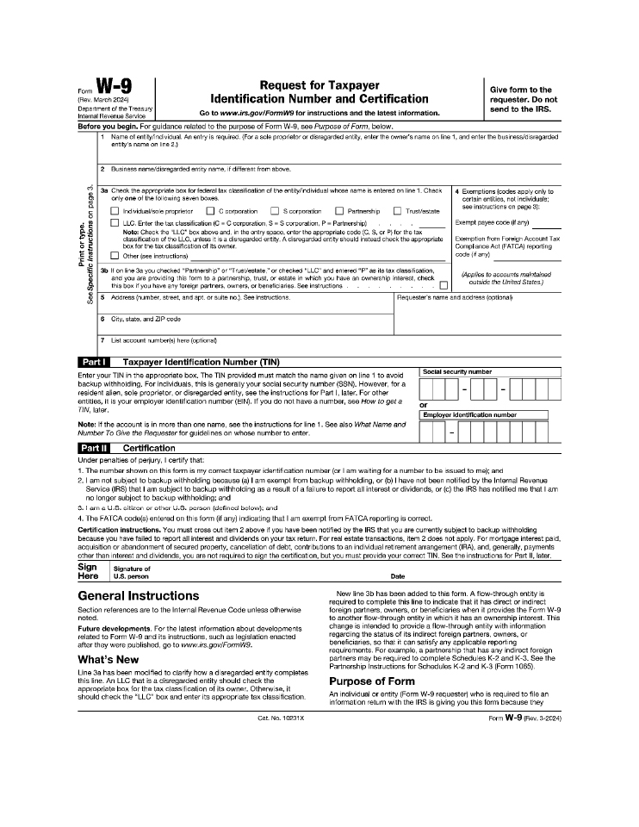
Request for Taxpayer Focm W 9 Give fonn to the (Rev. March 2024) Identification Number and Certification requester. Do not Department of the Treasury send to the IRS. Go to www.irs.gov/FormW9 for instructions and the latest information. Internal Revenue Service Before you begin. For guidance related to the purpose of Form W-9, see Purpose of Form, below. 1 Name of entity/individual. An entry is required. (For a sole proprietor or disregarded entity, enter the owner’s name on line 1, and enter the business/disregarded entity’s name on line 2.) 2 Business name/disregarded entity name, if different from above. ‘” 3a Check the appropriate box for federal tax classification of the entity/individual whose name is entered on line 1. Check 4 Exemptions (codes apply only to g, only one of the following seven boxes. certain entities, not individuals; C. see instructions on page 3): C Individual/sole proprietor C corporation S corporation Partnership Trust/estate LLC. Enter the tax classification (C = C corporation, S = S corporation, P = Partnership) —- Exempt payee code (if any) ——_g;:B Note: Check the “LLC” box above and, in the entry space, enter the appropriate code (C, S, or P) for the tax 2 classification of the LLC, unless it is a disregarded entity. A disregarded entity should instead check the appropriate Exemption from Foreign Account Tax 0 box for the tax classification of its owner. Compliance Act (FATCA) reporting ‘E “ti Other (see instructions) code (1f any) ·;::.E 0. .g ·u 3b If on line 3a you checked “Partnership” or “Trust/estate,” or checked “LLC” and entered “P” as its tax classification, (Applies to accounts maintained and you are providing this form to a partnership, trust, or estate in which you have an ownership interest, check outside the United States.) ~ this box if you have any foreign partners, owners, or beneficiaries. See instructions 5 Address (number, street, and apt. or suite no.). See instructions. Requester’s name and address (optional) <f) 6 City, state, and ZIP code 7 List account number(s) here (optiona0 . ~- Taxpayer Identification Number (TIN) I Social security number I Enter your TIN in the appropriate box. The TIN provided must match the name given on line 1 to avoid backup w1thhold1ng. For 1nd1v1duals, this Is generally your social security number (SSN). However, for a resident alien, sole proprietor, or disregarded entity, see the instructions for Part I, later. For other [Il]-ITJ-11 I I I entities, it is your employer identification number (EIN). If you do not have a number, see How to get a or TIN, later. I Employer identification number Note: If the account is in more than one name, see the instructions for line 1. See also What Name and Number To Give the Requester for guidelines on whose number to enter. Certification Under penalties of perjury, I certify that: 1. The number shown on this fonn is my correct taxpayer identification number (or I am waiting for a number to be issued to me); and 2. I am not subject to backup withholding because (a) I am exempt from backup withholding, or {b) I have not been notified by the Internal Revenue Service (IRS) that I am subject to backup withholding as a result of a failure to report all interest or dividends, or (c) the IRS has notified me that I am no longer subject to backup withholding; and 3. I am a U.S. citizen or other U.S. person (defined below); and 4. The FATCA code(s) entered on this form (if any) indicating that I am exempt from FATCA reporting is correct. Certification instructions. You must cross out item 2 above if you have been notified by the IRS that you are currently subject to backup withholding because you have failed to report all interest and dividends on your tax return. For real estate transactions, item 2 does not apply. For mortgage interest paid, acquisition or abandonment of secured property, cancellation of debt, contributions to an individual retirement arrangement (IRA), and, generally, payments other than interest and dividends, you are not required to sign the certification, but you must provide your correct TIN. See the instructions for Part II, later. Sign I Signature of Here . U.S. person Date General Instructions New line 3b has been added to this form. A flow-through entity is required to complete this line to indicate that it has direct or indirect Section references are to the lniernal Revenue Code unless otherwise foreign partners, owners, or beneficiaries when it provides the Form W-9 noted. to another flow-through entity in which it has an ownership interest. This change is intended to provide a flow-through entity with information Future developments. For the latest information about developments related to Form W-9 and its instructions, such as legislation enacted regarding the status of its indirect foreign partners, owners, or beneficiaries, so that it can satisfy any applicable reporting after they were published, go to www.irs.gov/FormW9. requirements. For example, a partnership that has any indirect foreign What’s New partners may be required to complete Schedules K-2 and K-3. See the Partnership Instructions for Schedules K-2 and K-3 (Form 1065). Line 3a has been modified to clarify how a disregarded entity completes this line. An LLC that is a disregarded entity should check the Purpose of Form appropriate box for the tax classification of its owner. Otherwise, it An individual or entity (Form W-9 requester) who is required to file an should check the “LLC” box and enter its appropriate tax classification. information return with the IRS is giving you this form because they Cat. No. 10231 X Form W-9 (Rev. 3-2024) 54755545.5

- 10 -
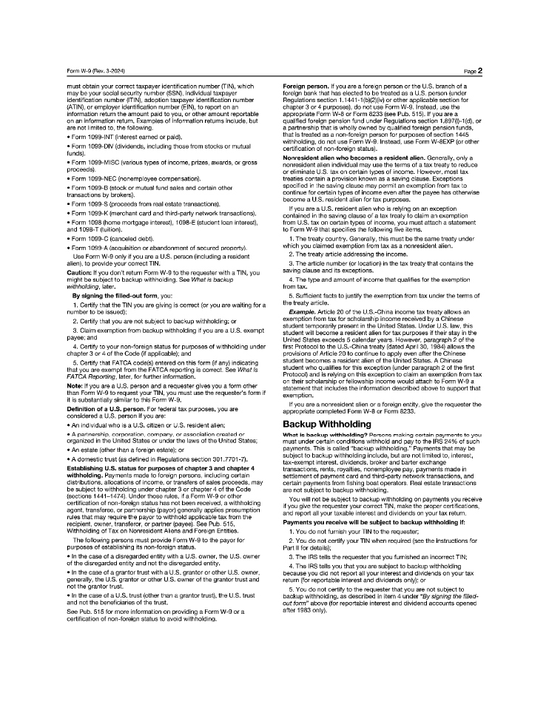
- 11—Form W-9 (Rev. 3-2024) must obtain your correct taxpayer identification number (TIN), which may be your social security number (SSN), individual taxpayer identification number (ITIN), adoption taxpayer identification number (ATIN), or employer identification number (EIN), to report on an information return the amount paid to you, or other amount reportable on an information return. Examples of information returns include, but are not limited to, the following. Form 1099-INT (interest earned or paid). Form 1099-DIV (dividends, including those from stocks or mutual funds). Form 1099-MISC (various types of income, prizes, awards, or gross proceeds). Form 1099-NEC (nonemployee compensation). Form 1099-8 (stock or mutual fund sales and certain other transactions by brokers). Form 1099-S (proceeds from real estate transactions). Form 1099-K (merchant card and third-party network transactions). Form 1098 (home mortgage interest), 1098-E (student loan interest), and 1098-T (tuition). Form 1099-C (canceled debt). Form 1099-A (acquisition or abandonment of secured property). Use Form W-9 only if you are a U.S. person (including a resident alien), to provide your correct TIN. Caution: If you don’t return Form W-9 to the requester with a TIN, you might be subject to backup withholding. See What is backup withholding, later. By signing the filled-out form, you: 1. Certify that the TIN you are giving is correct (or you are waiting for a number to be issued); 2. Certify that you are not subject to backup withholding; or 3. Claim exemption from backup withholding if you are a U.S. exempt payee; and 4. Certify to your non-foreign status for purposes of withholding under chapter 3 or 4 of the Code (if applicable); and 5. Certify that FATCA code(s) entered on this form (if any) indicating that you are exempt from the FATCA reporting is correct. See What Is FATCA Reporting, later, for further information. Note: If you are a U.S. person and a requester gives you a form other than Form W-9 to request your TIN, you must use the requester’s form if it is substantially similar to this Form W-9. Definition of a U.S. person. For federal tax purposes, you are considered a U.S. person if you are: An individual who is a U.S. citizen or U.S. resident alien; A partnership, corporation, company, or association created or organized in the United States or under the laws of the United States; An estate (other than a foreign estate); or A domestic trust (as defined in Regulations section 301.7701-7) . Establishing U.S. status for purposes of chapter 3 and chapter 4 withholding. Payments made to foreign persons, including certain distributions, allocations of income, or transfers of sales proceeds, may be subject to withholding under chapter 3 or chapter 4 of the Code (sections 1441-1474). Under those rules, if a Form W-9 or other certification of non-foreign status has not been received, a withholding agent, transferee, or partnership (payor) generally applies presumption rules that may require the payor to withhold applicable tax from t he recipient, owner, transferor, or partner (payee). See Pub. 515, Withholding of Tax on Nonresident Aliens and Foreign Entities. The following persons must provide Form W-9 to the payor for purposes of establishing its non-foreign status. In the case of a disregarded entity with a U.S. owner, the U.S. owner of the disregarded entity and not the disregarded entity. In the case of a granter trust with a U.S. granter or other U.S. owner, generally, the U.S. grantor or other U.S. owner of the granter trust and not the granter trust. In the case of a U.S. trust (other than a granter trust), the U.S. trust and not the beneficiaries of the trust. See Pub. 515 for more information on providing a Form W-9 or a certification of non-foreign status to avoid withholding. Page2 Foreign person. If you are a foreign person or t he U.S. branch of a foreign bank that has elected to be treated as a U.S. person (under Regulations section 1.1441-1 (b)(2)(iv) or other applicable section for chapter 3 or 4 purposes), do not use Form W-9. Instead, use the appropriate Form W-8 or Form 8233 (see Pub. 515). If you are a qualified foreign pension fund under Regulations section 1.897(I)-t(d), or a partnership that is wholly owned by qualified foreign pension funds, that is treated as a non-foreign person for purposes of section 1445 withholding, do not use Form W-9. Instead, use Form W-8EXP (or other certification of non-foreign status). Nonresident alien who becomes a resident alien. Generally, only a nonresident alien individual may use the terms of a tax treaty to reduce or eliminate U.S. tax on certain types of income. However, most tax treaties contain a provision known as a saving clause. Exceptions specified in the saving clause may permit an exemption from tax to continue for certain types of income even after the payee has otherwise become a U.S. resident alien for tax purposes. If you are a U.S. resident alien who is relying on an exception contained in the saving clause of a tax treaty to claim an exemption from U.S. tax on certain types of income, you must attach a statement to Form W-9 that specifies the following five items. 1. The treaty country. Generally, this must be the same treaty under which you claimed exemption from tax as a nonresident alien. 2. The treaty article addressing the income. 3. The article number (or location) in the tax treaty that contains the saving clause and its exceptions. 4. The type and amount of income that qualifies for the exemption from tax. 5. Sufficient facts to justify the exemption from tax under the terms of the treaty article. Example. Article 20 of the U.S.-China income tax treaty allows an exemption from tax for scholarship income received by a Chinese student temporarily present in the United States. Under U.S. law, this student will become a resident alien for tax purposes if their stay in the United States exceeds 5 calendar years. However, paragraph 2 of the first Protocol to the U.S.-China treaty (dated April 30, 1984) allows the provisions of Article 20 to continue to apply even after the Chinese student becomes a resident alien of the United States. A Chinese student who qualifies for this exception (under paragraph 2 of the first Protocol) and is relying on this exception to claim an exemption from tax on their scholarship or fellowship income would attach to Form W-9 a statement that includes the information described above to support that exemption. If you are a nonresident alien or a foreign entity, give the requester the appropriate completed Form W-8 or Form 8233. Backup Withholding What is backup withholding? Persons making certain payments to you must under certain conditions withhold and pay to the IRS 24% of such payments. This is called “backup withholding.” Payments that may be subject to backup withholding include, but are not limited to, interest, tax-exempt interest, dividends, broker and barter exchange transactions, rents, royalties, nonemployee pay, payments made in settlement of payment card and third-party network t ransactions, and certain payments from fishing boat operators. Real estate transactions are not subject to backup withholding. You will not be subject to backup withholding on payments you receive if you give the requester your correct TIN, make the proper certifications, and report all your taxable interest and dividends on your tax return. Payments you receive will be subject to backup withholding if: 1. You do not furnish your TIN to t he requester; 2. You do not certify your TIN when required (see the instructions for Part II for details); 3. The IRS tells the requester that you furnished an incorrect TIN; 4. The IRS tells you that you are subject to backup w ithholding because you did not report all your interest and dividends on your tax return (for reportable interest and dividends only); or 5. You do not certify to t he requester that you are not subject to backup withholding, as described in item 4 under “By signing the filled-out form” above (for reportable interest and dividend accounts opened after 1983 only). 54755545.5

- 11 -
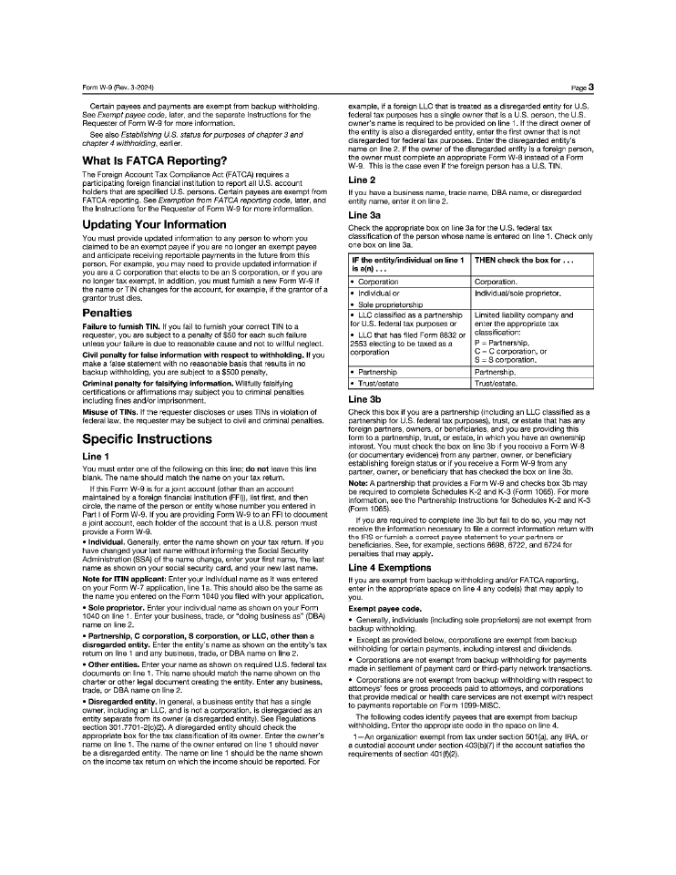
- 12 – Form W-9 (Rev. 3-2024) Certain payees and payments are exempt from backup withholding. See Exempt payee code, later, and the separate Instructions for the Requester of Form W-9 for more information. See also Establishing U.S. status for purposes of chapter 3 and chapter 4 withholding, earlier. What Is FATCA Reporting? The Foreign Account Tax Compliance Act (FATCA) requires a participating foreign financial institution to report all U.S. account holders that are specified U.S. persons. Certain payees are exempt from FATCA reporting. See Exemption from FATCA reporting code, later, and the Instructions for the Requester of Form W-9 for more information. Updating Your Information You must provide updated information to any person to whom you claimed to be an exempt payee if you are no longer an exempt payee and anticipate receiving reportable payments in the future from this person. For example, you may need to provide updated information if you are a C corporation that elects to be an S corporation, or if you are no longer tax exempt. In addition, you must furnish a new Form W-9 if the name or TIN changes for the account, for example, if the granter of a granter trust dies. Penalties Failure to furnish TIN. If you fail to furnish your correct TIN to a requester, you are subject to a penalty of $50 for each such failure unless your failure is due to reasonable cause and not to willful neglect. Civil penalty for false information with respect to withholding. If you make a false statement with no reasonable basis that results in no backup withholding, you are subject to a $500 penalty. Criminal penalty for falsifying information. Willfully falsifying certifications or affirmations may subject you to criminal penalties including fines and/or imprisonment. Misuse of TINs. If the requester discloses or uses TINs in violation of federal law, the requester may be subject to civil and criminal penalties. Specific Instructions Line 1 You must enter one of the following on this line; do not leave this line blank. The name should match the name on your tax return. If this Form W-9 is for a joint account (other than an account maintained by a foreign financial institution (FFI)), list first, and then circle, the name of the person or entity whose number you entered in Part I of Form W-9. If you are providing Form W-9 to an FFI to document a joint account, each holder of the account that is a U.S. person must provide a Form W-9. Individual. Generally, enter the name shown on your tax return. If you have changed your last name w ithout informing the Social Security Administration (SSA) of the name change, enter your first name, the last name as shown on your social security card, and your new last name. Note for ITIN applicant: Enter your individual name as it was entered on your Form W-7 application, line 1a. This should also be the same as the name you entered on the Form 1040 you filed with your application. Sole proprietor. Enter your individual name as shown on your Form 1040 on line 1. Enter your business, trade, or “doing business as” (OBA) name on line 2. Partnership, C corporation, S corporation, or LLC, other than a disregarded entity. Enter the entity’s name as shown on the entity’s tax return on line 1 and any business, trade, or OBA name on line 2. Other entities. Enter your name as shown on required U.S. federal tax documents on line 1. This name should match the name shown on the charter or other legal document creating the entity. Enter any business, trade, or OBA name on line 2. Disregarded entity. In general, a business entity that has a single owner, including an LLC, and is not a corporation, is disregarded as an entity separate from its owner (a disregarded entity). See Regulations section 301.7701-2(c)(2) . A disregarded entity should check the appropriate box for the tax classification of its owner. Enter the owner’s name on line 1. The name of the owner entered on line 1 should never be a disregarded entity. The name on line 1 should be the name shown on the income tax return on which the income should be reported. For Page3 example, if a foreign LLC that is treated as a disregarded entity for U.S. federal tax purposes has a single owner that is a U.S. person, the U.S. owner’s name is required to be provided on line 1. It the direct owner of the entity is also a disregarded entity, enter the first owner that is not disregarded for federal tax purposes. Enter the disregarded entity’s name on line 2. If the owner of the disregarded entity is a foreign person, the owner must complete an appropriate Form W-8 instead of a Form W-9. This is the case even if the foreign person has a U.S. TIN. Line 2 If you have a business name, trade name, OBA name, or disregarded entity name, enter it on line 2. Line 3a Check the appropriate box on line 3a for the U.S. federal tax classification of the person whose name is entered on line 1. Check only one box on line 3a. IF the entity/individual on line 1 THEN check the box for . isa(n) . Corporation Corporation. Individual or Individual/sole proprietor. Sole proprietorship LLC classified as a partnership Limited liability company and for U.S. federal tax purposes or enter the appropriate tax LLC that has filed Form 8832 or classification: 2553 electing to be taxed as a P = Partnership, corporation C = C corporation, or S = S corporation. Partnership Partnership. Trust/estate Trust/estate. Line 3b Check this box if you are a partnership (including an LLC classified as a partnership for U.S. federal tax purposes), t rust, or estate that has any foreign partners, owners, or beneficiaries, and you are providing this form to a partnership, trust, or estate, in which you have an ownership interest. You must check the box on line 3b if you receive a Form W-8 (or documentary evidence) from any partner, owner, or beneficiary establishing foreign status or if you receive a Form W-9 from any partner, owner, or beneficiary that has checked the box on line 3b. Note: A partnership that provides a Form W-9 and checks box 3b may be required to complete Schedules K-2 and K-3 (Form 1065). For more information, see the Partnership Instructions for Schedules K-2 and K-3 (Form 1065). If you are required to complete line 3b but fail to do so, you may not receive the information necessary to file a correct information return with the IRS or furnish a correct payee statement to your partners or beneficiaries. See, for example, sections 6698, 6722, and 6724 for penalties that may apply. Line 4 Exemptions If you are exempt from backup withholding and/or FATCA reporting, enter in the appropriate space on line 4 any code(s) that may apply to you. Exempt payee code. Generally, individuals (including sole proprietors) are not exempt from backup withholding. Except as provided below, corporations are exempt from backup withholding for certain payments, including interest and dividends. Corporations are not exempt from backup withholding for payments made in settlement of payment card or third-party network transactions. Corporations are not exempt from backup withholding with respect to attorneys’ fees or gross proceeds paid to attorneys, and corporations that provide medical or health care services are not exempt with respect to payments reportable on Form 1099-MISC. The following codes identify payees that are exempt from backup withholding. Enter the appropriate code in the space on line 4. 1-An organization exempt from tax under section 501 (a), any IRA, or a custodial account under section 403(b)(7) if the account satisfies the requirements of section 401 (1)(2). 54755545.5

- 12 -
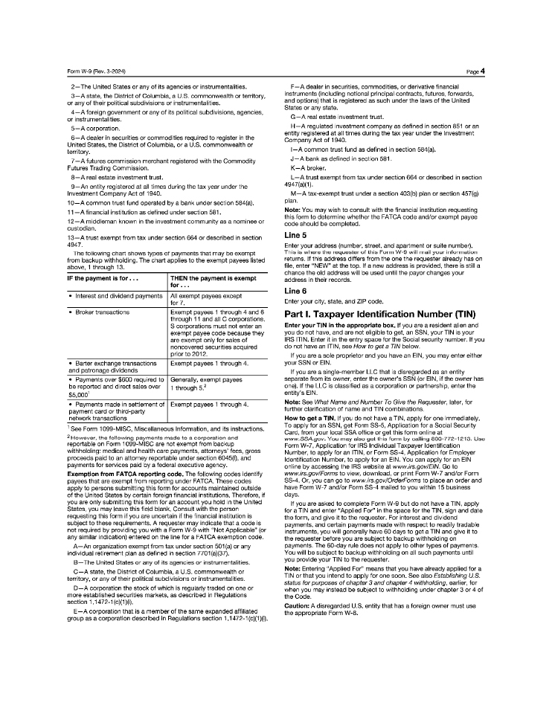
- 13—Form W-9 (Rev. 3-2024) 2-The United States or any of its agencies or instrumentalities. 3-A state, the District of Columbia, a U.S. commonwealth or territory, or any of their political subdivisions or instrumentalities. 4-A foreign government or any of its political subdivisions, agencies, or instrumentalities. 5-A corporation. 6-A dealer in securities or commodities required to register in the United States, the District of Columbia, or a U.S. commonwealth or territory. 7-A futures commission merchant registered with the Commodity Futures Trading Commission. 8-Areal estate investment trust. 9-An entity registered at all times during the tax year under the Investment Company Act of 1940. 10-A common trust fund operated by a bank under section 584(a). 11-A financial institution as defined under section 581. 12-A middleman known in the investment community as a nominee or custodian. 13-A trust exempt from tax under section 664 or described in section 4947. The following chart shows types of payments that may be exempt from backup withholding. The chart applies to the exempt payees listed above, 1 through 13. IF the payment is for ... THEN the payment is exempt for Interest and dividend payments All exempt payees except for 7. Broker transactions Exempt payees 1 through 4 and 6 through 11 and all C corporations. S corporations must not enter an exempt payee code because they are exempt only for sales of noncovered securities acquired prior to 2012. Barter exchange transactions Exempt payees 1 through 4. and patronage dividends Payments over $600 required to Generally, exempt payees be reported and direct sales over 1 through 5_2 1 $5,000 Payments made in settlement of Exempt payees 1 through 4. payment card or third-party network transactions 1 See Form 1099-MISC, Miscellaneous Information, and its instructions. 2 However, the following payments made to a corporation and reportable on Form 1099-MISC are not exempt from backup withholding: medical and health care payments, attorneys’ fees, gross proceeds paid to an attorney reportable under section 6045(1), and payments for services paid by a federal executive agency. Exemption from FATCA reporting code. The following codes identify payees that are exempt from reporting under FATCA. These codes apply to persons submitting this form for accounts maintained outside of the United States by certain foreign financial institutions. Therefore, if you are only submitting this form for an account you hold in the United States, you may leave this field blank. Consult with the person requesting this form if you are uncertain if the financial institution is subject to these requirements. A requester may indicate that a code is not required by providing you with a Form W-9 with “Not Applicable” (or any similar indication) entered on the line for a FATCA exemption code. A-An organization exempt from tax under section 501 (a) or any individual retirement plan as defined in section 7701 (a)(37). B-The United States or any of its agencies or instrumentalities. C-A state, the District of Columbia, a U.S. commonwealth or territory, or any of their political subdivisions or instrumentalities. D- A corporation the stock of which is regularly traded on one or more established securities markets, as described in Regulations section 1.1472-1(c)(1)(i). E-A corporation that is a member of the same expanded affiliated group as a corporation described in Regulations section 1.1472-1 (c)(1 )(i). Page4 F-A dealer in securities, commodities, or derivative financial instruments (including notional principal contracts, futures, forwards, and options) that is registered as such under the laws of the United States or any state. G-A real estate investment trust. H-A regulated investment company as defined in section 851 or an entity registered at all times during the tax year under the Investment Company Act of 1940. I-A common trust fund as defined in section 584(a). J-A bank as defined in section 581. K-A broker. L-A trust exempt from tax under section 664 or described in section 4947(a)(1). M-A tax-exempt trust under a section 403(b) plan or section 457(g) plan. Note: You may wish to consult with the financial institution requesting this form to determine whether the FATCA code and/or exempt payee code should be completed. Line 5 Enter your address (number, street, and apartment or suite number). This is where the requester of this Form W-9 will mail your information returns. If this address differs from the one the requester already has on file, enter “NEW” at the top. If a new address is provided, there is still a chance the old address will be used until the payor changes your address in their records. Line 6 Enter your city, state, and ZIP code. Part I. Taxpayer Identification Number (TIN) Enter your TIN in the appropriate box. If you are a resident alien and you do not have, and are not eligible to get. an SSN. your TIN is your IRS ITIN. Enter ii in the entry space for the Social security number. If you do not have an ITIN, see How to get a TIN below. If you are a sole proprietor and you have an EIN, you may enter either your SSN or EIN. If you are a single-member LLC that is disregarded as an entity separate from its owner. enter the owner’s SSN (or EIN, if the owner has one). If the LLC is classified as a corporation or partnership, enter the entity’s EIN. Note: See What Name and Number To Give the Requester, later, for further clarification of name and TIN combinations. How to get a TIN. If you do not have a TIN, apply for one immediately. To apply for an SSN, get Form SS-5, Application for a Social Security Card. from your local SSA office or get this form online at www.SSA.gov. You may also get this form by calling 800-772-1213. Use Form W-7, Application for IRS Individual Taxpayer Identification Number, to apply for an ITIN, or Form SS-4, Application for Employer Identification Number, to apply for an EIN. You can apply for an EIN online by accessing the IRS website at www.irs.gov/EIN. Go to www.irs.gov/Forms to view, download, or print Form W-7 and/ or Form SS-4. Or, you can go to www.irs.gov/OrderForms to place an order and have Form W-7 and/or Form SS-4 mailed to you within 15 business days. If you are asked to complete Form W-9 but do not have a TIN, apply for a TIN and enter “Applied For” in the space for the TIN, sign and date the form, and give it to the requester. For interest and dividend payments, and certain payments made with respect to readily tradable instruments, you will generally have 60 days to get a TIN and give it to the requester before you are subject to backup withholding on payments. The 60-day rule does not apply to other types of payments. You will be subject to backup withholding on all such payments until you provide your TIN to the requester. Note: Entering “Applied For” means that you have already applied for a TIN or that you intend to apply for one soon. See also Establishing U.S. status for purposes ofchapter 3 and chapter 4 withholding, earlier, for when you may instead be subject to withholding under chapter 3 or 4 of the Code. Caution: A disregarded U.S. entity that has a foreign owner must use the appropriate Form W-8. 54755545.5

- 13 -
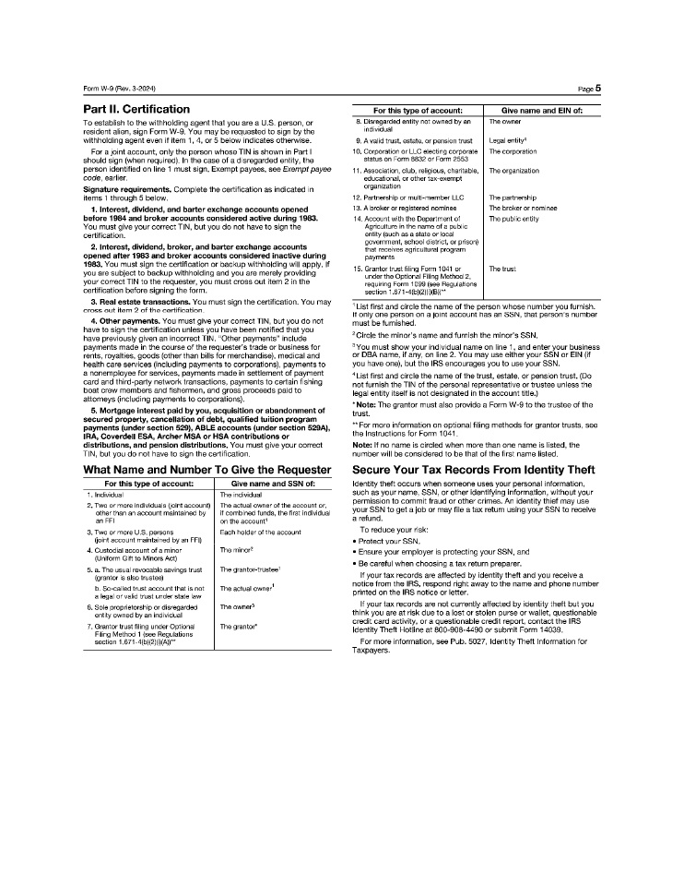
- 14—Form W-9 (Rev. 3-2024) Part II. Certification To establish to the withholding agent that you are a U.S. person, or resident alien, sign Form W-9. You may be requested to sign by the withholding agent even if item 1, 4, or 5 below indicates otherwise. For a joint account, only the person whose TIN is shown in Part I should sign {when required). In the case of a disregarded entity, the person identified on line 1 must sign. Exempt payees, see Exemptpayee code, earlier. Signature requirements. Complete the certification as indicated in items 1 through 5 below. 1. Interest, dividend, and barter exchange accounts opened before 1984 and broker accounts considered active during 1983. You must give your correct TIN, but you do not have to sign the certification. 2, Interest, dividend, broker, and barter exchange accounts opened after 1983 and broker accounts considered inactive during 1983. You must sign the certification or backup withholding will apply. If you are subject to backup withholding and you are merely providing your correct TIN to the requester, you must cross out item 2 in the certification before signing the form. 3. Real estate transactions. You must sign the certification. You may cross out item 2 of t he certification. 4, Other payments. You must give your correct TIN, but you do not have to sign the certification unless you have been notified that you have previously given an incorrect TIN. “Other payments” include payments made in the course of the requester’s trade or business for rents, royalties, goods (other than bills for merchandise), medical and health care services (including payments to corporations), payments to a nonemployee for services, payments made in settlement of payment card and third-party network transactions, payments to certain fishing boat crew members and fishermen, and gross proceeds paid to attorneys (including payments to corporations). 5. Mortgage interest paid by you, acquisition or abandonment of secured property, cancellation of debt, qualified tuition program payments (under section 529), ABLE accounts (under section 529A), IRA, Coverdell ESA, Archer MSA or HSA contributions or distributions, and pension distributions. You must give your correct TIN, but you do not have to sign the certification. What Name and Number To Give the Requester For this type of account: Give name and SSN of: 1. Individual The individual 2. Two or more individuals fjoint account) The actual owner of the account or, other than an account maintained by if combined funds, the first individual an FFI on the account 1 3. Two or more U.S. persons Each holder of the account ijoint account maintained by an FFI) 4. Custodial account of a minor The minor2 (Uniform Gift to Minors Act) 5. a. The usual revocable savings trust The granter-trustee1 (granter is also trustee) 1 b. Sa-called trust account that is not The actual owner a legal or valid trust under state law 6. Sole proprietorship or disregarded The owner3 entity owned by an individual 7. Grantor trust filing under Optional The granter* Filing Method 1 (see Regulations section 1.671-4(b)(2)(i)(A)) Page5 For this type of account: Give name and EIN of: 8. Disregarded enlity not owned by an The owner individual 9. A valid trus1, es1ate, or pension trust Legal entity4 t 0. Corporation or LLC electing corporate The corporation status on Fonn 8832 or Form 2553 11. Association, club, religious, charitable, The organization educational, or other tax-exempt organization 12. Partnership or multi-member LLC The partnership 13. A broker or registered nominee The broker or nominee 14. Account with the Department of The public entity Agriculture in the name of a public entity (such as a state or local government, school district, or prison) that receives agricultural program payments 15. Granter trust filing Form 1041 or The trust under the Optional Filing Method 2, requiring Form 1099 (see Regulations section 1.671-4(b)(2)(i)(B))” 1 List first and circle the name of the person whose number you furnish. If only one person on a joint account has an SSN, that person’s number must be furnished. 2 Circle the minor’s name and furnish the minor’s SSN. 3 You must show your individual name on line 1, and enter your business or DBA name, if any, on line 2. You may use either your SSN or EIN (if you have one), but the IRS encourages you to use your SSN. 4 List first and circle the name of the trust, estate. or pension trust. (Do not furnish the TIN of the personal representative or trustee unless the legal entity itself is not designated in the account title.) Note: The granter must also provide a Form W-9 to the trustee of the trust. .. For more information on optional filing methods for granter trusts, see the Instructions for Form 1041. Note: If no name is circled when more than one name is listed, the number will be considered to be that of the first name listed. Secure Your Tax Records From Identity Theft Identity theft occurs when someone uses your personal information, such as your name, SSN, or other identifying information, without your permission to commit fraud or other crimes. An identity thief may use your SSN to get a job or may fi le a tax return using your SSN to receive a refund. To reduce your risk: Protect your SSN, Ensure your employer is protecting your SSN, and Be careful when choosing a tax return preparer. If your tax records are affected by identity theft and you receive a notice from the IRS, respond right away to the name and phone number printed on the IRS notice or letter. If your tax records are not currently affected by identity theft but you think you are at risk due to a lost or stolen purse or wallet, questionable credit card activity, or a questionable credit report, contact t he IRS Identity Theft Hotline at 800-908-4490 or submit Form 14039. For more information, see Pub. 5027, Identity Theft Information for Taxpayers. 54755545.5

- 14 -
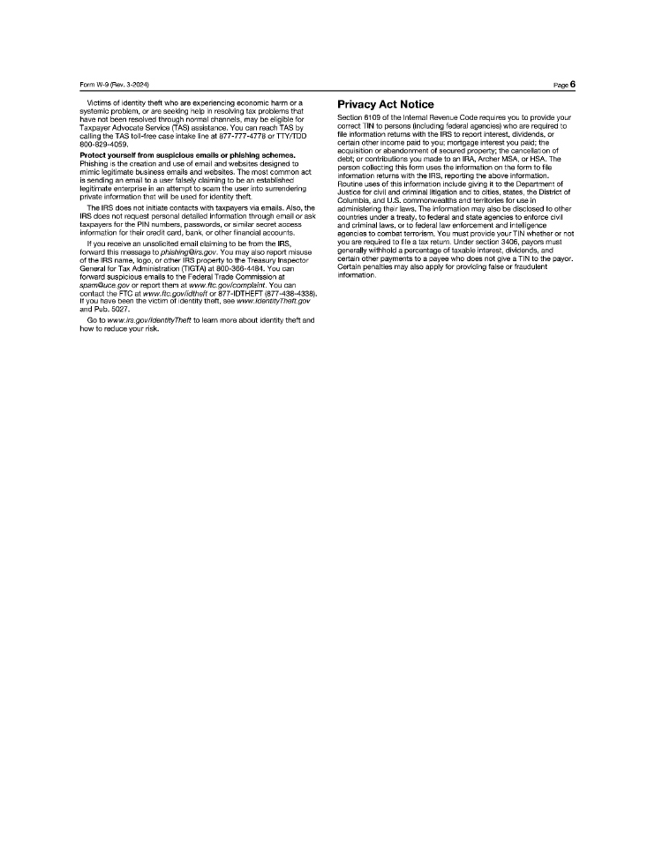
- 15—Form W-9 (Rev. 3-2024) Victims of identity theft who are experiencing economic harm or a systemic problem, or are seeking help in resolving tax problems that have not been resolved through normal channels, may be eligible for Taxpayer Advocate Service (TAS) assistance. You can reach TAS by calling the TAS toll-free case intake line at 877-777-4778 or TTY/TDD 800-829-4059. Protect yourself from suspicious emails or phishing schemes, Phishing is the creation and use of email and websites designed to mimic legitimate business emails and websites. The most common act is sending an email to a user falsely claiming to be an established legitimate enterprise in an attempt to scam the user into surrendering private information that will be used for identity theft. The IRS does not initiate contacts with taxpayers via emails. Also, the IRS does not request personal detailed information through email or ask taxpayers for the PIN numbers, passwords, or similar secret access information for their credit card, bank, or other financial accounts. If you receive an unsolicited email claiming to be from the IRS, forward this message to phishing@irs.gov. You may also report misuse of the IRS name, logo, or other IRS property to the Treasury Inspector General for Tax Administration (TIGTA) at 800-366-4484. You can forward suspicious emails to the Federal Trade Commission at spam@uce.gov or report them at www.ftc.gov/compfaint. You can contact the FTC at www.ftc.gov/idtheft or 877-IDTHEFT (877-438-4338). If you have been the victim of identity theft, see www.fdentityTheft.gov and Pub. 5027. Go to www.irs.gov/fdentityTheft to learn more about identity theft and how to reduce your risk. Page6 Privacy Act Notice Section 6109 of the Internal Revenue Code requires you to provide your correct TIN to persons (including federal agencies) who are required to file information returns with the IRS to report interest , dividends, or certain other income paid to you; mortgage interest you paid; t he acquisition or abandonment of secured property; the cancellation of debt; or contributions you made to an IRA, Archer MSA, or HSA. The person collecting this form uses the information on the form to file information returns with the IRS, reporting the above information. Routine uses of this information include giving it to the Department of Justice for civil and criminal litigation and to cities, states, the District of Columbia, and U.S. commonwealths and territories for use in administering their laws. The information may also be disclosed to other countries under a treaty, to federal and state agencies to enforce civil and criminal laws, or to federal law enforcement and intelligence agencies to combat terrorism. You must provide your TIN whether or not you are required to file a tax return. Under section 3406, payors must generally withhold a percentage of taxable interest, dividends, and certain other payments to a payee who does not give a TIN to the payor. Certain penalties may also apply for providing false or fraudulent information. 54755545.5

- 15 -

INSTRUCTIONS

1. | Delivery of Letter of Transmittal.

A duly executed Letter of Transmittal and any accompanying certificate(s) representing shares and any other documents required by this Letter of Transmittal, should be hand delivered, couriered or mailed to the Depositary at the appropriate address set forth herein.

The method of delivery of all documents is at the election and risk of the shareholder. Delivery is only effective upon receipt by the Depositary. If delivery is by mail, registered mail, properly insured, is recommended.

2. | Inadequate Space.

If the space provided in any Box is inadequate, attach a separate signed document to this Letter of Transmittal.

3. | Signatures on the Letter of Transmittal.

This Letter of Transmittal must be filled in and signed by the holder of shares described above or by such holder’s duly authorized representative (in accordance with Instruction 5).

 | (a) | If this Letter of Transmittal is signed by the registered owner(s) of the accompanying certificate(s), the signature(s) must correspond exactly with the name(s) as written on the face of the corresponding share certificate(s) without any change whatsoever.

 | (b) | If this Letter of Transmittal is signed by a person other than the registered owner(s) of the accompanying certificate(s):

 | (i) | such transmitted certificate(s) must be endorsed or be accompanied by an appropriate share transfer power of attorney duly and properly completed by the registered owner(s); and

 | (ii) | the signature(s) on such endorsement or share transfer power of attorney must correspond exactly to the name(s) of the registered owner(s) as registered or as appearing on the certificate(s) and must be guaranteed as noted in Instruction 4 below.

 | (c) | If the shares are registered in the names of two or more joint owners, each such owner must sign this Letter of Transmittal.

 | (d) | If any shares are registered in different names on several certificates, it will be necessary to complete, sign, and submit as many separate Letters of Transmittal as there are different registrations of certificates.

4. | Guarantee of Signatures.

If this Letter of Transmittal is signed by a person other than the registered owner(s) of the transmitted share certificates, or if a registered holder of shares wishes that its new share certificate(s) be registered in the name of a person other than the registered owner(s) as shown on the registers of the Company, or if payment on account of the fractional shares is to be issued in the name of a person other than the registered owner of the transmitted share certificates, such signature must be guaranteed by an Eligible Institution (as defined below), or in some other manner satisfactory to the Depositary (except that no guarantee is required if the signature is that of an Eligible Institution).

- 16 -

An “Eligible Institution” means a Canadian Schedule I chartered bank, a major trust company in Canada, a commercial bank or trust company in the United States, a member of the Securities Transfer Association Medallion Program (STAMP), a member of the Stock Exchange Medallion Program (SEMP) or a member of the New York Stock Exchange Inc. Medallion Signature Program (MSP). Members of these programs are usually members of a recognized stock exchange in Canada or the United States, members of the Canadian Investment Regulatory Organization, members of the Financial Industry Regulatory Authority, Inc. or banks and trust companies in the United States.

5. | Fiduciaries, Representatives and Authorizations.

Where this Letter of Transmittal is executed by a person on behalf of an executor, administrator, trustee, guardian, corporation, partnership or association or is executed by any other person acting in a representative capacity, this Letter of Transmittal must be accompanied by satisfactory evidence of the authority to act. Either the Company or the Depositary, at its discretion, may require additional evidence of authority or additional documentation.

6. | Irregularities.

All questions as to the Transaction and the form of documents will be determined by the Company, in its sole discretion, acting reasonably, which determination will be final and binding on all parties, absent a finding to the contrary by a court of competent jurisdiction. The Company reserves the absolute right to reject any or all Letters of Transmittal determined in its sole discretion not to be in proper form or completed in accordance with the Instructions herein and any Letters of Transmittal, which may, in the opinion of the Company’s counsel, be unlawful. The Company also reserves the absolute right to waive any of the conditions of the Transaction or any defect or irregularity in any Letter of Transmittal. No Letter of Transmittal will be deemed to be properly submitted until all defects and irregularities have been cured or waived. None of the Company, the Depositary nor any other person will be obligated to give notice of defects or irregularities in Letters of Transmittal, nor shall any of them incur any liability for failure to give any such notice. The Company’s interpretation of the terms and conditions of the Transaction (including this Letter of Transmittal) will be final and binding absent a finding to the contrary by a court of competent jurisdiction. No alternative, conditional or contingent delivery of share certificates will be accepted.

7. | Questions and Requests for Assistance and Additional Copies.

Questions and requests for assistance may be directed to the Depositary at the address, telephone number and e-mail address set forth on the cover of this Letter of Transmittal. Additional copies of the Circular and this Letter of Transmittal may be obtained from the Depositary. The Circular and this Letter of Transmittal are also available under the Company’s profile on SEDAR+ at www.sedarplus.com and on EDGAR at www.sec.gov.

8. | Lost Certificates.

Option #1: If share certificate(s) have been lost, stolen or destroyed, this Letter of Transmittal should be completed as fully as possible and forwarded together with a letter describing the loss to the Depositary. The Depositary will respond with the replacement requirements.

Option #2: Alternatively, shareholders whose certificate(s) have been lost, stolen or destroyed may participate in Computershare’s blanket bond program with Aviva Insurance Company of Canada by completing Box E above, and submitting the applicable certified cheque or money order made payable to Computershare Investor Services Inc.

- 17 -

9. | Fractional Shares.

Fractional shares arising as a result of the Share Consolidation (other than those held in Thomson Reuters’ dividend reinvestment plan and employee stock purchase plans) will not be distributed but will be aggregated and sold in the market by a broker appointed by the Depositary, which will distribute the net cash proceeds, after commission expenses, to registered shareholders pro rata based on their fractional entitlements. Such shareholders will receive such net cash proceeds instead of fractional shares.

10. | Important U.S. Tax Information for Shareholders.

For purposes of this Letter of Transmittal, a “U.S. person” is any person that, for U.S. federal income tax purposes, is (a) an individual who is a citizen or resident of the United States; (b) a corporation, partnership, or other entity classified as a corporation or partnership for U.S. federal income tax purposes that is created or organized in or under the laws of the United States or any political subdivision thereof or therein; (c) an estate if the income of such estate is subject to U.S. federal income tax regardless of the source of such income; or (d) a trust if (i) such trust has validly elected to be treated as a U.S. person for U.S. federal income tax purposes or (ii) a U.S. court is able to exercise primary supervision over the administration of such trust and one or more U.S. persons have the authority to control all substantial decisions of such trust.

To prevent U.S. federal backup withholding from applying to payments made to a participating U.S. shareholder (or any person acting on behalf of a U.S. shareholder) pursuant to the Return of Capital, such U.S. shareholder must, unless an exemption applies, provide the Depositary with a correct U.S. taxpayer identification number (“TIN”), which is generally the holder’s social security number or federal employer identification number, certify under penalties of perjury that such TIN is correct (or that the holder is waiting for a TIN to be issued), and provide certain other certifications by completing the Internal Revenue Service (“IRS”) Form W-9 included with this Letter of Transmittal.

If the included IRS Form W-9 does not apply to a U.S. shareholder because the holder is not a U.S. person for U.S. federal income tax purposes (but the holder provided a U.S. address in Box B or C of this Letter of Transmittal or has a U.S. address on the register of shareholders of the Company), such U.S. shareholder should instead properly complete and provide an IRS Form W-8BEN, W-8BEN-E, W-8IMY, W-8ECI, or W-8EXP, as applicable, attesting to such exempt status. An appropriate IRS Form W-8 may be obtained from the Depositary or from the IRS website at www.irs.gov.

A U.S. SHAREHOLDER WHO FAILS TO PROPERLY COMPLETE THE ENCLOSED IRS FORM W-9 INCLUDED WITH THIS LETTER OF TRANSMITTAL OR, IF APPLICABLE, THE APPROPRIATE IRS FORM W-8 MAY BE SUBJECT TO PENALTIES, AND ANY PAYMENTS MADE TO SUCH HOLDER PURSUANT TO THE RETURN OF CAPITAL MAY BE SUBJECT TO BACKUP WITHHOLDING. BACKUP WITHHOLDING IS NOT AN ADDITIONAL TAX. RATHER, THE TAX LIABILITY OF PERSONS SUBJECT TO BACKUP WITHHOLDING WILL BE REDUCED BY THE AMOUNT OF TAX WITHHELD. IF WITHHOLDING RESULTS IN AN OVERPAYMENT OF TAXES, A REFUND MAY BE OBTAINED BY FILING A TAX RETURN WITH THE IRS. THE DEPOSITARY CANNOT REFUND AMOUNTS WITHHELD BY REASON OF BACKUP WITHHOLDING.

Opting-out shareholders are not required to complete the U.S. tax forms included with this Letter of Transmittal, including, for greater certainty, IRS Form W-9 or any IRS Form W-8, nor are such shareholders required to complete Box D above.

- 18 -

11. | Privacy Notice.

The Depositary has a Privacy Statement that is available at www.computershare.com or in writing or by telephone using the telephone number and address provided above in this Letter of Transmittal.
Exhibit 99.6
The Instructions accompanying this opt-out election and certification form should be read carefully before completing it. Please contact Computershare Investor Services Inc. (the Depositary) or your investment dealer, stock broker, bank, trust company or other financial advisor if you have any questions or require assistance in completing this form.

OPT-OUT ELECTION AND CERTIFICATION FORM
for registered shareholders who are taxable in a jurisdiction other than Canada
THOMSON REUTERS CORPORATION
that wish to opt out of the Return of Capital

YOU SHOULD ONLY COMPLETE AND SUBMIT THIS OPT-OUT ELECTION AND CERTIFICATION
FORM IF YOU ARE AN ELIGIBLE OPT-OUT SHAREHOLDER (AS FURTHER DESCRIBED IN THIS
FORM) WHO WISHES TO OPT OUT OF THE RETURN OF CAPITAL.

A DULY COMPLETED FORM MUST BE RECEIVED BY THE DEPOSITARY BY APRIL 27,
2026 AT 5:00 P.M. (TORONTO TIME).

Offices of the Depositary, Computershare Investor Services Inc.,
for the Return of Capital and Share Consolidation Transactions:

By Mail  Computershare Investor Services Inc.  P.O. Box 7021  31 Adelaide Street East  Toronto, Ontario  M5C 3H2  Canada  Attention: Corporate Actions |  | By Hand, Courier or Registered Mail  Computershare Investor Services Inc.  320 Bay Street, 14th Floor  Toronto, Ontario  M5H 4A6  Canada  Attention: Corporate Actions
By E-Mail: onlinedeposits@computershare.com
Toll Free in Canada and the U.S.: 1-800-564-6253
Outside North America: 1-514-982-7555
Who should use this form?
This Form is for use by a registered holder of common shares (referred to as “shares”) in the capital of Thomson Reuters Corporation (“Thomson Reuters” or the “Company”) that is, or is acting on behalf of a beneficial owner of shares that is, as applicable (a) not a resident of Canada for Canadian income tax purposes and is subject to income tax in a jurisdiction other than Canada (and is not exempt from income tax in that jurisdiction) or (b) an individual who is a resident of Canada for Canadian income tax purposes and who is also subject to income tax in a jurisdiction other than Canada as a resident of that other jurisdiction (and is not exempt from income tax in that other jurisdiction) (an “Eligible Opt-Out Shareholder”) for the purpose of opting out of the Return of Capital (as defined below). You are a registered shareholder if your name appears directly on your share certificates or if you hold shares in

- 2 -

book-entry form through the direct registration system (“DRS”) on the records of our transfer agent, Computershare Trust Company of Canada.
If you are a non-registered shareholder satisfying the requirements to be an Eligible Opt-Out Shareholder, you should contact your investment dealer, stock broker, bank, trust company or other nominee or other intermediary to opt out of the Return of Capital. You are a non-registered shareholder if you own shares indirectly; nonregistered shareholders do not have shares registered in their name, but the shares are registered in the name of an intermediary, which include, among others, banks, trust companies, securities dealers or brokers and trustees or administrators of self-administered RRSPs, RRIFs, RESPs and similar plans.
Participants in Thomson Reuters’ employee stock purchase plans (“ESPP”) and holders of Depositary Interests should not use this Form.
Where can I find additional information?
A plan of arrangement (the “Plan of Arrangement”) implementing the Return of Capital and Share Consolidation (as defined below) (together, the “Transaction”) is being submitted for approval at the special meeting of shareholders of the Company to be held on April 28, 2026 (the “Meeting”), as described in a management proxy circular dated March 13, 2026 (the “Circular”). Shareholders are encouraged to review in their entirety the Circular prepared in connection with the Meeting, which is available under the Company’s profile on SEDAR+ at www.sedarplus.com and on EDGAR at www.sec.gov. The terms and conditions of the Transaction are incorporated by reference in this Form. Capitalized terms used but not defined in this Form have the meanings ascribed to them in the Plan of Arrangement and Circular that accompanies this Form. In the case of any inconsistency between the terms of this Form and the Plan of Arrangement and Circular, the terms of the Plan of Arrangement and Circular shall prevail.
What happens under the Transaction?
The Transaction consists of a special cash distribution of US$605 million in the aggregate, or approximately US$1.36 per participating share (estimated based on the number of common shares issued and outstanding as of March 6, 2026 and assuming no shareholders opt-out of the Return of Capital) (the “Return of Capital”) followed by a consolidation of our outstanding common shares (or “reverse stock split”) on a basis that is proportional to the special cash distribution (the “Share Consolidation”). The share consolidation ratio will be fixed based on the volume weighed average trading price of the shares on the Nasdaq for the five trading days immediately prior to the Effective Time. The formula to calculate the share consolidation ratio is set forth in the “Information Regarding the Transaction – Terms of the Arrangement - Share Consolidation Ratio” section of the Circular. As described below, shareholders who opt-out of the Return of Capital will still participate in the Transaction through a share exchange and the Share Consolidation but upon completion of the Transaction will continue to hold the same number of shares that they currently hold.
What happens if I exercise my right to opt out of the Return of Capital?
Shareholders that exercise their right to opt out (each an “opting out shareholder”) of the Return of Capital (the “opt-out right”) will not receive the special cash distribution. Opting-out shareholders will still participate in the Transaction though a share exchange and the Share Consolidation, but will continue to hold the same number of shares that they currently hold. An opting-out shareholder will realize a proportionate increase in its equity and voting interests in the Company by virtue of the Share Consolidation. For more information on the Transaction, please refer to the Circular.
Why is the opt-out right only being given to certain shareholders?
The opt-out right is being given to Eligible Opt-Out Shareholders because the tax consequences of not participating in the Return of Capital may be preferable to those associated with participating in the Return of Capital. For more information, see the “Income Tax Considerations” section of the Circular. Shareholders wishing to exercise their opt-out right are strongly urged to carefully consider the income tax consequences of exercising the opt-out right and to consult with their own tax advisors with respect to their particular circumstances and tax considerations applicable to them.

- 3 -

If I want to opt out of the Return of Capital, what do I need to send to the Depositary and what’s the deadline?
Each Eligible Opt-Out Shareholder holding shares in its own name, by holding physical share certificates or by holding shares through DRS, may exercise the opt-out right by forwarding the following documents to the Depositary prior to April 27, 2026 at 5:00 p.m. (Toronto time) or if the Meeting is adjourned or postponed, no later than 24 hours (excluding Saturdays, Sundays and holidays) before any adjourned or postponed meeting (the “opt-out deadline”):

 | (a) | a duly completed version of this Form; and

 | (b) | a duly completed Letter of Transmittal enclosed separately (on yellow paper), accompanied by any certificates representing your shares.
This Form may be submitted to the Depositary by mail, hand delivery, courier, registered mail or e-mail (at the addresses set forth on the cover of this Form) but the Letter of Transmittal and accompanying share certificate(s), if any, must be submitted to the Depositary by mail, hand delivery, courier or registered mail to the addresses set forth on the cover of the Letter of Transmittal.
Registered shareholders exercising the opt-out right may, upon request, be required to execute any additional documents and instruments as may be required by the Depositary or the Company, at their discretion, to be reasonably necessary or desirable to opt-out of the Return of Capital.
This Form is for use by registered shareholders only and is not to be used by beneficial (non-registered) holders of shares. Non-registered shareholders should contact their intermediary to exercise the opt-out right.
What happens to my shares if I opt out of the Return of Capital?
Although the number of shares held by each opting-out shareholder will not change as a result of the Transaction, as of the Effective Time, opting-out shareholders will still participate in the Transaction though a share exchange and the Share Consolidation. As a result, each registered opting-out shareholder shall be entitled to receive new DRS statement(s) (or if requested in its Letter of Transmittal, share certificate(s)) representing its shares reflecting the new CUSIP number for the shares.
Can I withdraw an opt-out election?
This Form may be withdrawn by a shareholder prior to the opt-out deadline, but is irrevocable thereafter. To withdraw this Form, the shareholder must provide a written notice of revocation to the Depositary that (a) specifies the name of the shareholder having exercised the opt-out right under this Form to be withdrawn and (b) is signed by the shareholder in the same manner as the signature on this Form. If a shareholder does not revoke its election to opt out of the Return of Capital before the opt-out deadline, such shareholder will not be able to transfer its shares for any reason until the completion of the Transaction.
Can I sell or transfer shares after delivering this Form?
Registered shareholders wishing to sell or transfer their shares after delivering a duly completed version of this Form must provide written notice to the Depositary prior to the opt-out deadline which revokes their election with respect to the shares that they wish to transfer and requests the return of such shares that are deposited with the Depositary. Registered shareholders should allow sufficient time for this

- 4 -

process in order to transfer deposited shares. Otherwise, you will not be able to transfer shares until after the Transaction is completed.
General
It is recommended that registered shareholders wishing to opt out of the Return of Capital complete, sign and return this Form to the Depositary as soon as practicable following receipt. Any shareholder who does not deposit with the Depositary a duly completed Form prior to the opt-out deadline, or otherwise fails to comply with the requirements under this Form, the Plan of Arrangement or the Circular, shall be deemed to be a participating shareholder.
None of Thomson Reuters, its board of directors, the Information Agent or the Depositary makes any recommendation to any shareholder as to whether to opt out of the Return of Capital. Shareholders are urged to evaluate carefully all information in this Opt-Out Election and Certification Form, the Circular and other material related to the Transaction, consult their own financial, legal, investment and tax advisors and make their own decisions as to whether to exercise the opt-out right. See the “Information Regarding the Transaction – Terms of the Arrangement – Opt-Out Right” and “Income Tax Considerations” sections of the Circular.
Delivery of this instrument to an address other than shown above does not constitute a valid delivery.

TO: |  | THOMSON REUTERS CORPORATION
AND TO: |  | COMPUTERSHARE INVESTOR SERVICES INC.

The Instructions set forth in this Opt-Out Election and Certification Form, the Circular and other materials related to the Transaction should be read carefully before this Form is completed.

TO: COMPUTERSHARE INVESTOR SERVICES INC.

STEP #1: ELECTION TO EXERCISE OPT-OUT RIGHT
A) Registered Shareholders:
This Step 1(A) should only be completed if the shareholder holds physical share certificates or hold shares through DRS in its own name. If the shareholder is holding shares on behalf of one or more beneficial holders of shares, please fill out Step 1(B) below.
PLEASE CHECK THIS BOX if you wish to opt out of the Return of Capital:

☐ | The undersigned hereby elects to opt out of the Return of Capital for all of the shares held by the undersigned (as detailed in the table below). By opting out of the Return of Capital, the undersigned shareholder acknowledges and understands that it will not receive the special cash distribution.
The undersigned hereby certifies that the undersigned is (a) not a resident of Canada for Canadian income tax purposes and is subject to income tax in a jurisdiction other than Canada (and is not exempt from income tax in that jurisdiction) or (b) an individual who is a resident of Canada for Canadian income tax purposes and who is also subject to income tax in a jurisdiction other than Canada as a resident of that other jurisdiction (and is not exempt from income tax in that jurisdiction).

- 5 -

Please list all details of the share certificates or DRS positions that you hold. If you hold shares through DRS, you do not need to fill out “Certificate Number(s)” in the table below. See Instructions 2 and 3.

Certificate Number(s) |  | Name in Which Registered |  | Number of Shares
B) Registered Shareholders Who Are Intermediaries Acting on Behalf of Beneficial Owners:
This Step 1(B) should only be completed if the registered shareholder holds shares on behalf of one or more beneficial holders of shares (the “Beneficial Owners)”.
PLEASE CHECK ONE BOX ONLY, as applicable:

☐ | The registered shareholder is not the Beneficial Owner of the shares. There is only one Beneficial Owner and such Beneficial Owner wishes to opt out of the Return of Capital in respect of all of the shares held by such Beneficial Owner.

☐ | The registered shareholder is not the Beneficial Owner of the shares. There is more than one Beneficial Owner and the Beneficial Owners holding (insert number of shares) shares wish to opt out of the Return of Capital in respect of all of the shares held by each Beneficial Owner wishing to opt out.
The undersigned hereby certifies that each Beneficial Owner who wishes to exercise the opt-out right is (a) not a resident of Canada for Canadian income tax purposes and is subject to income tax in a jurisdiction other than Canada (and is not exempt from income tax in that jurisdiction) or (b) an individual who is a resident of Canada for Canadian income tax purposes and who is also subject to income tax in a jurisdiction other than Canada as a resident of that other jurisdiction (and is not exempt from income tax in that jurisdiction).

STEP #2: COMPLETE BOX A BELOW
Eligible Opt-Out Shareholders should carefully consider the income tax consequences of exercising the opt-out right. See the “Income Tax Considerations” section of the Circular that accompanies this Opt-Out Election and Certification Form.
The undersigned hereby represents and warrants that the undersigned is the owner, or is acting on behalf of the owner, of the number of shares described above and the undersigned has good title to the shares represented by the said certificate(s), free and clear of all liens, charges and encumbrances, and has full power and authority to herewith deposit such shares. The undersigned hereby represents and warrants that all information provided by the undersigned herein is complete, true and accurate. The undersigned covenants and agrees to execute and deliver all such documents and other assurances as may be necessary or desirable to complete the election and opt out of the Return of Capital pursuant to the Plan of Arrangement. The undersigned covenants not to sell or transfer, or permit to be sold or transferred, any of the shares covered by this Form following the exercise of its opt-out right unless written notice is provided to the Depositary prior to the opt-out deadline revoking its election with respect to the shares in the manner specified herein. These representations, warranties, covenants, acknowledgements and agreements shall survive the completion of the Transaction.

- 6 -

The undersigned hereby acknowledges that the delivery of this Opt-Out Election and Certification Form, and the exercise of the opt-out right shall be effected, only upon proper receipt thereof by the Depositary. The undersigned understands that if the undersigned does not deliver to the Depositary, or if the Depositary does not properly receive, at or prior to the opt-out deadline, a duly completed version of this Form and, in the case of shareholders holding shares in certificated form, a duly completed Letter of Transmittal and such share certificate(s), as well as any other required documents deemed by the Depositary or the Company in their discretion, then the undersigned will be deemed to be a participating shareholder under the Return of Capital.
All authority conferred or agreed to be conferred by the undersigned in this Form may be exercised upon death or during any subsequent legal incapacity of the undersigned and all obligations of the undersigned in this Form shall be binding upon the heirs, personal representatives, successors and assigns of the undersigned.
The undersigned recognizes that under certain circumstances set forth in the Plan of Arrangement and the Circular, the Company may terminate or amend the Plan of Arrangement.
By reason of the use by the undersigned of an English language form of this Opt-out Election and Certification Form, the undersigned shall be deemed to have required that any contract evidenced by the Plan of Arrangement as accepted through this Opt-Out Election and Certification Form, as well as all documents related thereto, be drawn exclusively in the English language. En raison de l’usage d’un formulaire de retrait et d’attestation en langue anglaise par le soussigné, le soussigné est réputé avoir requis que tout contrat attesté par le plan d’arrangement et son acceptation par ce formulaire de retrait et d’attestation, de même que tous les documents qui s’y rapportent, soient rédigés exclusivement en langue anglaise.

- 7 -

BOX A
SHAREHOLDER(S) SIGN HERE
(See Instructions 1 and 3)

Must be duly executed by registered owner(s) exactly as name(s) appear(s) on the undersigned’s share certificate(s) or DRS statement(s) and any other documents transmitted with this Opt-Out Election and Certification Form. If signature is by attorney-in-fact, executor, administrator, trustee, guardian, officer of a corporation or other legal representative acting in a fiduciary or representative capacity, please set forth the full title. See Instructions 3 and 5.
 |  | Authorized Signature(s):
Signature guaranteed by
(if required under Instruction 4)
 |  | (Guarantor) |  |  |  | (Shareholder(s) or Legal Representative signature)
 |  | Name(s) |  |  |  | Name(s)
 |  | Address |  |  |  | Holder ID Number(s) (10 digit number)
 |  |  |  |  |  | C
 |  |  |  |  |  | C
 |  | (Include Postal Code or Zip Code) |  |  |  | Capacity
 |  | Area Code and Telephone Number |  |  |  | Address
 |  |  |  |  |  | (Include Postal Code or Zip Code)
 |  |  |  |  |  | Area Code and Telephone Number
 |  | Date

- 8 -

INSTRUCTIONS
Forming Part of the Terms of the Opt-Out Right

1. | Delivery of Opt-Out Election and Certification Form.
A duly executed version of this Form, and any other documents required by this Form, should be hand delivered, couriered or mailed to the Depositary at the appropriate address set forth herein and must be received by the Depositary by the opt-out deadline (as defined herein and in the Circular).
The method of delivery of all documents is at the election and risk of the shareholder. Delivery is only effective upon receipt by the Depositary. If delivery is by mail, registered mail, properly insured, is recommended.

2. | Inadequate Space.
If the space provided in any Box is inadequate, attach a separate signed document to this Form.

3. | Signatures on the Opt-Out Election and Certification Form.

 | (a) | If Box A in this Form is signed by the registered owner(s) of the shares, the signature(s) must correspond exactly with the name(s) as written on the face of the corresponding share certificate(s) or DRS statement(s) without any change whatsoever.

 | (b) | If the shares are registered in the names of two or more joint owners, each such owner must sign in Box A in this Form.

 | (c) | If any shares are registered in different names on several certificates, it will be necessary to complete, sign, and submit as many separate Opt-Out Election and Certification Forms as there are different registrations of certificates.

4. | Guarantee of Signatures.
If this Form is signed by a person other than the registered owner(s) of the share certificates, such signature must be guaranteed by an Eligible Institution (as defined below), or in some other manner satisfactory to the Depositary (except that no guarantee is required if the signature is that of an Eligible Institution).
An “Eligible Institution” means a Canadian Schedule I chartered bank, a major trust company in Canada, a commercial bank or trust company in the United States, a member of the Securities Transfer Association Medallion Program (STAMP), a member of the Stock Exchange Medallion Program (SEMP) or a member of the New York Stock Exchange Inc. Medallion Signature Program (MSP). Members of these programs are usually members of a recognized stock exchange in Canada or the United States, members of the Canadian Investment Regulatory Organization, members of the Financial Industry Regulatory Authority, Inc. or banks and trust companies in the United States.

5. | Fiduciaries, Representatives and Authorizations.
Where this Form is executed by a person on behalf of an executor, administrator, trustee, guardian, corporation, partnership or association or is executed by any other person acting in a representative capacity, this Form must be accompanied by satisfactory evidence of the

- 9 -

authority to act. Either the Company or the Depositary, at its discretion, may require additional evidence of authority or additional documentation.

6. | Irregularities.
All questions as to the opt-out right, the form of documents and the validity of and eligibility to exercise (including time of receipt) the opt-out right, will be determined by the Company, in its sole discretion, acting reasonably, which determination will be final and binding on all parties, absent a finding to the contrary by a court of competent jurisdiction. The Company reserves the absolute right to reject any or all Opt-Out Election and Certification Forms or opt-outs determined in its sole discretion not to be in proper form or completed in accordance with the Instructions herein and any opt-outs, which may, in the opinion of the Company’s counsel, be unlawful. The Company also reserves the absolute right to waive any of the conditions of the Transaction or any defect or irregularity in any Opt-Out Election and Certification Form. No opt-out right will be deemed to be properly exercised until all defects and irregularities have been cured or waived. None of the Company, the Depositary nor any other person will be obligated to give notice of defects or irregularities in any Opt-Out Election and Certification Form, nor shall any of them incur any liability for failure to give any such notice. The Company’s interpretation of the terms and conditions of the Transaction (including this Form) will be final and binding absent a finding to the contrary by a court of competent jurisdiction.

7. | Questions and Requests for Assistance and Additional Copies.
Questions and requests for assistance may be directed to the Depositary at the address and telephone number set forth on the cover of this Form. Any e-mail inquiries are to be sent to corporateactions@computershare.com. Additional copies of the Circular and this Form may be obtained from the Depositary. The Circular and this Form are also available under the Company’s profile on SEDAR+ at www.sedarplus.com and on EDGAR at www.sec.gov.

8. | Privacy Notice.
The Depositary has a Privacy Statement that is available at www.computershare.com or in writing or by telephone using the telephone number and address provided above in this Form.
IMPORTANT: This Form or a manually signed photocopy of it (together with a Letter of Transmittal, certificates for shares, if any, and all other required documents, where applicable), must be received by the Depositary on or before the opt-out deadline.
Exhibit 99.7

March 13, 2026
ACTION IS REQUIRED BY REGISTERED HOLDERS
OF THOMSON REUTERS COMMON SHARES
In order to provide returns to shareholders derived from our May 2024 dispositions of shares in London Stock Exchange Group plc co-owned by the company and certain investment funds affiliated with Blackstone, we have proposed return of capital and share consolidation transactions consisting of:

 |  |  | a special cash distribution of US$605 million in the aggregate, or approximately US$1.36 per participating share (estimated based on the number of common shares issued and outstanding as of March 6, 2026 and assuming no shareholders opt-out of the return of capital); and

 |  |  | a consolidation of our outstanding common shares (or “reverse stock split”) on a basis that is proportional to the special cash distribution.
The proposed transactions require shareholder approval and a special meeting of shareholders will be held on April 28, 2026. While the full details of the proposed transactions are described in the accompanying management proxy circular and other related materials, action is required by each registered shareholder in connection with the transactions.
Here’s what you must do:

Action |  | Send To |  | Deadline
If you hold share certificate(s), complete and sign the enclosed letter of transmittal and return it with your share certificate(s).  (No action is required if you hold shares through the direct registration system (DRS) of our transfer agent) |  | Computershare Investor Services Inc.  (using the  addresses indicated  on the enclosed forms) |  | We request that you return these as promptly as practicable and, if you opt out of the return of capital, they must be received no later than April 27, 2026 at 5:00 p.m. (Toronto time)
If you’re eligible to opt out of the return of capital and decide to do so, complete and sign the enclosed opt-out election and certification form.  (Certain shareholders who are taxable in a jurisdiction outside of Canada - including taxable U.S. resident shareholders and others - can opt out of the return of capital) |  |  |  | April 27, 2026  at 5:00 p.m.  (Toronto time)
Please note that the voting deadline for the meeting for registered shareholders is 5:00 p.m. (Toronto time) on April 24, 2026.
Questions? Need Help?
Please contact our Information Agent, D.F. King & Co., Inc.
Canada/U.S. Toll Free Phone:
1-800-967-5068
e-mail: tri@dfking.com
Outside Canada/U.S., call collect: 1-212-561-5870
This summary is provided for convenience only and should be read in conjunction with, and is qualified in its entirety by, the more detailed information and provisions in the accompanying management proxy circular and other related materials. Computershare Investor Services Inc. may require the delivery of other documents in connection with the transactions.

Exhibit 99.8
March 13, 2026
ACTION MAY BE REQUIRED BY NON-REGISTERED HOLDERS
OF THOMSON REUTERS COMMON SHARES
In order to provide returns to shareholders derived from our May 2024 dispositions of shares in London Stock Exchange Group plc co-owned by the company and certain investment funds affiliated with Blackstone, we have proposed return of capital and share consolidation transactions consisting of:

 | ● |  | a special cash distribution of US$605 million in the aggregate, or approximately US$1.36 per participating share (estimated based on the number of common shares issued and outstanding as of March 6, 2026 and assuming no shareholders opt-out of the return of capital); and

 | ● |  | a consolidation of our outstanding common shares (or “reverse stock split”) on a basis that is proportional to the special cash distribution.
The proposed transactions require shareholder approval and a special meeting of shareholders will be held on April 28, 2026. While the full details of the proposed transactions are described in the accompanying management proxy circular and other related materials, action is required if an eligible non-registered shareholder wishes to opt out of the return of capital. You’re a “non-registered shareholder” because you hold your Thomson Reuters shares indirectly and they’re registered in the name of an intermediary (such as an investment dealer, stock broker, bank, trust company or other nominee).
Here’s what you should do:

Action
Follow your intermediary’s instructions if you’re eligible to opt out of the return of capital and decide to do so. Any opt-out elections should be completed by your intermediary’s deadline. You should contact your intermediary if you did not receive information regarding how to opt out.

(Certain shareholders who are taxable in a jurisdiction outside of Canada - including taxable U.S. resident shareholders and others - can opt out of the return of capital)

If you’re not eligible to opt out of the return of capital or are eligible to opt out but decide not to, no further action is required to participate in the return of capital.
Please note that as a non-registered shareholder, you are subject to voting deadlines set out in the proxy or voting instructions provided by your intermediary. You should contact your intermediary if you have any questions regarding your proxy or voting instructions.
Questions? Need Help?
Please contact our Information Agent, D.F. King & Co., Inc.
Canada/U.S. Toll Free Phone:
1-800-967-5068
e-mail: tri@dfking.com
Outside Canada/U.S., call collect: 1-212-561-5870
This summary is provided for convenience only and should be read in conjunction with, and is qualified in its entirety by, the more detailed information and provisions in the accompanying management proxy circular and other related materials. Your intermediary may require the delivery of other documents in connection with the transactions.

Exhibit 99.9
THOMSON REUTERS CORPORATION
Certificate Pursuant to National Instrument 54-101
Communication with Beneficial Owners of Securities of a Reporting Issuer

TO: | CANADIAN SECURITIES REGULATORY AUTHORITIES
Thomson Reuters Corporation (the “Issuer”) hereby certifies, pursuant to paragraph 2.20(c) of National Instrument 54-101 (“NI 54-101”), that it is relying upon section 2.20 of NI 54-101 in connection with the proxy-related materials relating to the special meeting of the Issuer’s shareholders scheduled for April 28, 2026 and that it has made the arrangements described in paragraphs 2.20(a) and 2.20(b) of NI 54-101.
Dated March 13, 2026.

THOMSON REUTERS
CORPORATION
By: |  | /s/ Jennifer Ruddick
Name: Jennifer Ruddick
Title: Deputy Company Secretary

